Hometown Heroes Banner Project
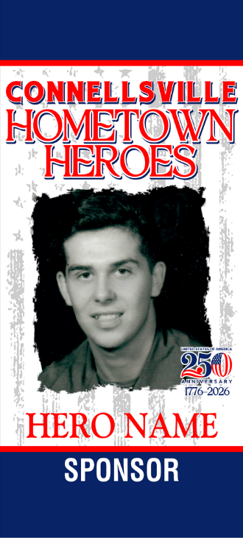

This year’s large banner allows the sponsor to single out a member of the community to name as a “Hometown Hero.” Sponsors may submit the name of the honoree along with a clear “head shot” photo to be used in the banner art. Honorees are NOT restricted to military service personnel, and may be anyone you wish to honor, male or female, young or old. For example, beloved grandmothers, high school sports champions and military veterans are all possible. Banners will be installed in mid-May and will remain until the holiday lights are installed in November. Banner locations include selected poles in Cameron Park and in Yough River Park. Price for a 30” x 62” banner (printed the same on both sides) is $200., or $180 for Chamber members.
Deadline is April 24, 2026
Name of Honoree__________________________________________________________________________________
Line of Text below Honoree’s name (optional)_________________________________________________________
Banner Sponsor____________________________________________________ Contact Phone________________
Mailing Address___________________________________________________________________________________
Does the Name of Sponsor appear on banner ? ( ) Yes ( ) No
How is Sponsor’s name worded? (optional) ___________________________________________________________
Photo Submittal: Please send photo print along with this form to the Connellsville Chamber by mail or in person. Chamber will scan your photo and send it back by return mail. You may also email the photo to us at cvchamber@zoominternet.net Please identify the name of the person pictured.
Number of banners as described above___________ Total Amount Enclosed__________________________________
Greater Connellsville Chamber of Commerce 308 W Crawford Ave. Connellsville PA 15425 724 628-5500

