**Hometown Heroes Banner Project**

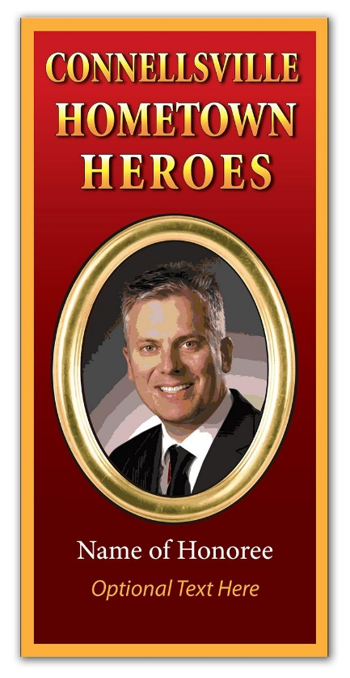

In response to many requests, this year’s large banner allows the sponsor to single out a member of the community to name as a “Hometown Hero.” Sponsors may submit the name of the honoree along with a clear “head shot” photo to be used in the banner art. Honorees are NOT restricted to military service personnel, and may be anyone you wish to honor, male or female, young or old. For example, beloved grandmothers, high school sports champions and military veterans are all possible. Banners will be installed in mid-May and will remain until the holiday lights are installed in November. Banner locations include selected telephone poles on Crawford Ave., Pittsburgh Street, Arch Street and 8th Street. Price for a 30” x 62” banner (printed the same on both sides) is $175., or $160 for Chamber members

Name of Honoree__________________________________________________________________________________

If sponsor has no preference for honoree, a name and photo can be selected from a list compiled by the Connellsville Veterans’ Memorial Project.

Line of Text below Honoree’s name (optional)_________________________________________________________

Banner Sponsor____________________________________________________ Contact Phone________________

Mailing Address___________________________________________________________________________________

Does the Name of Sponsor appear on banner? ( ) Yes ( ) No

How is Sponsor’s name worded? (optional) ___________________________________________________________

**Photo Submittal**: Please send photo print along with this form to the Connellsville Chamber by mail or in person. Chamber will scan your photo and send it back by return mail. You may also email the photo to us at [cvchamber@zoominternet.net](mailto:cvchamber@zoominternet.net) Please identify the name of the person pictured.

Number of banners as described above___________ Total Amount Enclosed__________________________________

**Greater Connellsville Chamber of Commerce** 100 South Arch St. Connellsville PA 15425 724 628-5500