Spring Banners - 2023

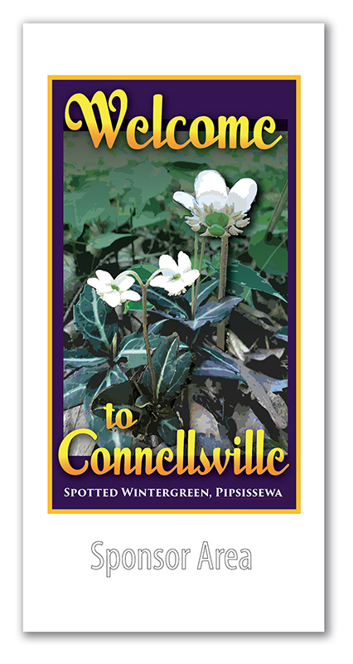

These street banners will be displayed on the smaller decorative lamp posts on Crawford Avenue from Pittsburgh Street to 8th Street. 18” x 36” in size, they will be installed from May to November. The name of the sponsor will be imprinted on both sides of the banner. Price is $125. For chamber members or $150 for non-chamber members. Sponsors may claim their banners after display by contacting the chamber at 628-5500. Please make checks payable to The Greater Connellsville Chamber of Commerce. Deadline for sponsorship is April 6th.
Name_________________________________________________________________________
Number of Banners__________AmountEnclosed_____________________Telephone_________________
Desired Sponsor Lettering_____________________________________________________________________
Greater Connellsville Chamber of Commerce 100 South Arch St., Connellsville, PA 15425 724 628-5500

