Holiday Season Banners 2026
Designed by Connellsville Area Elementary Students
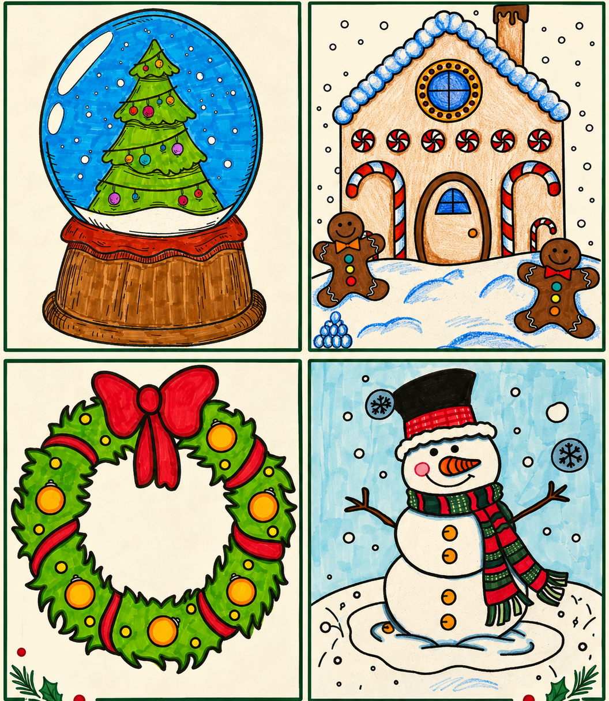
Sponsor a festive street banner in Downtown Connellsville!
These street banners will be displayed on the smaller decorative lamp posts along Crawford Avenue from Pittsburgh Street to 8th Street. Each banner measures 18” × 36” and features one of four student-designed holiday illustrations. Designs will be randomly assigned to sponsors. The sponsor’s name will be printed on both sides of the banner.
CHAMBER MEMBERS $130 | NON-CHAMBER MEMBERS $160
To sponsor a banner, return this form with payment to the Greater Connellsville Chamber of Commerce, 308 W Crawford Ave, Connellsville, PA 15425. Make checks payable to Greater Connellsville Chamber of Commerce. Pay online at www.paypal.me/connellsvillechamber For questions, call 724-628-5500.
ORDER FORM
Name / Business: ______________________________________________________________
Number of banners: __________ Amount enclosed: $____________ Phone: __________________
Desired sponsor lettering: ________________________________________________________
Email: _________________________________________________________________________

