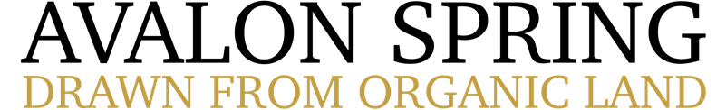

London and surrounding areas
We use our own vehicles and trained drivers for orders upwards of £25.00. You’ll receive an email with a delivery window of two hours, the evening of the working day prior to your delivery.
under £25 – Delivery is £16.50 (fulfilled by UPS)
over £25 – Delivery is £12.50
over £35 – Delivery is £8.50
over £50 – Delivery is £5.00
Rest of UK – Smaller Orders
Your order will be fulfilled via UPS. This is charged at a flat rate so you can enjoy more of the water you love!
We re-package your order in bottle specific plastic air-shock inflated sleeves to best protect your order in transit.
UK Mainland, NI and IOW – Delivery is £16.50
Scottish Highlands & Islands and IOM – Delivery is £55.00
Rest of UK – Larger Orders
For bulk orders, we can arrange delivery via a 20 case min order or pallet network, allowing for a more convenient bulk shipping option.
If you’re willing and able to accept pallet deliveries via large vehicle – get in touch!

