Options Booklet
2022

Introduction

Dear Parents / Carers
Today’s young people are growing up in a fast-changing world. Most will change careers several times in their working lives. Many will have the opportunity to work abroad or work for companies with international links. They will all experience changes brought on by increasing technological developments, greater globalisation and more reliance by employers on a multi-skilled, flexible workforce.
We aim, at Key Stage 4, to provide a curriculum that enables the majority of students to follow a broad and balanced programme of study, which will allow them access to many different pathways at the end of Year 11. At the same time, we also aim to give opportunities for students to specialise, to meet the needs of those with particular interests and strengths. Ours is a ‘personalised curriculum’: invaluable preparation for work, further training and academic study.
Within the curriculum it is vital to note the importance of English and Mathematics. With the changes to education, students who do not achieve the benchmark Grade in either of these subjects will have to continue to study these subjects after their GCSEs/Functional Skills.
Students will need to make two choices in their curriculum. The subjects on offer allow all students to take a path that meets their needs and interests, whilst at the same time allowing them to receive academic accreditation.
I am sure you will agree that we are offering a very exciting curriculum.
Kind regards

Michelle Homer
Deputy Headteacher

Advice for Students

Details of the courses available, including the common core, are included in this booklet.
You will be able to find out more detailed information about individual courses and be able to discuss these with your teachers.
In addition to this booklet you will receive a “Option Request Form”.
We do hope that we agree with your choices and that you will be able to study them. However, some courses may be oversubscribed, and under-subscribed courses might not run. Should this happen, we will consult you about changing one of your choices.
Once you have completed your “Option Request Form”, you need to return it to your form tutor by Friday 18th June.

understanding the qualifications

AQA Unit Awards | Entry Level qualification  OCR | Level 1 qualification  Functional Skills Level 1 | Level 2 qualification  BTEC Firsts  Functional Skills Level 2  Edexcel Award/Certificate
The Unit Award Scheme is an achievement scheme, rather than a qualification. | This is similar to having  1 GCSE grade 1 | This is similar to having  1 GCSE at grade 1-3 | This is similar to having  1 GCSE at grade 4-9
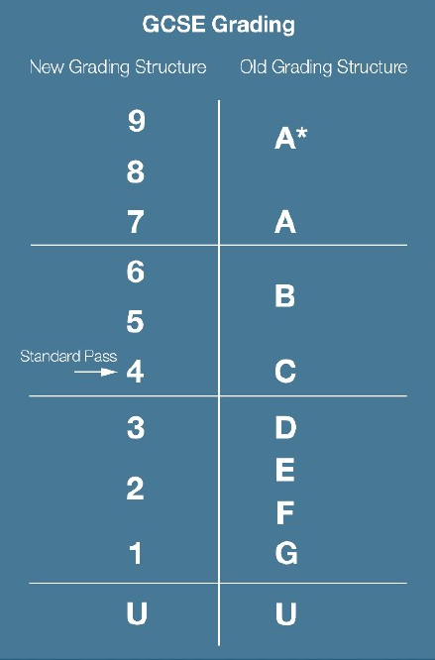
Our aspiriation is that all children will leave City of Rochester school with 5 GCSE’s at grade 4-9 to enable them to go on to further study.

core curriculum
We believe that some aspects of education are too important to allow students to opt out of them. All students will have PSHE, including Careers, PE and Duke of Edinburgh as part of their timetable. The next section contains details of the courses that will be formally accredited that all students will follow.
Additional GCSEs not outlined will be catered for individually as need arises.
Vocational pathways may be more appropriate for some students and bespoke programmes will be offered in partnership with external providers where necessary. This will be discussed with your child and you if necessary.

Functional Skills English
All students are entered for Pearson Edexcel Functional Skills English at either Level 1 or 2. Those that are capable may sit GCSE English.

Course Content
A key aim for Functional Skills English is that it should enable the student to develop confidence and fluency in, and a positive attitude towards, English. Students should be able to demonstrate their competence in English by using it in real-world situations as well as demonstrating a sound grasp of basic English knowledge and skills.
Students will:
- Listen, understand and make relevant contributions to discussions with others in a range of contexts;
- Apply their understanding of language to adapt delivery and content to suit audience and purpose;
- Read a range of different text types confidently and fluently, applying their knowledge and understanding of texts to their own writing;
- Write texts of varying complexity, with accuracy, effectiveness, and correct spelling, punctuation and grammar; and
- Understand the situations when, and audiences for which, planning, drafting and using formal language are important, and when they are less important.
Students should be able to use these functional skills autonomously, applying them to a range of formal and informal contexts, in the workplace and in real life.

Assessment
Consists of:
- one internally-set and internally-marked Speaking, listening and communicating assessment
- one externally-assessed Reading assessment and
- one externally assessed Writing assessment.

They are available as paper-based and onscreen, on demand assessments.
The qualification is graded pass/fail.

CAREERS
Sports Journalist, Lawyer, Film Director, Public Relations Executive, Fashion Journalist, Author, Newsreader, Politician, Actor, Architect, Creative Director, Scriptwriter, Teacher, Customer Service, Retail and many, many more!

functional skills maths
All students are entered for Pearson Edexcel Functional Skills Maths at either Level 1 or 2. Those that are capable may sit GCSE Maths

course content
Functional Skills mathematics specifications should enable the student to gain confidence and fluency in and a positive attitude towards, and to develop behaviours such as persistence and logical thinking as they apply mathematical tools and approaches.
Students will:
- demonstrate their ability in mathematical skills and their ability to apply these, through appropriate reasoning and decision making, to solve realistic problems of increasing complexity;
- be introduced to new areas of life and work so that they are exposed to concepts and problems which, while not of immediate concern, may be of value in later life; and
- develop an appreciation of the role played by mathematics in the world of work and in life generally

assessment
- Consists of one externally assessed assessment.
- Each assessment comprises two sections – a non-calculator section (calculator
prohibited) and a calculator section (calculator permitted).
The assessments are available as paper-based and onscreen, on-demand assessment.
The qualification is graded Pass/Fail.

CAREERS
Many careers stem from maths qualifications including: teaching, finance, banks and building societies, technical and scientific jobs, engineering, medicine, dentistry, and nursing.

functional skills ict
All students are entered for Pearson Edexcel Functional Skills ICT at either Level 1 or 2.

Course content
Functional Skills Information and Communication Technology (ICT) qualifications are designed to give learners the skills to operate confidently, effectively and independently in education, work and everyday life. They have been created in response to employers’ perceptions that many learners are not achieving a sufficiently firm grounding in the basics.
The aims of these qualifications are to develop learner understanding and skills in:
- using ICT
- finding and selecting information
- developing, presenting and communicating information.

Assessment
A 2 hour test paper set and marked by Pearson
- Section A involves using the internet to find and select information.
- Section B involves working with numbers, creating a digital product, using communication tools and organising work.
The qualification is graded Pass/Fail.

CAREERS
Computing, Computer Programming, Computer Operations, IT Product Development, Systems Analyst, Technical Support.

AQA Entry Level Science
All students are entered for AWA Entry Level Science.
Some students may go on to study GCSE Biology in year 11.

course content
Biology is the science of living organisms (including animals, plants, fungi and microorganisms) and their interactions with each other and the environment. The study of biology involves collecting and interpreting information about the natural world to identify patterns and relate possible cause and effect. Biological information is used to help humans improve their own lives and strive to create a sustainable world for future generations.

Chemistry is the science of the composition, structure, properties and reactions of matter, understood in terms of atoms, atomic particles and the way they are arranged and link together. It is
concerned with the synthesis, formulation, analysis and characteristic properties of substances and
materials of all kinds.

Physics is the science of the fundamental concepts of field, force, radiation and particle structures, which are inter-linked to form unified models of the behaviour of the material universe. From such
models, a wide range of ideas, from the broadest issue of the development of the Universe over time to the numerous and detailed ways in which new technologies may be invented, have emerged. These have enriched both our basic understanding of, and our many adaptations to, our material environment.

assessment
The specification comprises six components. Students must study three of these.
Each component has two assessments: one externally set and one internally set.
Biology
1. The human body
2.Environment, evolution and inheritance

Chemistry
1. Elements, mixtures and compounds
2. Chemistry in our world

Physics
1. Energy, forces and the structure of matter
2. Electricity, magnetism and waves

CAREERS
Astronomer, Technician, Aviation, Chemist, Teacher, Electrician, Film and Video Editor, Food Tester, Food Scientist, Forensic Scientist, Nuclear Technician, Nuclear Power Operator, Occupational Health Specialist, Physicist, Physiotherapist, Pilot, Ship Captain, Sound Engineer, Doctor, Nurse, Pharmacist, Dentist, Marine Biologist, Veterinarian, Veterinary Nurse, Optician, Chemical Engineer, Marine Biologist, an endless list!

Level 1 personal growth and well being

course content
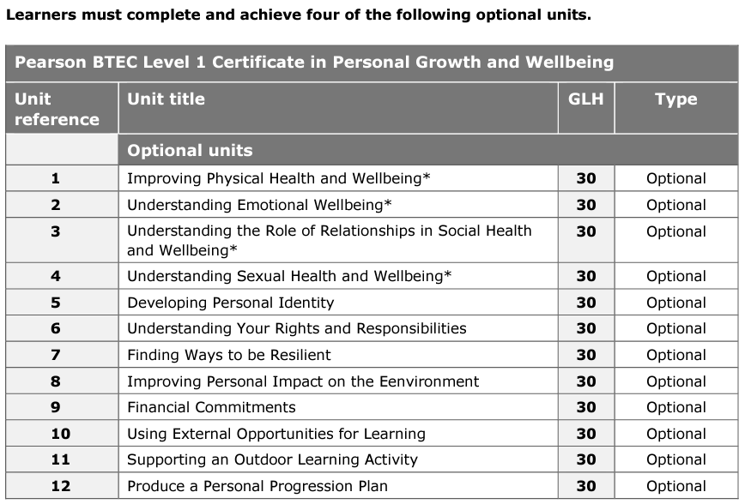

assessment
All units in this qualification are internally assessed and externally verified.
The qualification is graded Pass/Fail.

CAREERS
The mode of delivery and assessment in the units is designed to build confidence in learning, working with others and demonstrating personal-related responses within a broad range of activities. Learners will be given contexts and scenarios to help them develop skills and acquire knowledge through application. Learners will develop pre-employability skills to allow them to progress to further learning and training, and, ultimately, to become successful in their future career choices.

open options
Students may choose two of the following options:
    - Vocational Award in Performing Arts (Level 2)
(Music or Drama or Music Tech or Musical Theatre)
    - Vocational Award in Sport and Coaching Principles (Level 2)
    - Vocational Award in Construction and the Built Environment (Level 2)
    - Certificate in Digital Media (Level 1)
    - GCSE Art and Design
    - GCSE Computer Science (ICT)
    - Vocational Award in Hospitality and Catering (Level 2)
    - Vocational Award in Health and Social Care (Level 2)
    - Vocational Award in Retail Business (Level 2)
    - OCR History (Entry Level)
    - OCR Geography (Entry Level)

More details follow below on these qualifications.

vocational award in performing arts

course content
Our Vocational Award in Performing Arts will develop students’ knowledge and understanding of the performing arts sector and provide them with opportunities to develop associated practical skills. It covers performing, creating and performance arts in practice.

This qualification can be completed through any one of the following:
Drama
Music
Music Technology
Musical Theatre

This can include but is not limited choreography, music composition, music composition using technology, costume design, lighting design, sound design, make-up and hair design and set design.

Unit 1 enables learners to gain a knowledge and understanding of the skills and techniques needed to reproduce an existing piece(s) of professional/published work.

Unit 2 enables learners to gain, develop and demonstrate knowledge and understanding of the skills and techniques needed to create and refine original work in the performing arts.

Unit 3 introduces learners to areas of the performing arts that need to be considered when responding to an industry commission.

assessment

Units 1 and 2 are assessed through internal controlled assessment and submitted for external moderation. Unit 3 will be externally assessed.

The qualification is graded as a Level 2 Distinction*, Level 2 Distinction, Level 2 Merit, Level 2 Pass, Level 1 Distinction*, Level 1 Distinction, Level 1 Merit, Level 1 Pass.

CAREERS
There are many careers which Music is a valuable foundation. These include: Musician, Music tutor, Music teacher, Children’s entertainer, stage performer, music composer, singer/song writer, orchestral manager, sound engineer, music therapist.
Careers in education, theatre, marketing and the television and film Industry.

vocational award in CONSTRUCTION AND THE BUILT ENVIRONMENT

course content
Our Vocational Award in Construction and the Built Environment will develop learners’ knowledge and understanding of the sector and provide them with opportunities to enhance their practical skills. In addition, learners will explore different ideas and concepts of the built environment and gain knowledge and understanding of a range of professional and trade roles.

Unit 1 introduces learners to the built environment and provides them with the opportunity to develop skills, knowledge and understanding in identifying, explaining and evaluating different ideas and concepts of the built environment. Learners will explore a range of profession and trade roles, and some of the different structures and buildings of the built environment.

Unit 2 offers learners the opportunity to develop skills, knowledge and understanding of the design of the built environment, including exploring what is needed to interpret and produce drafts, drawings, and models of design plans.

Unit 3 offers learners the opportunity to develop skills, knowledge and understanding of three construction trade areas of the built environment, including planning, undertaking and evaluating construction tasks.

assessment

Unit 1 is assessed through an external on-screen examination.

Units 2 and 3 are assessed through controlled assessment and submitted for external moderation.

The qualification is graded as a Level 2 Distinction*, Level 2 Distinction, Level 2 Merit, Level 2 Pass, Level 1 Distinction*, Level 1 Distinction, Level 1 Merit, Level 1 Pass.

CAREERS
There are many careers which Music is a valuable foundation. These include: Musician, Music tutor, Music teacher, Children’s entertainer, stage performer, music composer, singer/song writer, orchestral manager, sound engineer, music therapist.
Careers in education, theatre, marketing and the television and film Industry.

vocational award in sport and coaching principles

course content
The Vocational Award in Sport and Coaching Principles will develop students’ knowledge and understanding of the Sport and Coaching sector and provide them with opportunities to develop associated practical skills. It covers fitness for sport, improving sporting performance and, coaching principles.
Unit 1 introduces learners to the adaptations that take place in the body following exercise, how training can lead to improvements in fitness, and the planning of training programmes. The aim of this unit is to develop the knowledge, understanding and skills needed to plan training programmes to improve the fitness of individuals.
Unit 2 introduces learners to how different areas of sporting performance can be improved. The aim of this unit is to provide learners with the knowledge and understanding needed to be able to analyse sporting performance, identify strengths and weaknesses and plan for improvement.
Unit 3 introduces learners to the principles involved in sports coaching. The aim of this unit is to provide learners with the appropriate knowledge and understanding to be able to plan, lead and evaluate a coaching session within a sporting activity.

assessment

Unit 1 is assessed through an external examination. Units 2 and 3 are assessed through controlled assessment and submitted for external moderation.

The qualification is graded as a Level 2 Distinction*, Level 2 Distinction, Level 2 Merit, Level 2 Pass, Level 1 Distinction*, Level 1 Distinction, Level 1 Merit, Level 1 Pass.

CAREERS
Useful for careers in Sports Coaching, Armed Forces, Leisure Industry, Sports Development, Emergency Services, Teaching, Professional Sport and Physiotherapy

Level 1 certificate in digital media

course content

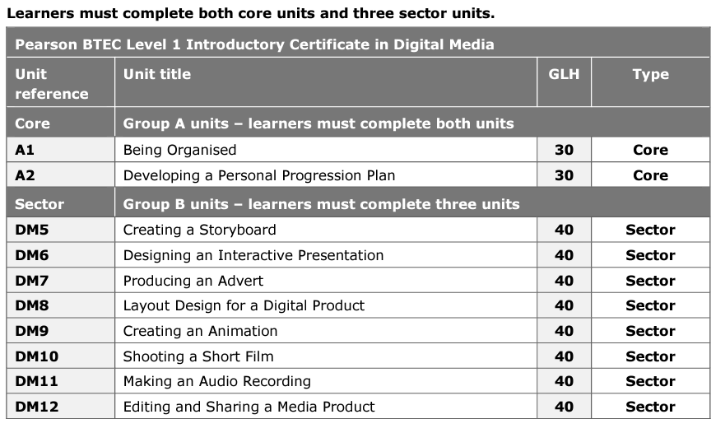

assessment

All units in this qualification are internally assessed and subject to external standards verification.

The qualification is graded using a scale of Distinction, Merit, Pass and Unclassified.

CAREERS
Digital media photographer, Video editor, Animator, Social media specialist, Graphic designer, Video game designer, Web analytics specialist, Web developer.

GCSE ARt and design

course content
Art and Design equips students with the skills to enjoy, produce and engage with the visual arts throughout their lives, and it has immense value as a GCSE subject.
GCSE Art and Design provides the opportunity for students to:
- explore both contemporary and historical sources of art, craft and design first hand through, for example:
  - visiting museums, galleries, art shows and fairs
  - experiencing audio-visual productions, including still and moving imagery
  - their surroundings and environments.
- take an individual approach to their art, craft and design making
- develop the skill of selecting their best and most appropriate work for presentation.

assessment

The GCSE in Art and Design consists of two internally assessed and externally moderated components.
Component 1: Personal Portfolio (internally set)
Component 2: Externally Set Assignment

This GCSE qualification will be graded and certificated on a nine-grade scale from 9 to 1 using the total subject mark where 9 is the highest grade.

CAREERS
There are many careers for which Art is a valuable foundation. These include Architecture, Graphic Design, Teaching, Jewellery Design, Fashion, Television work, Shoe Design, Textile Design, Film making, Printing, Pottery, Animation, Illustration, Costume Design, Theatre Design and Garden Design.

Vocational award in hospitality and catering

course content

The Vocational Award in Hospitality and Catering will develop students’ knowledge and understanding of the Hospitality and Catering sector and provide them with opportunities to develop associated practical skills. It covers the hospitality and catering industry and hospitality and catering in action.
Unit 1 enables learners to gain and develop comprehensive knowledge and understanding of the hospitality and catering industry including provision, health and safety, and food safety.
Unit 2 enables learners to develop and apply knowledge and understanding of the importance of nutrition and how to plan nutritious menus. They will learn the skills needed to prepare, cook and present dishes. They will also learn how to review their work effectively

assessment
Unit 1 is assessed through an external examination.
Unit 2 is assessed through controlled assessment and submitted for external moderation.
The qualification is graded as a Level 2 Distinction*, Level 2 Distinction, Level 2 Merit, Level 2 Pass, Level 1 Distinction*, Level 1 Distinction, Level 1 Merit, Level 1 Pass.

CAREERS
Baker, bar person, butcher, catering or restaurant manager, cellar technician, chef, consumer scientist, counter service assistant, food processing worker, food scientist, food technologist, housekeeper, kitchen assistant, kitchen manager, kitchen porter, publican, waiting staff.

vocational award in health and social care

course content
The Vocational Award in Health and Social Care will develop students’ knowledge and understanding of the Health and Social Care sector and provide them with opportunities to develop associated practical skills. It covers health, well-being and development throughout the lifespan and enables learners to understand the value of person-centred practice, safeguarding and modern-day challenges to health and well-being.
Unit 1 enables learners to gain and develop knowledge and understanding of how individuals grow and develop during the life stages; they will also gain an understanding of how health and well-being is promoted.
Unit 2 enables learners to develop and apply knowledge and understanding of the value of person-centred practice, safeguarding and modern-day challenges to health and well-being.

assessment
Unit 1 is assessed through an external examination. Unit 2 is assessed through controlled assessment and submitted for external moderation.

The qualification is graded as a Level 2 Distinction*, Level 2 Distinction, Level 2 Merit, Level 2 Pass, Level 1 Distinction*, Level 1 Distinction, Level 1 Merit, Level 1 Pass.

CAREERS
Occupational therapist, Care worker, Rehab worker, Counsellor, Health psychologist, Social worker, Health visitor.

vocational award in retail business

course content
The Vocational Award in Retail Business will develop students’ knowledge and understanding of the retail business sector and provide them with opportunities to develop associated practical skills. It covers the business of retail, customer service for retail business and merchandising and marketing retail products.
Unit 1 introduces learners to the business of retail and provides them with the opportunity to explore the dynamic and competitive nature of the retail industry. They will gain knowledge and understanding of different types of retail business and retail activity, as well as the impact of external factors on the industry.
Unit 2 allows learners to develop knowledge and understanding of the principles of customer service for retail business and offers the opportunity for learners to develop skills in investigating the customer service experience across retail organisations.
Unit 3 provides learners with the opportunity to develop their understanding of the importance of merchandising and marketing retail products, and how retail businesses use merchandising and marketing to achieve their aims. Learners will also apply their knowledge and understanding to develop skills in designing visual merchandising installations and promotional materials that achieve specific aims.

assessment
Unit 1 is assessed through an external examination. Units 2 and 3 are assessed through controlled assessment, submitted for external moderation.

The qualification is graded as a Level 2 Distinction*, Level 2 Distinction, Level 2 Merit, Level 2 Pass, Level 1 Distinction*, Level 1 Distinction, Level 1 Merit, Level 1 Pass.

CAREERS
Cashier, Sales Associate, Store Manager, Buyer, Visual Merchandiser, Advertising & Marketing Manager, Cleaning & Maintenance, Security Guard, Inventory Manager, Stocker, Retail Warehouse Worker, Social Media Manager, Customer Service Representative, Human Resources, Loss Prevention Manager, Team Leaders and Floor Managers, Logistics.

OCR history
OCR Entry Level History

course content
Unit 1
One from:
- Crime and Punishment
- People’s Health
- Migration
- War and British Society
- Power, Monarchy and Democracy.

Unit 2
One from:
- Germany 1925–55
- The USA 1919–74
- Normans 1065–1087
- Elizabethans 1580–1603
- The Making of America 1789–1900
- The Viking Age c. 750–c. 1050
- Britain: Peace and War 1900–18
- International Relations 1918–2001.

Unit 3
Learners choose either a site or an individual to study and complete two pieces of work:
- A 150-word biography (of the person) or guide (to the site)
- A 250-word explanation of the importance and impact of their site or individual over time.

assessment
Unit 1 and 2 are assessed internally through two tasks which consists of a series of questions testing learners’ knowledge and understanding of the units studied.
Unit 3 is assessed internally through the submission of the pieces of work mentioned above.
Entry Level qualifications are graded on the scale:
Entry 3, Entry 2 and Entry 1, where Entry 3 is the highest grade available.

Candidates who fail to reach the minimum standard of Entry 1 will be Unclassified (U).

CAREERS
Lawyer, Journalist, Media, Teacher, Management, Archaeologist, Civil Service, Researcher, Social Worker, Conservation etc.

ocr geography
OCR Entry Level Geography

course content
Unit 1
- Our World
- Destructive World
- Resourceful World

Unit 2
Practical experience of fieldwork
In completing fieldwork, learners practise a range of skills, gain new geographical insights and begin to understand the world around them. Fieldwork adds ‘geographical value’ enabling learners to ‘anchor’ their studies within a real world context.

Unit 3
A project based on any part of the specification
Learners will complete one Personal Project which can be based on any area of the specification. The project can be based on exemplar titles provided by OCR or can be
centre/learner developed. The project can be presented in any appropriate manner, for example as a poster, PowerPoint presentation or a written project to best suit individual learners needs. Learners will be awarded for their ability to research geographical facts from various sources and use a range of presentation methods to help them answer their project title. Learners will also be credited for accurate use of
geographical vocabulary and logical structure to their project.

assessment
Unit 1 is an internally assessed test which will assess all three topics studied.
Unit 2 is a fieldwork notebook is submitted for internal assessment detailing fieldwork completed.
Unit 3 is assessed internally through the submission of the project mentioned above.

CAREERS
Careers people have been employed in through studying Geography include: Town Planning, Estate Agent, Travel Agent, Expedition Leader, Air Cabin Crew, Lawyer, Conservation Manager, Armed Forces, Teacher, Human Rights Officer, Surveyor, Weather Forecaster, Landscape Architect, Hazard Prediction, Travel Writer, Pollution Analyst, Aid Worker, Marketing, Flood Protection Manager…

