**EXPLORER CENTER SUMMER CAMP 2024**

**Summer Learning Initiative (SLI) - United Way of Rhode Island Collaboration**

Global Science Envirotech (GSET) is proud to announce this year’s Summer Camp!

GSET is teaming up again with several partners throughout the state, including Prepare RI (SkillsRI), Professors from University of Rhode Island’s College of Engineering; Andy Wu, Engineering student, Boston’s Northeastern University; Kareem Kader, Computer Science, from University of Illinois, Urbana, Tina Huang, Biotechnology, Rhode Island College, Sianna-Marie Hamilton and Lily Wu, University of Rhode Island, and many others, to offer our annual in-person summer camp centered around STEAM + C.

STEAM + C uses Environmental Sciences, Technology, Engineering, Additive (3D Printing), and Mathematics to build upon projects and ideas to explore and find ways to fight climate change, and explore land, inner and outer space!

We integrate learning with hands-on activities and important skills, such as reading, writing, and critical thinking, in order to help our youth gain better understanding and skills that will help them get ahead as they navigate their career path.

Over the course of 6+ weeks, students will:

1. Work in small groups on hands-on projects while learning & practicing relevant skills and subjects that will help them complete these projects
2. Work with Next Generation Science Standards, basic and advanced electronics, additive manufacturing, computer-aided design (CAD), video production, and laboratory science
3. Design, test, and monitor basic electronics and ROVs
4. Learn about health, safety, and exploration
5. Go on field trips and conduct field studies
6. Meet and learn from enrichment providers on educational topics
7. Explore job & career workforce development using STEAM+C and secondary education

*High school students with experience and past exposure to STEAM + C materials may be offered the option of training to become research assistants.*

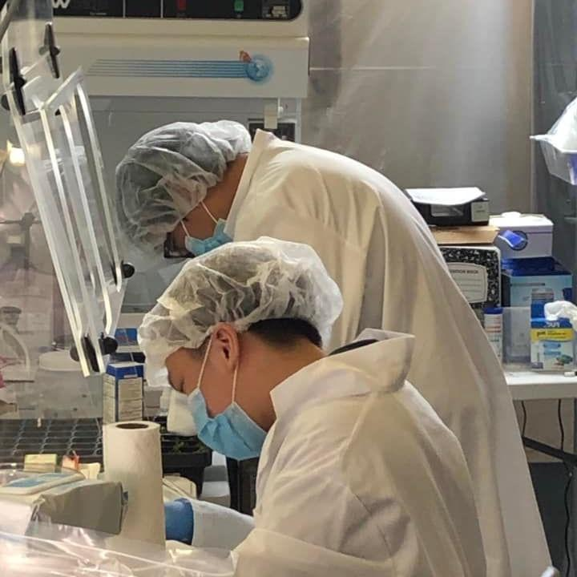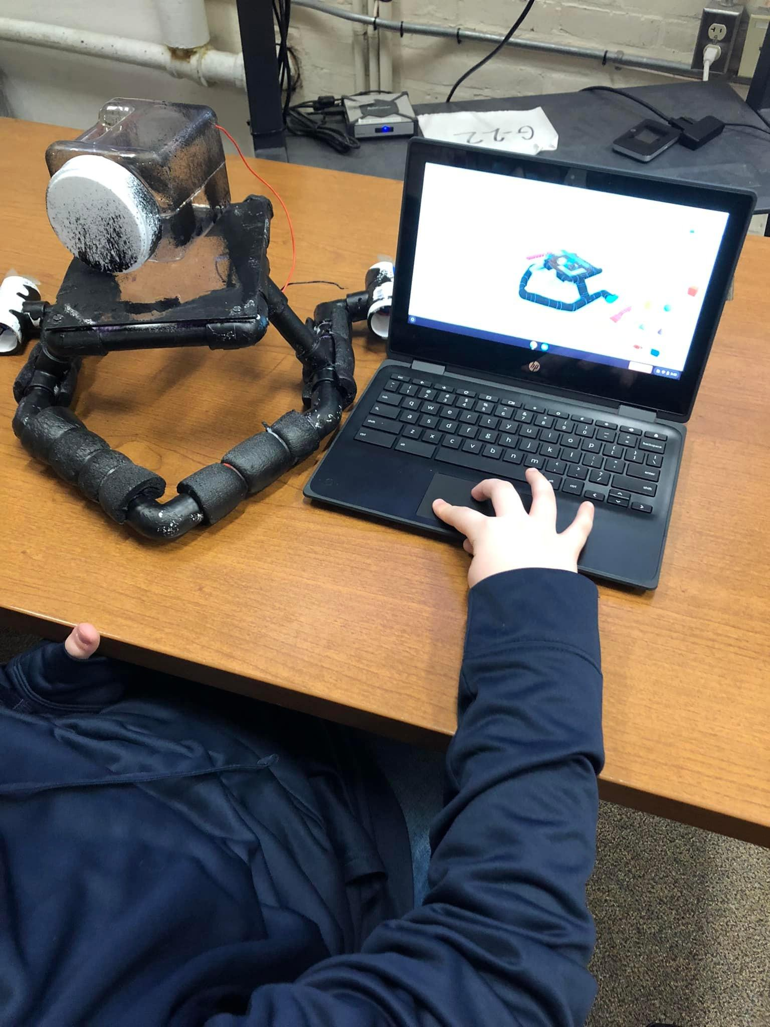

***Where will this take place?:***

* Global Science & Envirotech, Inc: 1370 Cranston Street, Suite 1, Cranston, RI, 02920

We may have a site at Hugh B. Bain- PENDING School Department collaboration

***Who can participate?:*** Students entering 6th grade, up to currently in 12th grade

***When will it take place?:*** July 2025 to August 2025, Monday - Friday 8:30 A.M. - 3:00 P.M.

| Middle School Session  July 7th 2025 - August 15th, 2025 | High School Session  (additional time available as needed)  July 7th, 2025 - August 22nd, 2025 |
| --- | --- |

Student mentors, staff, and research assistants must attend orientation/training before the sessions (July 1st - July 3rd, 2025).

***To be announced, Fall 2024***: A celebration, special award & scholarship ceremony for high schoolers.

***How much will it cost?***

|  | Non-Cranston | Cranston |
| --- | --- | --- |
| Middle School | $5001 | 2 |
| High School | $5001 | 2 |

2,1 Circumstances may require further mentoring and tutoring - please reach out to Dr. Jordan to discuss.

2 Dependent on funding from United Way of RI, otherwise refer to the Non-Cranston student fee.

Please make checks payable to:

GLOBAL SCIENCE & ENVIROTECH, INC.

State Certification #209372450

***Scholarships and discounts are available! Please reach out to Dr. Jordan to discuss:*** [jessejordanmd@gmail.com](mailto:jessejordanmd@gmail.com) or [drjexplorercenter@outlook.com](mailto:drjexplorercenter@outlook.com)

**A P P L I C A T I O N**  
  
*\*Please note: There will be additional forms to follow\**

*We respect all people, regardless of age, sex, ethnicity, religion, or socioeconomic background.*

______________________________ ______________________________

***First name Last name***

______________________________ _________ ______________

***Birthdate (MM/DD/YYYY) Age Gender***

______________________________

______________________________ _________________ RI _________

***Address City State Zip Code***

_________________________________________ ___________________

***School School ID #***

______________________________

***Student’s Email Address (non-school email preferred)***

______________________________ ___________ ____________________

***Primary Contact Relationship Primary Contact #***

______________________________ ____________________

***Email Address Alternate Phone #***

______________________________ ___________ ____________________

***Emergency Contact #1 Relationship Contact #***

______________________________ ___________ ____________________

***Emergency Contact #2 Relationship Contact #***

**A P P L I C A T I O N**

**Participant’s name**: _______________________________________________

**Areas of Interest** (Please circle up to 3):

Volunteering (including: fundraising opportunities)

Electronics, and Special Projects

Computer-Aided Drafting (CAD) and 3-D Printing

Artificial Intelligence (A.I.) and Podcasting

Coding

Strength Training

Sports

Other Activities: ______________________________________________

**Annual income of Participant’s Family**: Scholarships require proof of income

$0 - $13,999 (Scholarship Available)

$14,000 - $24,999 (Partial Scholarship)

$25,000 - $39,000 (Partial Scholarship)

$40,000 - $54,000 (Partial Scholarship)

$55,000 - $74,999

$75,000 or more

**Ethnic Orientation** (Circle all that apply):

African American Caucasian Caribbean Asian/ Pacific

Hispanic Native American Alaskan Native

Other: _______________________________