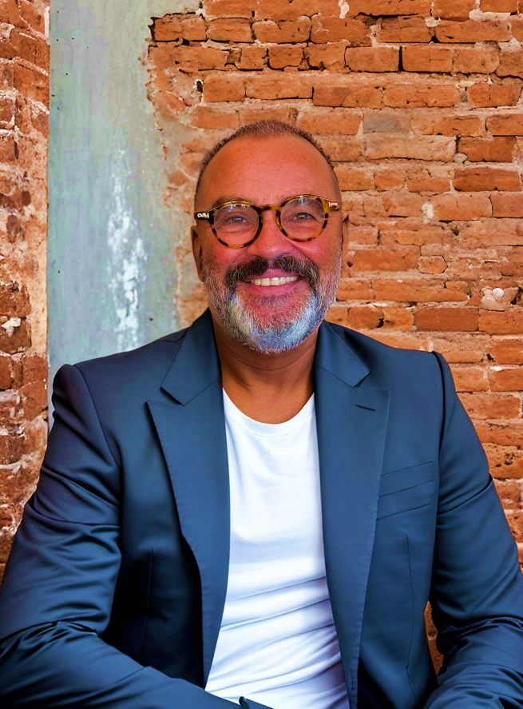

Klaus

Hasmann

**Interior Designer & Set Decorator**

Accomplished Set Decorator with a 33-year track record of creating captivating and immersive environments for film, television, and commercial projects. Proven ability to transform spaces into visually stunning and authentic settings. Extensive experience collaborating with top-tier directors, designers, and production teams. Possessing a deep understanding of interior design, furniture, and construction, I excel in delivering exceptional results within demanding timelines.

l

**Skills**

* Set Design and Decoration
* Budget Management
* Team Leadership
* Problem Solving
* Time Management
* Furniture & Interior Design Sourcing & Construction
* Fundamental Sketchup Skills
* Construction Knowledge
* Visual Design & Merchandising
* Location Scouting
* Prop & Food Styling
* Strong Floral Design Skills

**Experience & Selected Projects**

**Project Manager - 2022 Ferrari /Without Productions SRL**

Project managed and oversaw the Fabrication & installation of custom LED light art objects for Fall 2022 fashion campaign window displays at the Ferrari Store on Rodeo Drive in Beverly Hills.

**Project Manager - 2021 Ferrari /Without Productions SRL**

Project managed and supervised the renovation of the Ferrari Beverly Hills Fashion Store on Rodeo Drive, adhering to design guidelines provided by Without Productions SRL, Milan, and architect Rossana Capruso.

**Art Director - 2019 Activision Blizzard**

Art directed and project managed the construction and installation of the Darkmoon Faire Photo-Op entrance gate and tree installation for the 2019 Activision Blizzard BlizzCon show.

**Co-Founder / CEO - 2013 – 2018 -ZG04 Décor**

Demonstrated global sourcing expertise by leading trade missions to China, curating Modern Contemporary furniture and lighting at the Guangzhou Consumer Fair. Successfully outfitted a 22,000 square foot showroom with hand-selected inventory. Spearheaded the launch of Los Angeles-based Prop house ZG04 Décor, conceptualizing store layout, merchandising strategy, and operational management plans."

**Interior Designer - 2016-2017 Interior Design / Staging**

Designed and executed for Real estate Developer Sue Parsons visually stunning interior staging for high-end residential properties. Strategically styled spaces to highlight architectural features, optimize layout functionality, and create an inviting ambiance. Collaborated closely with real estate developers and agents to align staging designs with target market preferences and demographic trends. Utilized global sourcing expertise to curate unique decor pieces and furnishings that elevated each property’s appeal. Consistently achieved rapid sales success, with staged properties selling within two weeks of hitting the market.

**Language Skills**

**German**  - C2 monther tongue

**English** - C1 fluent

klaushasmann@gmail.com

213.819.4227

Sherman Oaks, CA

Married

**Art Director - 2011 Event Designer Prada Group**

Conceived and executed the art direction for Prada's 2011 "Mui Mui" sunglass launch event, inspired by a "Film Noir" concept by Production Designer Martin Childs. Managed all aspects of production, including casting talent, hiring lighting and video professionals, and securing projection specialists and security & transportation services. Designed and oversaw the construction of custom furniture to create an immersive event experience.

**Furniture Designer - 2011 Rochdale Spears Vietnam**

Designed an 18-piece upholstery line under Robb Witleff for the Black Box Furniture Collection, encompassing up to eight SKUs per design. Demonstrated expertise in upholstery design and development

**Furniture Designer - 2011 RH/Bobo Intriguing Objects**

Spearheaded the design and prototype development for Restoration Hardware's Soho Collection, resulting in a complete 12 SKU line. Successfully executed production of sectional sofas for flagship stores in Beverly Hills, New York, San Francisco, Chicago, and Houston. Demonstrated expertise in commercial-grade furniture by building custom sectionals for the Public Hotel in Chicago.

**Interior Designer - 2007-2009**

Interior Designed the interior of the mid-century Malibu residence for renowned film director John Mastromonaco, creating a high-end, eclectic aesthetic tailored to his personal style.

**Co-Founder - 1994-1998 Zeitgeist**

Conceptualized and curated inventory than launched Los Angeles-based prop house “Zeitgeist”. Defined the company's aesthetic and brand identity while overseeing inventory management, customer acquisition and sales, marketing strategies, and daily operations.

**Freelance Set Decorator & Art Director 1994 - present**

Executed over 280+ commercial campaigns for top brands, working with leading directors and designers. Created sets for five feature films and ten TV movies, enhancing narrative and aesthetics. Transformed spaces into diverse environments, from period pieces to contemporary settings. Collaborated with production teams to ensure set designs met directorial vision and budget constraints.

Consistently delivered projects on time and within budget, maintaining high quality. Expert in sourcing and constructing custom furniture and props for authentic set designs.

**Education**

**Visual Designer & Merchandiser**

**1979 -1983 Apprenticeship in Germany with degree in Visual Design & Merchandising**

**1984-1990 Free Lance Visual Designer & Merchandiser**

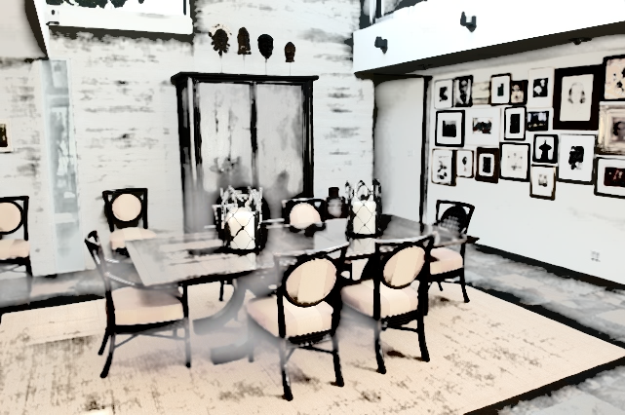

Los Angeles, 02/17/2025

Klaus Hasmann

**Awards and Recognitions**

**2008 Art Directors Guild Award of Excellence for Best Art Direction**

**2009 Art Directors Guild Nomination for Best Art Direction**

**SET DECORATOR**

**Commercial:**

***Production Company / Product.* *Title Production Designer Director***

Imperial Woodpecker / Palms Casino Set Decorator Quito Cooksey Sam Brown

Eagle Eleven / Bet MGM Set Decorator Page Buckner Peter Berg

Radical Media / Powerade Set Decorator Bruce McCloskey Dave Meyers

World War 7 / Xfinity Set Decorator Johnny Flanagan Sheena Brady

Radical Media / AMEX Set Decorator Tom Foden Ron Howard

Smuggler / Tony Hawk ”Ride” Set Decorator Brock Houghton Oscar Holmedal

Radical Media / Kia Set Decorator Tom Foden Peter Miller

Epoch Films / Wells Fargo Set Decorator Floyd Albee Jeff Preiss

Smuggler / Liberty Mutual Set Decorator Brock Houghton Russ Lamoureux

Super Studio / Ketel One Set Decorator Tom Foden Crime of the Century

Six Foot Seven Films / Sci-Fi Promo Set Decorator Tino Schädler Brett Foraker

M.J.Z. /US Army Set Decorator Sean Hargraves Phil Joanou

Radical Media / Miller Light Set Decorator Tom Foden Tarsem

Biscuit Filmworks / HBO Promo Set Decorator Dominic Watkins Noam Murro

M.J.Z. / Farmers Insurance Set Decorator Chris Gorak Dante Ariola

Anonymous Content / Jeep Set Decorator Tom Foden Mark Romanek

R.S.A. / HBO on Demand Set Decorator Tom Foden Jake Scott

Prettybird / Nissan Set Decorator Jeremy Reed Craig Gillespie

Anonymous Content / Orville Popcorn Set Decorator Tom Foden David Fincher

Anonymous Content / Nike Set Decorator Tom Foden Mark Romanek

Directors Bureau / Comcast Set Decorator Debra Evans Roman Coppola

Form / Sun Com Set Decorator Johannes Spalt Harry Patramanis

Bay Films / Levis Set Decorator Debra Evans Michael Bay

Crossroads Films / Verizon Set Decorator Bruce Rod Mark Pellington

R.S.A. / Barcleys Bank Set Decorator Tom Foden Jake Scott

Wild Scientific / HEB Set Decorator Bruce Rod David Wild

Hungry Man / Snapple Set Decorator Molly Flanagin Dave Laden

RSA /USA / Marlboro Set Decorator Debra Evans Tom Dey

House of Usher / Apple Set Decorator Jamie Vickers Kinka Usher

***A list of 280+ commercials is available upon request***

***2008 ADG Award for “Farmers Insurance Drowned Circus”***

***2009 ADG Award nomination for “Sci-Fi Promo”***

**Feature Film:**

***Production Company / Product.* *Title Production Designer Director*** 300 Rise of an Empire / Warner Bros Set Decorator LA Patrick Tatopolous Zack Snyder

Unstrung Heroes / Hollywood Pictures Asst. Set Decorator Garreth Stover / Larry Dias Diane Keaton

Doppelganger / Planet Productions Asst. Prop Maste. Ivo Christante / Lisa Monti Donald P. Borches

Twilight / Paramount Set Buyer David Gropman /Beth Rubino. Robert Benton Pie In the Sky / Newline Cinema Set Decorator Linda Pearl Bryan Gordo

**Television:**

***Production Company / Product.* *Title Production Designer Director***

Deconstructing Sarah / MOW / USA Cable Asst. Decorator Garreth Stover / Larry Dias Craig Baxley

Stolen Hearts / MOW /NBC Asst. Decorator Garreth Stover / Larry Dias Mimi Ledger

Deep Red / MOW / USA Cable Asst. Decorator Garreth Stover / Larry Dias Craig Baxley

Murder of Innocence / MOW / USA Asst. Decorator Garreth Stover / Larry Dias Tom McFaughin

A Life in Theater / MOW / TNT Asst. Decorator David Wasko / Sandy Wasko Gregory Mosher

There Was A Little Boy / MOW Asst. Decorator Garreth Stover / Larry Dias Mimi Ledger

Curacao / MOW / Showtime Asst. Decorator Garreth Stover / Larry Dias Carol Shultz

Barbarians at the Gate / HBO Set Dresser Linda Pearl / Karen O’Hara Glenn Jordan