PRF Aftercare
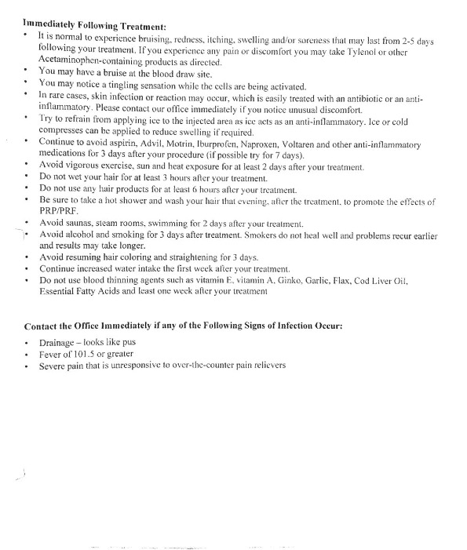
*Hair Treatment only*
*Hair Treatment only*
*Hair Treatment only*
*Hair Treatment only*

Office # 801-528-4033

