Micro Needling Aftercare Instructions
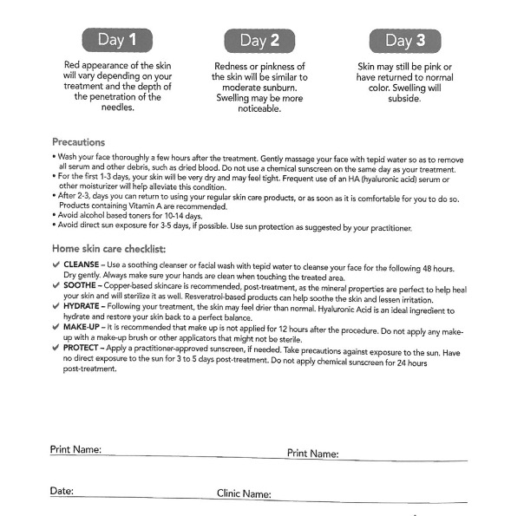

Patient Name: ___________________________ Patient Signature: _____________________

Date: __________________________________

Provider & phone number: Brandy Tafoya, APRN-C 801-528-4033

