Botox Party

_____________, Thank you for hosting a Botox party with your friends!

- Find at least 5 friends that would like to attend.
- Please choose 2 dates and 2 times to ensure that I am able to accommodate your needs.
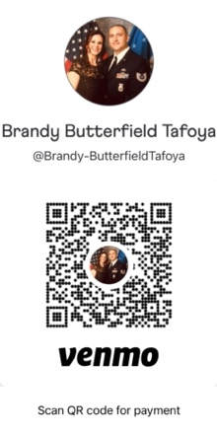
- Each friend needs to send Brandy Marie Family Aesthetic Care a $50 deposit to hold their place for the party and ensure enough product.
  - This money will go towards their Botox treatment.
  - If someone has to back out and can provide 24-hour notice
the money will be returned to them.
venmo this money to
@Brandy-ButterfieldTafoya 2 days prior to the party.
- Have your guests arrive with a clean face
(mascara, eye shadow and eye liner are ok).
- Have fun and create a memorable get together,
because we all need some socializing at this time.

I am also happy to do dermal fillers at this party. ½ or full syringe, please let me know if you have anyone that would like these so I can bring enough supplies.

Botox: $9 a unit (10-unit limit & no more than 350 units)
Dermal fillers: $325 for ½ syringe & $650 for a full syringe.

Benefit to host: after 10 aesthetic referrals the host get a free bottle of Xeomin which is 100 units!! You can use this all on you or come see me and bring a friend or family.

Love, Brandy, MSN FNP, APRN-C

