Tox Party!

You're invited to attend a tox party
Hosted By Heidi Wade

On: Monday November 15th, 2021
From 6pm until we are done getting beautified!

At: Brandy Marie Family & Aesthetic Care
1448 N. 2000 W. #3, Clinton, Ut. 84015
801.528.4033

Each friend needs to send
Brandy Marie Family Aesthetic Care
a $50 deposit to hold their place for the party
and ensure enough product.
This money will go towards their tox treatment.
If someone has to back out and can provide 24-hour
Notice the money will be returned to them.
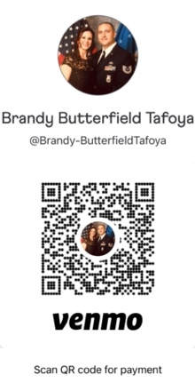
venmo this money to
@Brandy-ButterfieldTafoya
2 days prior to the party.

For a full list of treatments
& The Esthetician services
Please visit
Brandymariefamilyaestheticcare.com
If more than tox is wanted please
Call the clinic so we can ensure
Enough staff, time and product

Thank You,
Brandy & Heidi

