Vampire Facial Party

__________________, Thank you for hosting a Botox party with your friends!

- Find at least 5 friends that would like to attend & plan to purchase the vampire facial.
- Please choose 2 dates and 2 times to ensure that I am able to accommodate your needs.
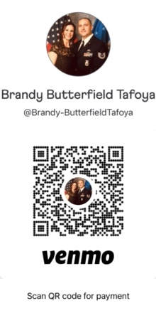
- Each friend needs to send Brandy Marie Family Aesthetic Care a $50 deposit to hold their place for the party and ensure enough product.
  - This money will go towards their treatment.
  - If someone has to back out and can provide 24-hour notice
the money will be returned to them.
  - Host-Please venmo this money to
@Brandy-ButterfieldTafoya 2 days prior to the party or have
individuals attending venmo me.
- Have your guests arrive with a clean face.
- Have fun and create a memorable get together,
because we all need some socializing at this time.

I will bring the consent forms for you to the party, please have pens and an area for your guests to read and sign the consents.

I am also happy to do dermal fillers at this party. ½ or full syringe, or Botox please let me know if you have anyone that would like these so I can bring enough supplies.

Vampire Facial: 5 guests confirmed for the facial at $450 each and $40 for the HA serum for after the facial for the next 24 hours of care for a total of $490, host will receive vampire facial for free. Host will want to purchase the HA serum for $40 for the after care.
Botox: $10 a unit (max limit no more than 350 units)
Dermal fillers: $325 for ½ syringe & $650 for a full syringe.

Love, Brandy, MSN FNP, APRN-C
801-528-4033

