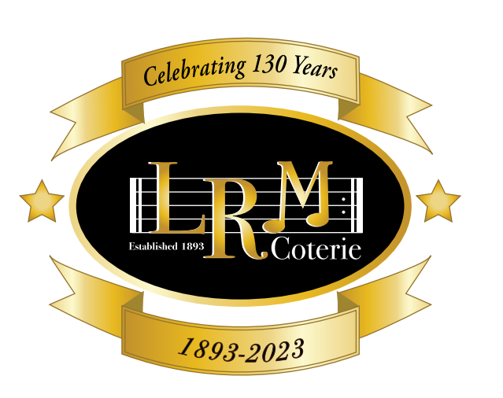

Little Rock Musical Coterie was organized in 1893 and is a Charter Member of the National Federation of Music Clubs (organized in 1898) and a Charter Member of the Arkansas Federation of Music Clubs (organized in 1915). The objectives of Coterie are to develop and maintain high musical standards, aid and encourage musical education, and promote American music and American artists.

Advantages of membership include:

Five concerts presented free of charge that include professional and other performers

Supporting scholarships for Senior High School and College Students

Membership in one of the largest philanthropic organizations in the U.S.

Participation in American Music Month and National Music Week

Promotion of folk music, composers, performers, opera, strings

Receive *Music Clubs Magazine* published three times a year by NFMC

Opportunity to attend the Arkansas Federation of Music Clubs Biennial State Convention

Opportunity to attend the National Federation of Music Clubs Annual meeting

Opportunity to network and interact with fellow music lovers

Inclusion in the Coterie Program/Membership Booklet

Name: ____________________________________________________________________________________

Address: ______________________________________________ City: ____________________________

Zip code: ____________________________ Phone: ___________________________________________

Email: ____________________________________________________________________________________

________________ Annual membership $30.00 for 2025-2026

________________ Additional donation amount

________________ Virginia Queen Scholarship donation (amount)

________________ Christine Wang Scholarship donation (amount)

________________ Little Rock Musical Coterie Scholarship donation (amount)

Please return this **Membership Form** and check for $30.00 made out to LRMC and send to Kathryn Coleman, 84 Robinwood, Little Rock, AR, 72227.

Please visit our website at: [www.littlerockmusicalcoterie.com](http://www.littlerockmusicalcoterie.com)