**April 2022 News**

Our spiky friends are beginning to emerge from hibernation and therefore we still have to be busy to support them.  They would have potentially lost a third of their body weight during hibernation and so it is a perfect time to start putting out supplementary food and water, as they urgently will need it! BUT PLEASE NO MILK, as our sticky friends are lactose intolerant.

Not only will hedgehogs be building up their body fat reserves but they will also be looking for a suitable nesting site. So, now is the best time to build those log piles or make a hedgehog house for the forth coming breeding season.

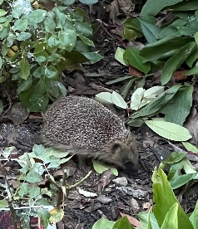

I will also continue to update you on the number of sightings within the village, and so I look forward to seeing your new pictures and videos you send in.  Last month I documented that the number of sightings stands at 70, let's try and see if we can get to 100 sightings.

For further information on hedgehogs please see the Hedgehog Group on [www.sustainablebishop.com](http://www.sustainablebishop.com/), where you can also see many of the pictures you have sent in of our spiky residents and also find some interesting information, for example, how to build a hedgehog house.  Don't forget you can also see plenty of information on the National Hedgehog Street website.

Best wishes

Dawn