**OCTOBER 2-6**

**IS BRING A FRIEND WEEK AT KDC!**

**\*Limit of 1 friend per student, per class.**

**\*All recital classes are eligible to bring a friend.**

**\*Comp classes can only bring a friend to Technique, Ballet Technique, or Conditioning classes.**

**\*Must have a signed waiver to participate! *See back of form.**

**\*\*Friend must be in the same age level as the class (if you are unsure, please ask).**

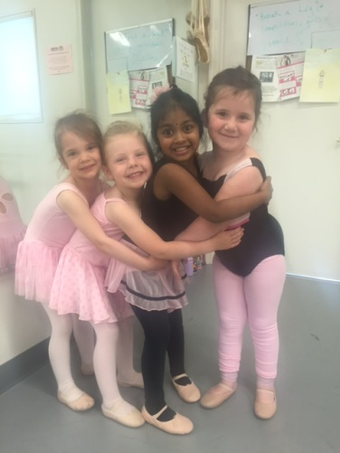

**Student Name:_________________________**

**Date of Birth___________**

**My child is trying the class with (name of KDC student): __________________________**

**Required Phone Number (for emergency): _____________________**

**Email Address (for follow up):_____________________**

WAIVER

**RELEASE OF LIABILITY, WAIVER OF LIABILITY, ASSUMPTION OF FULL RESPONSIBILITY OF ALL RISKS OF BODILY INJURY OR DAMAGES: As a participant myself and/or as a parent or legal guardian of the Kelley's Dance Craze dance student(s), I give my consent for her/him to participate in the programs at Kelley's Dance Craze. I understand that participation in dance, tumbling, stretching and other related activities may result in injuries. These injuries may include muscle strains and tears, broken bones, and severe injuries such as permanent paralysis or even death. I am fully aware of the risks and, possibility of injury involved in these activities, and assume full responsibility for such risks. As a participant myself and/or as a parent or legal guardian, I agree to provide health insurance for myself or for the minor child or children, or otherwise guarantee payment of any medical expenses incurred as a result of training, performing, or participating in the activities of Kelley's Dance Craze. I understand that it is this dance studio's intent to provide for the safety and protection of me and/or my child or children, and in consideration for allowing myself and/or the above-named minor child(ren) to participate in activities with Kelley's Dance Craze, I waive any and all rights or causes of action against Kelley Paronish and/or Kelley's Dance Craze for any injuries suffered by my child(ren) and other damages suffered my child(ren), or myself, while under the supervision or control of Kelley's Dance Craze and its employees, staff and independent contractors. This acknowledgment of risk and WAIVER OF LIABILITY has been read by me, understood completely and agreed to voluntarily. I am 18 years of age or older. This agreement will remain in effect until written revocation is received.**

**Signature:______________ Date:______**