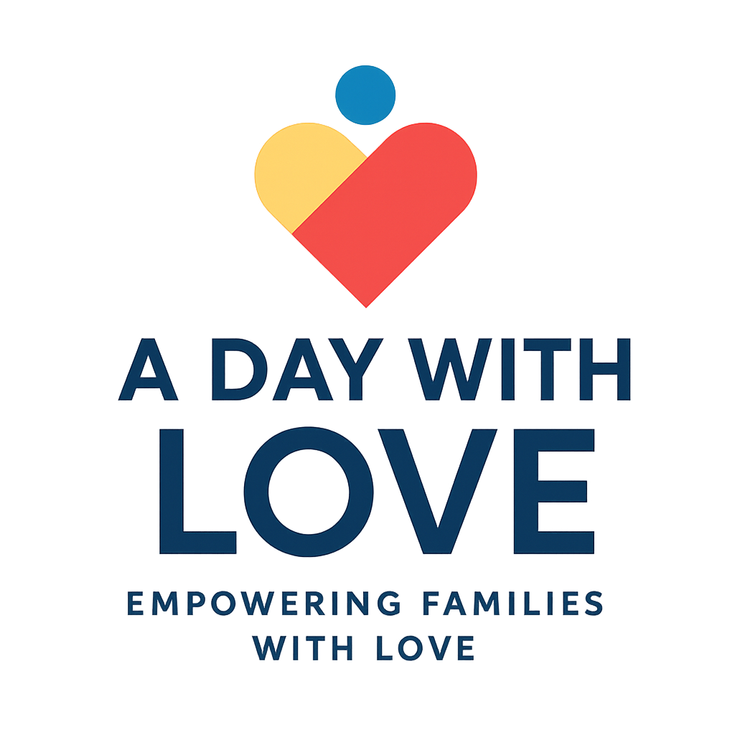
2026 Scholarship Application

Name: ___________________________________________
Address: _________________________________________
City: _____________________________ State: ______________ Zip code: _________
Phone: _______________
Email Address: _____________________________________

EDUCATION
High School attended? ________________________________
Are you or will you be a May 2026 high school graduate? ____________

Junior College or University attending? ___________________________
Are you an enrolled undergraduate college student? _________________
Major: _____________________________________________________
Graduation Year: __________
Pick a topic AND submit your response WITH application. Please type using Times New Roman font, size 12, and double spaced.
- What is your career objective?
- Why should you be awarded this scholarship?
- Do you think college education is important today? Why or why not
- How have recent economic challenges or community issues shaped your goals for the future?
- In what ways have you used your voice or actions to make a positive difference in your community?
- Describe a personal challenge you’ve overcome and how it has shaped who you are today.
☐ I understand that my personal information will be used only for scholarship review purposes.
☐ I grant A Day with Love permission to share my name, photo, and/or story on its website or social media if I am selected as a recipient.

You may email your COMPLETED application to: scholarships@adaywithlove.com with subject line: 2026 Scholarship Application
Incomplete applications won’t be accepted.

