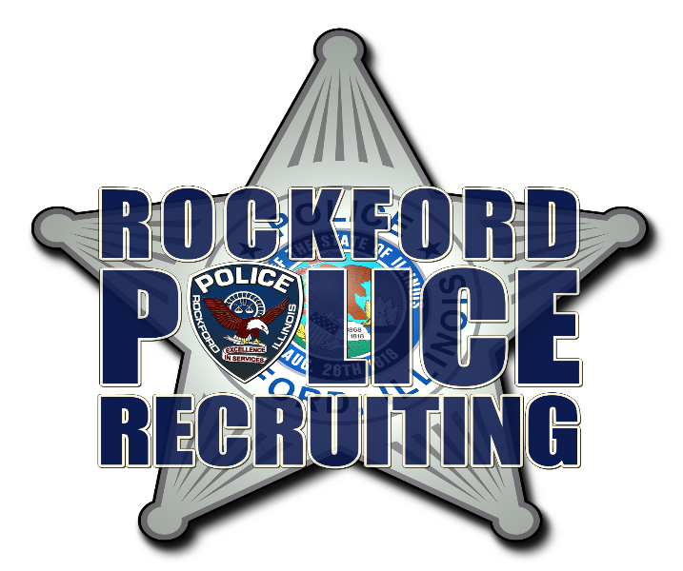
Starting Pay scale 2022 Patrol Officer
- Start of 1 year $59,169 ($28.45 an hour)
- Start of 2 years $ 63,836 ($30.69 an hour)
- Start of 3 years $68,505 ($32.94 an hour)
- Start of 4 years $73,177 ($35.18 an hour)
- Start of 5 years $76,293 ($36.68 an hour)
- Start of 6-10 years $80,186 ($38.55 an hour)
- Start of 11-15 years $84,433 ($40.59 an hour)
- Start of 16 years $86,124 ($41.41 an hour)

