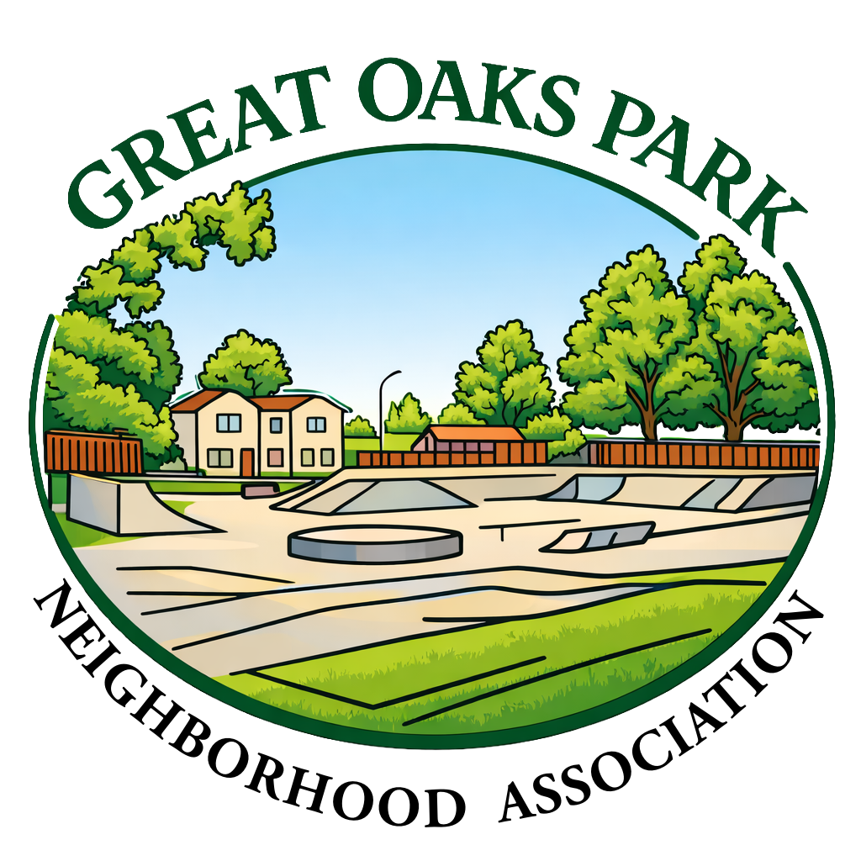
Great Oaks Park Neighborhood Association (GOPNA)
Meeting Agenda - Agenda de la Reunion de la Mesa Directiva
Thursday/jueves, May/Mayo 28, 2026
STEAM @ Stipe Elementary Cafeteria
6:30 p.m. - 8:00 p.m.

- Call to Order 6:30pm-6:35pm
- Roll Call 6:35pm-6:40pm
- Approval of Minutes 6:40pm-6:45pm
- San Jose Police Department Report 6:45pm-6:55pm
- Council District 2 Office Report 6:55pm-7:00pm
- Treasurer’s Report 7:00pm-7:05pm
- President’s Report 7:05pm-7:10pm
- Old Business 7:10pm-7:15pm
- New Business 7:15pm-7:20pm
- Presentation: 7:20pm-7:55pm
Jorge Casillas,
- Announcements: 7:55pm-8:00pm
  - Neighborhood Association Training Workshop: Planning National Night Out
Planning National Night Out at Hank Lopez Community Center – 5/12 @ 6pm-8pm
  - Next GOPNA meeting: 5/28 at 6:30pm at Stipe Elementary
- Adjournment 8:00pm

