**Flag Design Contest Rules**

The Maugansville Ruritan Club believes in a strong sense of community and takes pride in calling Maugansville our home. We are always seeking ways to serve while honoring our past and looking to the future. A flag represents this and is a symbol of our collective identity.

**ELIGIBILITY:**

* The contest is free and open to groups and individuals of all ages. If you’re under 18, a parent or guardian’s permission is required.
* Amateurs only, please.
* There is a limit of two submissions per participant.
* Participants must have a connection to Maugansville. Residency is not required.
* **Submissions must be received by July 31, 2025**. The winning design will be announced at Maugansville Community Day on Saturday, August 30th.

**CONTEST RULES:**

* No obscene, offensive, or discriminatory designs will be accepted. The Maugansville Ruritan Club Flag Selection Committee will determine appropriate content.
* Design elements protected by trademarks or copyright are not permitted.
* AI generated designs are not permitted.
* By entering, participants agree to release ownership of the winning design to allow for free use by the community.
* The winning participant agrees to allow the Maugansville Ruritan Club to use their name, design, and description of the flag. In some cases, designs may be altered for size, format, and image optimization.
* Hand-drawn designs can be scanned and emailed or attached to the entry form and returned by mail to **Maugansville Ruritan Club, P.O. Box 44** , **Maugansville, MD 21767**.
* High resolution digital designs can be submitted in JPEG, BMP, PNG, PDF (landscape) formats. Vector images are preferred but not required. Email entries to **maugansvilleruritanclub@myactv.net**
* The selection committee will have final authority on the winning design. The winning designer will receive a cash prize of $250.00, a flag with their design, and recognition at Maugansville Community Day.

**GUIDELINES:**

* Consider how your design will look when displayed as a 3’ X 5’ flag.
* Submissions will be evaluated for symbolism and representation of the Maugansville community.
* Your design should use basic colors but stand out and be easily recognizable.

**FLAG DESIGN CONTEST ENTRY FORM** (only complete entries will be accepted)

First and Last Name:

Address:

Phone: Email: 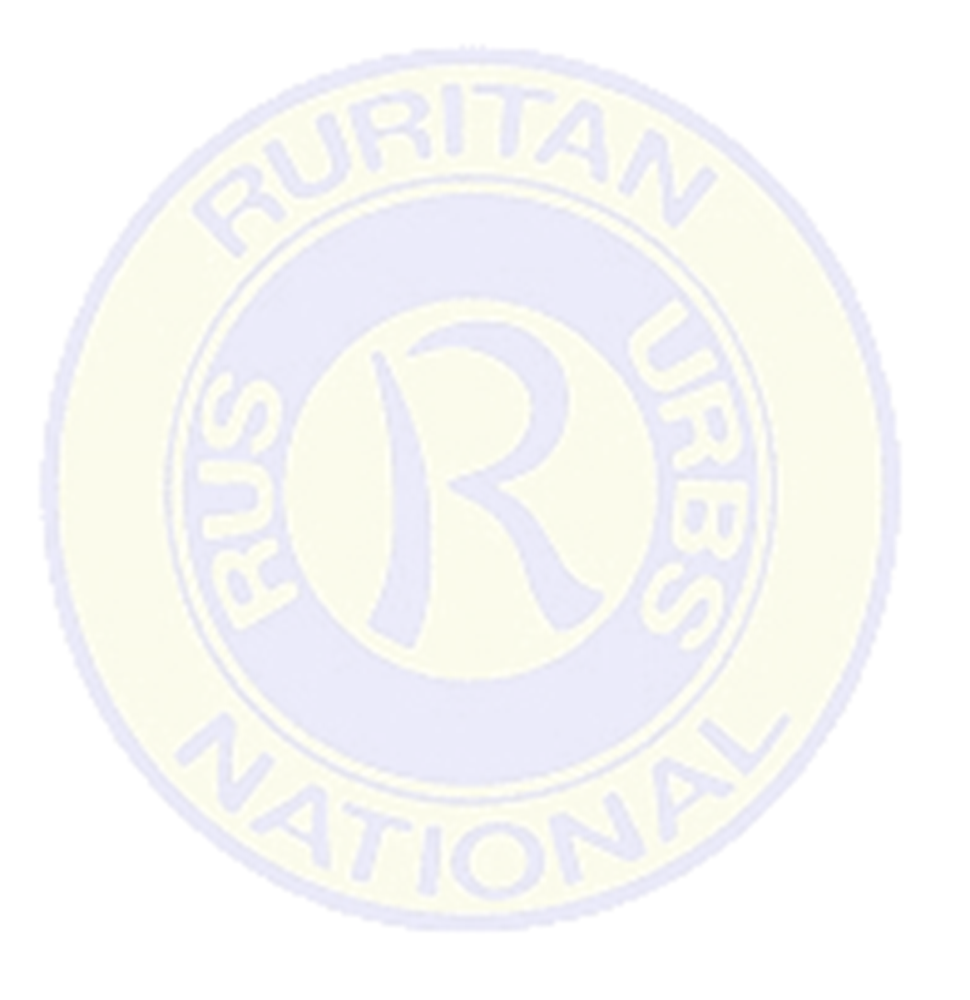

What is your connection to Maugansville?

Describe your design and how it represents Maugansville:

Signature: Date:

Name/Signature of Parent or Guardian:

Name of Organization (optional):