Meditation and Brainpower - RELAX WELL TO BE WELL

Welcome to part three of a 3-part blog series on the impact of exercise, nutrition, and meditation just on NEUROLOGICAL FUNCTION alone (of course we all know about the great all-over-body benefits, but for now let’s just focus on brainpower!)

I’m excited to report that in the last few years science has begun to prove what those of us who meditate already know to be true from our own experience.

Without regular meditation, whenever you feel anxious, scared or have a sensation in your body (e.g., a tingling, pain, itching, etc), you are far more likely to assume “there’s a problem here!” (related to you or your safety.) Moreover you’re much more likely to get stuck in repeating loops of thought about your life, mistakes you’ve made, how people feel about you, your body, and so on.

WITH regular meditation, however, the connections between bodily sensations or momentary feelings of fear and the idea that “something is wrong” begin to break down. This explains, in part, why anxiety decreases the more you meditate.

More importantly, over time you become more capable of looking at bodily sensations or something potentially dangerous or upsetting from more rational perspectives.

Finally, (and potentially most importantly!) an added bonus of meditating is a vastly enhanced capacity for empathy...an ability ALL ancient cultures and religions consider an enlightened state or even a saintly attribute.

Want to learn more? Check out <https://www.psychologytoday.com/blog/use-your-mind-change-your-brain/201305/is-your-brain-meditation>

OR SIGN UP FOR MY NEXT T’AI CHI CHIH MOVING MEDITATION CLASS (CLICK HERE FOR MORE INFO <http://www.sculpturlife.com/#!events/lk5fe>)

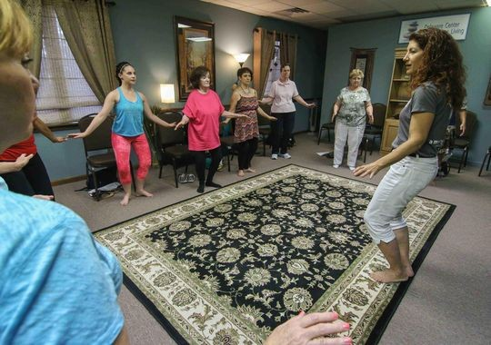

(AS SEEN IN AUGUST 13, 2015 DELAWARE NEWS JOURNAL,
Photo: SAQUAN STIMPSON/SPECIAL TO THE NEWS JOURNAL.
For more info click on http://www.delawareonline.com/story/life/2015/08/13/move-harnesses-chi/31647007/)

