T’ai Chi Chih Class Dates: Location:
Participant to complete:
Name: Address:
Cell Phone: Work: Home:
Contact person in case of emergency:
Cell Phone: Work: Home:
Program Guidelines
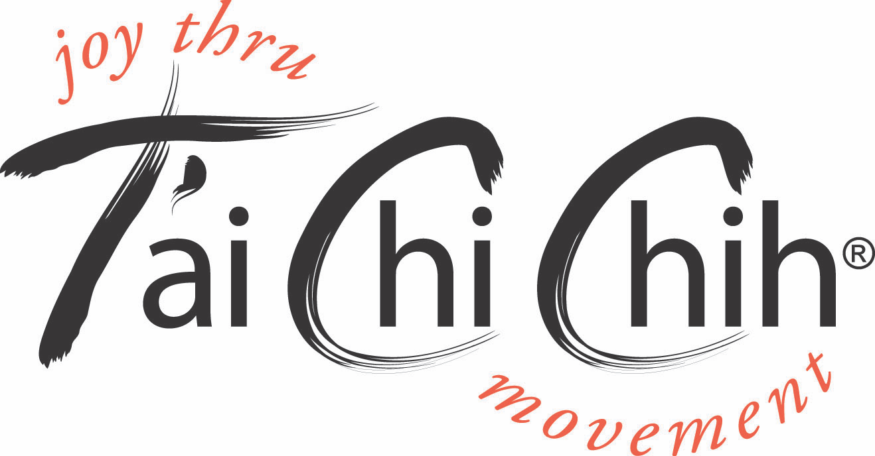
Classes are conducted by Accredited T'ai Chi Chih Instructors and are open to anyone who is medically fit, are independently mobile and can participate without assistance in the class. Any participant who has any doubt whether they are medically fit to attend the class, is required to have a medical clearance from their doctor prior to commencing. In terms of physical exertion, the T'ai Chi Chih movements in this program would be similar to walking.
Classes usually last for one hour. Participants are encouraged to have a rest in between, if needed, and to work within their own comfort zone at all times.
Acknowledgement of Personal Responsibility
I have read the Program Guidelines and understand there is an inherent risk in any exercise activities. I agree to abide by the rules set out.
In consideration for admission to this class, I hereby (a) accept full responsibility for, and assume the risk of any injuries sustained because of, my participation in this class or practice of T'ai Chi Chih: (b) release and hold harmless (your name or organization), its respective officers, directors and shareholders, the instructors and all personnel in association with this class for any liabilities, injuries and expenses which may arise as a result of participation in this class or practice or lessons involving T'ai Chi Chih.
I know of no medical reason why I should not participate in this class. I understand that if I do have any medical reason why I should not participate in this class, it is my responsibility to obtain a clearance from my doctor before commencing.

Signature:____________________________________ Date:

For Instructor's Use Only
Notes:

Signature:____________________________________ Date:

