
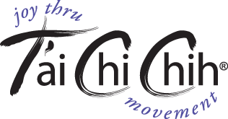

NEW CLASS FORMING AT THIS LOCATION
Contact Dana Kelley at 610-864-9003 for information

T’ai Chi Chih is a form of moving meditation that is easy to learn and fun to practice

FREE INTRODUCTION AND DEMONSTRATION
Monday September 12, 7PM
Main Line Unitarian Church
816 S. Valley Forge Rd.
Devon, PA.

