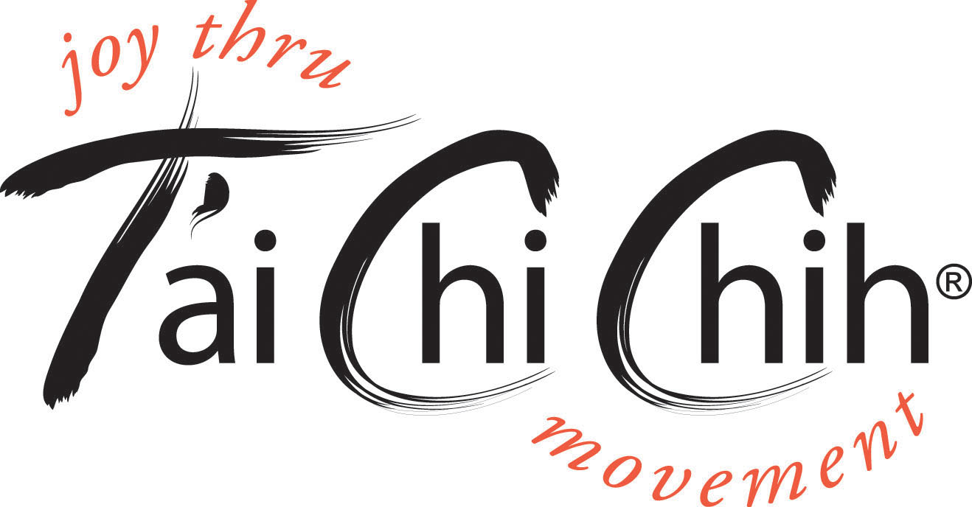

www.taichichih.org

T'ai Chi Chih® is a set of movements completely focused on the development
of an intrinsic energy called Chi. It's easy to learn and usually takes about two months (or eight classes). T'ai Chi Chih® (TCC) consists of 19 stand-alone movements and one pose.

T'ai Chi Chih® is not a martial art, it is completely non-violent.

T'ai Chi Chih® does not require a particular level of physical fitness or coordination. The very old and very young alike can learn it. For those with physical limitations, movements may be done seated – with some modification. No special clothing or equipment is required.

T'ai Chi Chih® may only be taught by accredited TCC teachers. They offer classes in corporate wellness programs; at schools and universities; at senior centers and retreat centers; through Parks and Recreation departments; and at hospitals, churches, and even prisons.

T'ai Chi Chih® has many benefits including:

- Circulating and balancing the internal energy (Chi)
- Increasing our physical energy;
- Improving our balance, flexibility, and stamina;
- Promoting longevity and bettering the quality of our lives;
- Expanding our creativity and awareness.
- Please note that benefits will come with regular practice.

Please visit www.taichichh.org for more information.

