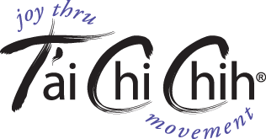

FREE INTRODUCTION AND DEMONSTRATION

Monday September 12, 7PM

Main Line Unitarian Church

816 S. Valley Forge Rd.

Devon, PA.

# T’ai Chi Chih is a form of moving meditation that is easy to learn and fun to practice

NEW CLASS FORMING AT THIS LOCATION

Contact Dana Kelley at 610-864-9003 for information