MEDICATION OR MEDITATION?

For so many medical conditions it often comes down to 2 choices: medication or meditation! And it doesn't always matter what style either…a recent study @ Stanford University proved that ALL meditation lights up areas of the brain that typically aren't even used like a Christmas tree!

BTW my next T'ai Chi Chih (MOVING MEDITATION...hint, hint, hint!!!) classes begin in only a few weeks...click here more details (or just call me!)

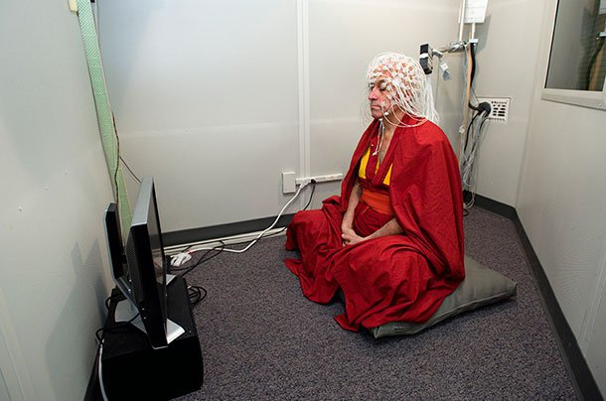

A buddhist monk shows “unheard of” brain activity during meditation…for more info click on < http://web.stanford.edu/group/hopes/cgi-bin/hopes_test/meditation-and-hd/>

