In honor of the holiday: a treatise on the value of working LESS

I think we can all agree we've become a nation with a primary goal of continuously striving to work smarter.

Each one of us is trained almost from birth to work harder and faster with every passing day. Indeed, multitasking has become a national pastime and our ability to multitask efficiently is rewarded time and time again with an ever-increasing amount of hardware and software to aid in that endeavor.

Bearing all that in mind, when was the last time somebody told you "You're working WAAAAAAAY too hard...in order to (fill in the blank) you’re simply going to have to do nothing at all!"

NEVER, right?

Unless you're practicing T’ai Chi Chih moving meditation, that is…I’ll explain.

Many of you have heard me talk about how I walked into a T’ai Chi Chih class by mistake about 8 years ago and subsequently fell in love with it…becoming Accredited to teach this gentle yet powerful evidence-based MOVING mindfulness technique is not only a distinction that sets me apart from my peers in the Health & Fitness world but has cranked my physical and mental health up to all-time highs.

But many of you may have missed the memo that one of the COOLEST aspects of T’ai Chi Chih is also what makes it the PERFECT COMPLIMENT to any exercise routine and, of course, the typical American super-busy hardworking lifestyle because T’ai Chi Chih is often described as THE EFFORT OF NO EFFORT AT ALL!

So in honor of the day in which we, as a nation, honor our hardworking nature, I offer a fantastic excerpt from my good friend Dr David Parrish’s* upcoming book regarding relaxation being the foundation of T’ai Chi Chih.
While the movements of T’ai Chi Chih stimulate, activate and balance the chi, unless the body is relaxed and open the chi cannot flow. This is why relaxation is key to the practice of T’ai Chi Chih.
Most human beings are in a constant state of tension that varies according to circumstances. This tension begins at birth. It could be said with accuracy that birth itself is a contraction. Energy comes into a gross physical form at conception and continues to manifest into a fully formed human body. As people move through the developmental processes and the challenges of growing physically and psychologically the body becomes chronically tense. This state of tension and contraction is not evident most of the time because it is a condition that evolved slowly and given that it is a constant element of experience we do not notice it unless it spikes as is the case in a headache. In various forms of body work such as Rolfing or Medical Orgonomy this tension is referred to as “armoring.” The fascia, a thin membrane that surrounds muscle tissue becomes taut over time and holds the muscle tissue in a compacted state. In addition, we typically “hold” our bodies up rather than allowing our weight to be supported by the ground. This is commonly recognized when we let our shoulders relax and notice them drop. Tension is further manifest in the interior of the body. The organs themselves can be contracted creating blockages that affect the flow of blood and the digestion of food. So, it is evident when we consider the tension in the body that the free flow of energy through the physical and neural systems is constricted which results in many ailments and overall poor health.
To learn to relax and practice relaxation is fundamental to the practice of T’ai Chi Chih. Learning to relax involves learning to “let go”. This is a subtle skill. To let go means to notice tension and allow it to release. We cannot try to relax, this actually creates more tension.

If you’ve ever tried (or in other words, worked hard) to meditate but was frustrated to the point of tears (or at least till you simply gave up), you are not alone…being able to sit still while focusing your attention on any one particular thing (breathing, etc) is almost MORE crazymaking for most people than simply not bothering to meditate at all!

So consider attending one of my T’ai Chi Chih classes because 9 little hours just might change EVERYTHING for you!!! Seriously, can you think of any other activity in which the primary goal is to work LESS? T’ai Chi Chih is literally a paradigm shift to the typical American SOP.

Just click here for more info (but hurry, classes are beginning soon!)

And of course I know that T'ai Chi Chih is certainly not the only way to meditate…it is, however, possibly THE EASIEST way and that just might make it the best way! Still have questions? Click here to watch a couple of short videos and all will become clear.

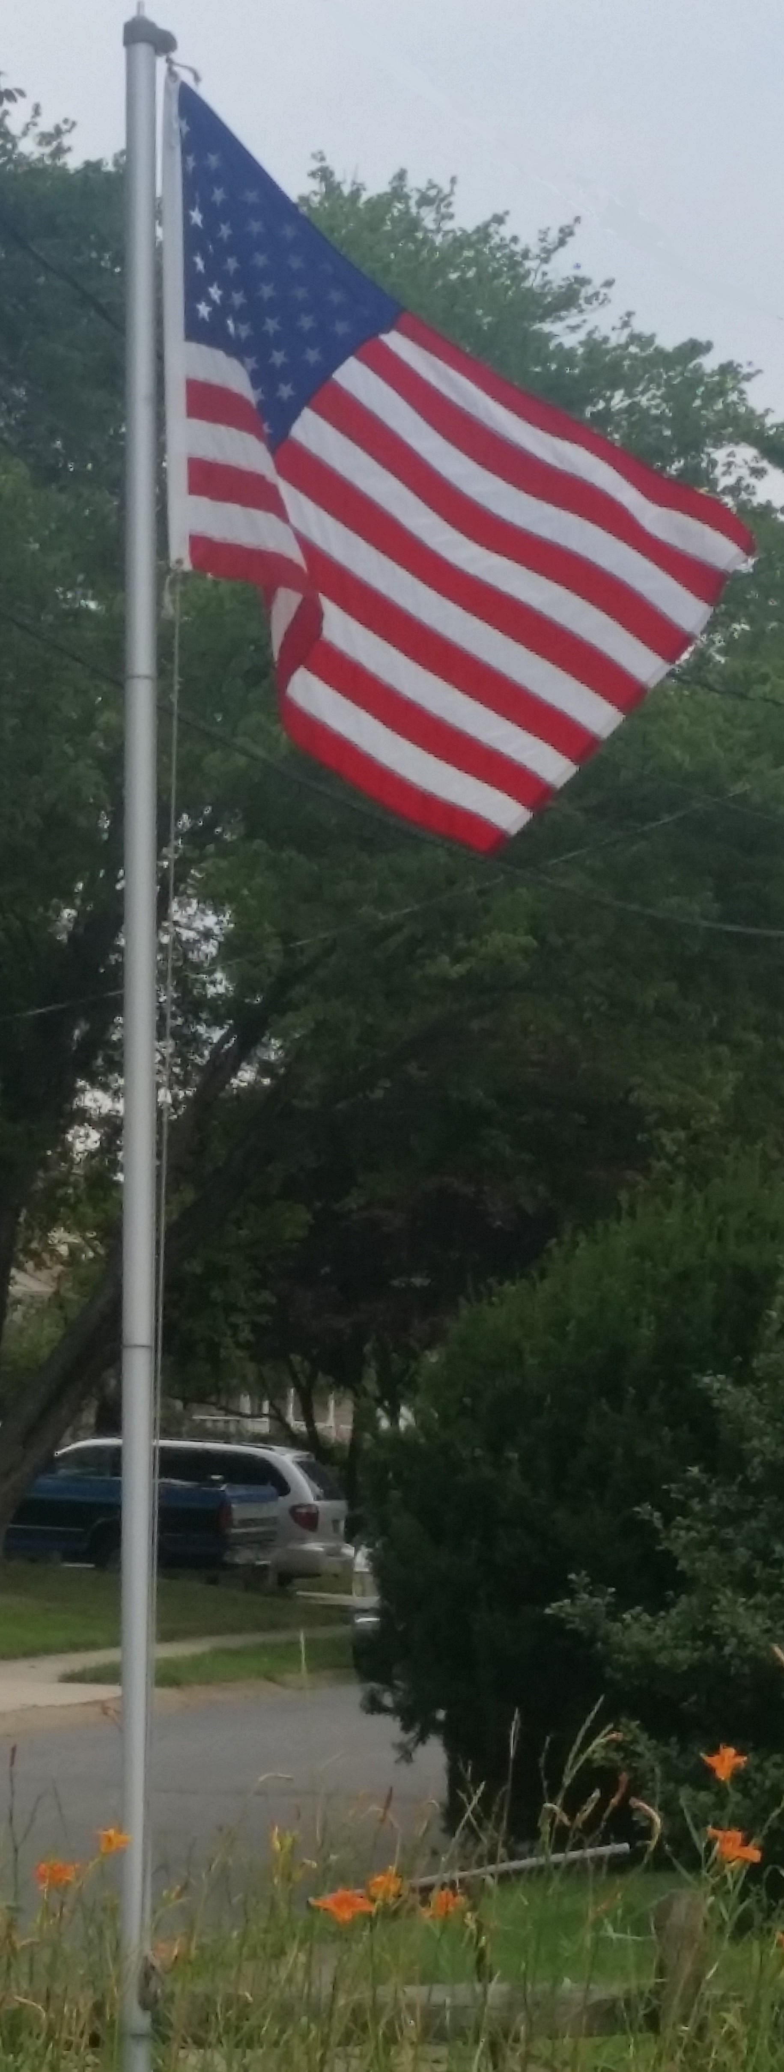

*David and I began studying T’ai Chi Chih at about the same time but he has clearly become one of my strongest mentors as well as highly respected within the entire T’ai Chi Chih international community of Accredited Instructors as one of our resident authorities on the science of T’ai Chi Chih. For over 20 years, David worked within the maximum security prison system as first a psychologist and then Warden. He retired to open his private practice (Media Psychological Associates) where, in addition to a WIDE variety of counseling and meditation treatments and services he also provides consultation and training to other Psychologists. David has also been a student of Werner Erhard's work since 1973 which has brought about sweeping, permanent shifts in the quality of his life, his work, and his ability to affect change in the world. The excerpt I referenced above is from David’s next book (yet to be titled) but in 2015 David also authored Enlightenment Made Easy (available on Amazon) which provides a clear and easy way roadmap to the enlightenment experience for anybody at anytime. To learn more about David click http://www.davidparrish.us/ or like him on Facebook https://www.facebook.com/david.parrish.50

