What if your life depended on making just one small change ...YOU’D DO IT, RIGHT?

These days the global medical community rarely agrees on anything but I’m happy to report that both West and East have recently become a united front on a single (very important) issue: mindfulness is now universally considered an effective way to either ward off or improve all types of cognitive dysfunction (like Alzheimer’s, Parkinson’s, and various forms of dementia)…just one of it’s many benefits is that mindfulness “exercises” the brain by increasing neuroplasticity (in other words it keeps your brain healthy and strong by allowing it to stay flexible and open to new ideas.)

That being said, this seems like a perfect time to tell you about my friend Linda Jones whose stressful life (especially her career as a high-powered CPA) led to a number of health concerns which eventually conspired to cause a condition known as Global Cerebral Atrophy (in other words her brain was shrinking and she was therefore dying in braincell-sized increments.) She gave up her career, however, began practicing T’ai Chi Chih and eventually became Accredited to teach it...long story short Linda's condition is now reversing mostly because she began practicing T’ai Chi Chih as if her life depended on it.

So I bet you've all already guessed the question of the day: if your life literally depended on you practicing mindfulness on a regular basis would you do it? And I imagine most of you are thinking “Are you kidding? That’s a no-brainer!” (HA…I couldn’t resist!)

But I assure you the question is considerably more complicated than it may seem at first glance because as Jon Kabat-Zinn (who certainly didn't invent mindfulness but basically put it on the map) often says, sitting mitionless with the express intent to simply empty your mind may be “the hardest easiest thing you'll ever do.”

What if I told you, however, that T’ai Chi Chih is not only one of MANY evidence-based mindfulness practices but it’s generally considered the EASIEST mindfulness practice of all (plus you can move while doing it…BONUS!) So if your life literally depended on you practicing mindfulness, you’d have to be a glutton for punishment NOT to choose T’ai Chi Chih over all other forms of mindfulness, right?

But wait, there’s more…in addition to helping you “train the brain,” T’ai Chi Chih has also been the focus of at least twelve controlled clinical trials over a twenty-year period all of which have irrefutably connected it to positive changes in all of the following:

- Depression, anxiety & general stress
- Healthy aging
- Weightloss
- Sleep quality
- Balance & ADL's
- Pain relief
- Peace & joy
- General Immune System function
- Immunity to the Shingles Virus specifically
- Various chronic inflammatory conditions & diseases (including cancer & arthritis)

No wonder the Arthritis Foundation, the American Medical Association, The Mayo Clinic, and other well-known and respected health & wellness authorities have endorsed T’ai Chi Chih as a viable treatment option (potentially more effective than medication) for so many physiological and psychological conditions!

But I digress…here’s where I’m going with all this.

It’s true that many of the conditions I listed above won’t kill most people but I’m sure we can all agree that living with any of these diagnoses makes life incredibly different (and in some cases, downright AWFUL!) Plus remember Linda’s story and how the conditions listed above can often lead to other much more serious diagnoses…it’s not a stretch, therefore, to say that no one WANTS to be diagnosed with these conditions, right? So given all that T’ai Chi Chih specifically (and by extension as just one of many evidence-based mindfulness practices) has been proven to ward off, improve, or even outright cure, in the grand scheme of things shouldn’t we ALL be doing T’ai Chi Chih as if our lives depended on it???

But wait, there’s more! Ever heard the phrase nature as medicine? It’s a not-quite-universal medical concept that’s really growing in popularity, in fact forest bathing is now commonly practiced in many Asian and European countries. So what if I offered you a unique opportunity to learn T’ai Chi Chih right in the great outdoors?

Well I’m excited to announce that the BEAUTIFUL home of one of my longtime students will be the locale for one of my intro-level T’ai Chi Chih classes once again this summer (and believe me: between all the dogs, cats, and horses the Roseman residence is more like a wildlife preserve than anything else!) These days everybody’s at least seen pictures of people doing T'ai Chi in the park (but if you somehow haven’t, take a look at the picture below)…isn’t just visualizing participating in such a thing relaxing?

So what are you waiting for? Click here for complete info then sign up TODAY (because your life as you know it may indeed already depend on it!) And no need to worry about inclement weather…Karin has plenty of room inside as well ☺

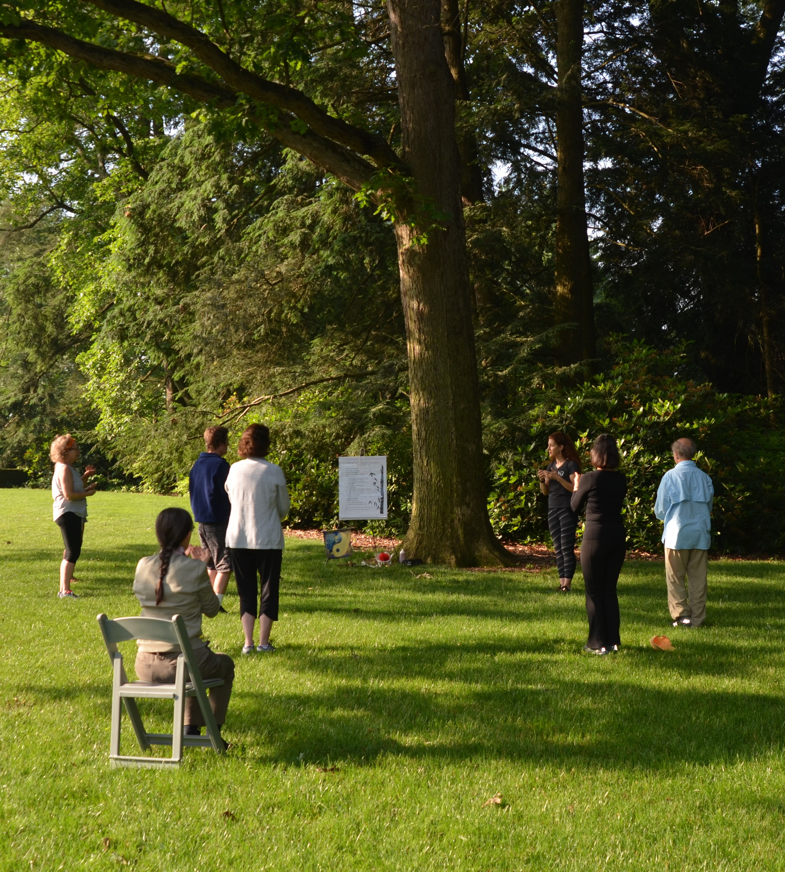

 I met Linda in 2013 at a T’ai Chi Chih workshop before I’d become truly serious about practicing every day (which, BTW, only takes about 30 minutes…not a huge commitment for such an amazing payoff, right?!) At the time I was struggling with a serious flair-up of my almost-lifelong battle with depression…of course I didn’t know Linda (or anybody at the workshop for that matter) so I certainly hadn’t shared my feelings with anyone that day! But she walked straight up to me from across the room and in an almost oracle-like manner proceeded to tell me that if I practiced T’ai Chi Chih every day I would get better. Frankly I was so taken aback by the out-of-the-blueness of her comment I decided I should pay attention…THAT VERY MOMENT I became fully committed to practicing T’ai Chi Chih on a daily basis, then in 2015 I became Accredited to teach T’ai Chi Chih, and about a year or so after that I finally went med-free (I’d been on and off Wellbutrin for major depression since about age 15.) To look at Linda now you’d never know what DEEP health concerns were on her plate just a few years ago! She’s a constant source of inspiration both for me and my work and I’m so very grateful that she’s also become a dear friend. Why don’t you take a minute to friend Linda Jones on Facebook? (I bet it’ll change your perspective on a lot of things!)

