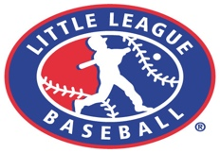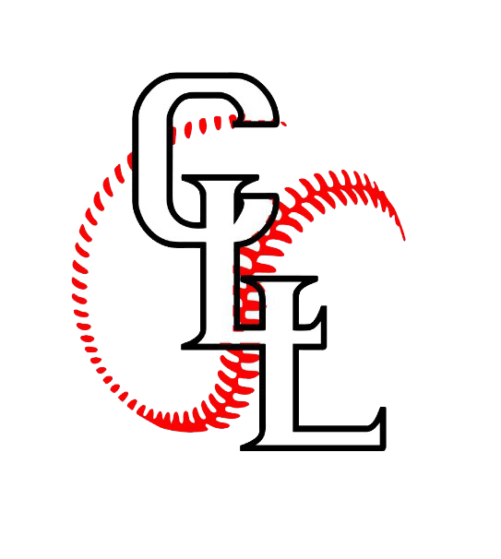
CLIFTON LITTLE LEAGUE
www.cliftonlittleleague.com
Lisa Valentine, President

Little League has provided a structured environment for the children of the City of Clifton for many years. Each year, hundreds of boys and girls ages 4 through 16, learn the fundamentals of baseball from volunteers who devote their time and efforts to this worthy endeavor. These ‘teachers’ help to create an atmosphere of sportsmanship and friendship. Clifton Little league promises to continue this longstanding commitment in serving the community as well as the children of Clifton and would ask that you help us carry on this fine tradition. We would appreciate any support you would be willing to provide. Several sponsorship options are listed below for your review.

Team Sponsorships with Business Billboard, Website Ad and Link ($350)
Clifton L.L. sponsors have their names printed on their uniform, which many of the youngsters continue to wear long after the season has ended. All team sponsors will be presented with a sponsor’s plaque, complete with team picture. This plaque can be prominently displayed in your place of business to demonstrate your support for the children of Clifton. Baseball field billboards (approximately 4 sq ft) are promimently displayed along outfield fences at the Mt. Prospect or Surgent fields. Team sponsorships are on a first come, first serve basis. Your prompt response will provide you the opportunity to be one of the first to sponsor a team.

Business Billboards with Website Ad and Link ($150)
Baseball field billboards (approximately 4 sq ft) promimently displayed along outfield fences at the Mt. Prospect or Surgent fields. Take advantage of this prime advertising space. If you have previously sponsored a sign, your renewal will gladly be accepted. Renewal only ($75).

Website Ad and Line ($50)
A banner or ad on our website would feature a link to your business website.

Opening Day Program ($25)
The Opening Day Program will offer the opportunity to advertise and support Clifton Little League. The program contains the day’s events and the names of all teams, players, and coaches. Business card or booster support announcements are welcome.

ANY Donation is Welcomed & Greatly Appreciated!!!
Our league has several thousands of dollars in costs in addition to uniforms for the players. We have to pay for umpires, baseball equipment, field maintenance, clubhouse maintenance, insurance and utilities, just to name a few . We could not do this without your generousity and much appreciated support. Please help us continue to make Little League Baseball available to the youth of Clifton.

Enclosed is a sponsorship application, which lists the previously described programs. We respectfully request your donation be sent no later than March 1, 2020. If you are requesting a specific team for sponsorship, please send your request as soon as possible. Please remember your tax deductible pledge will help the youth of Clifton.

Please complete the enclosed sponsorship form and return it along with your donation to:

Clifton Little League Sponsorship
Attention: April Graziano
16 Delawanna Ave.
Clifton, NJ 07014-1503

For your convenievce, you can call, text or e-mail us to make pick up arrangements.
We look forward to you being part of our 2020 season & thank you for your continued support.

April Graziano
Sponsorship / Fundraising Manager
201-314-8444 aprilgraz@gmail.com

