Assembly Instructions

for

ERC B-SikOne Sprint Car

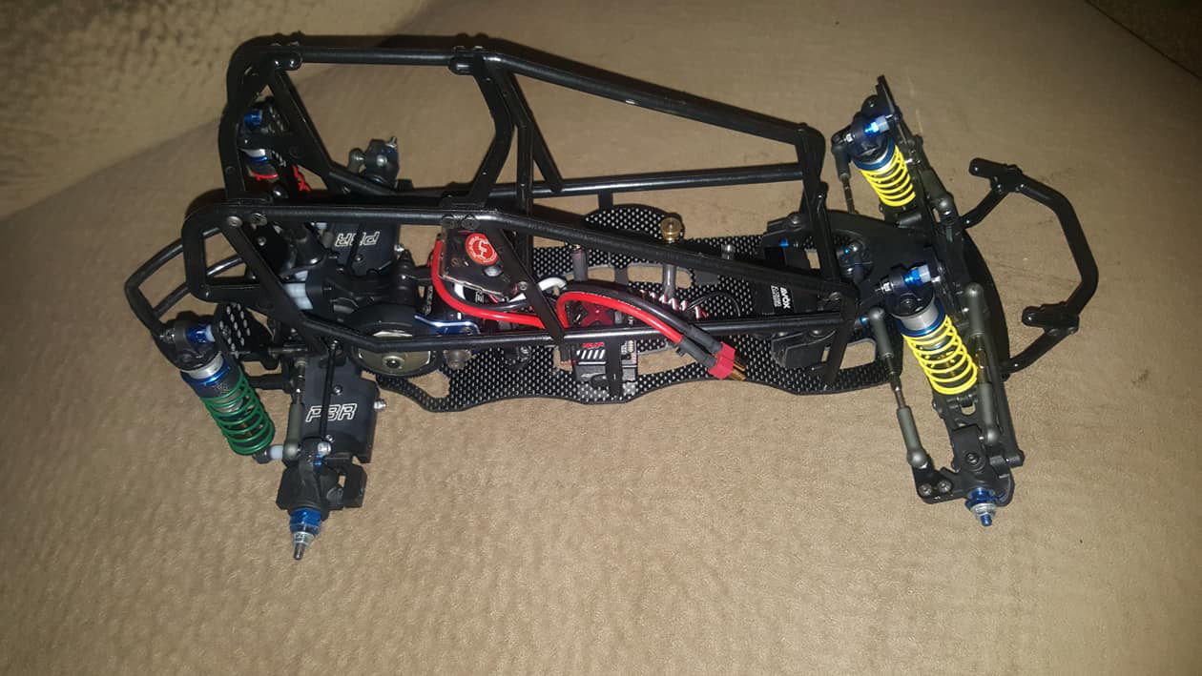

WELCOME TO EVOLUTION RACING CONCEPTS

Website: https://evolutionracingconcepts.com/

Overview
Evolution Racing Concepts (ERC) has created a new Carbon Fiber sprint car chassis that is based off of a Team Associated B6.1 or B6.1D off-road buggy. The following is a quick assembly instruction manual for you new ERC Sprint Car named B-SikOne.
You will need to purchase the ERC B-SikOne Chassis kit and you will need a Team Associated B6.1 or B6.1D donor car.
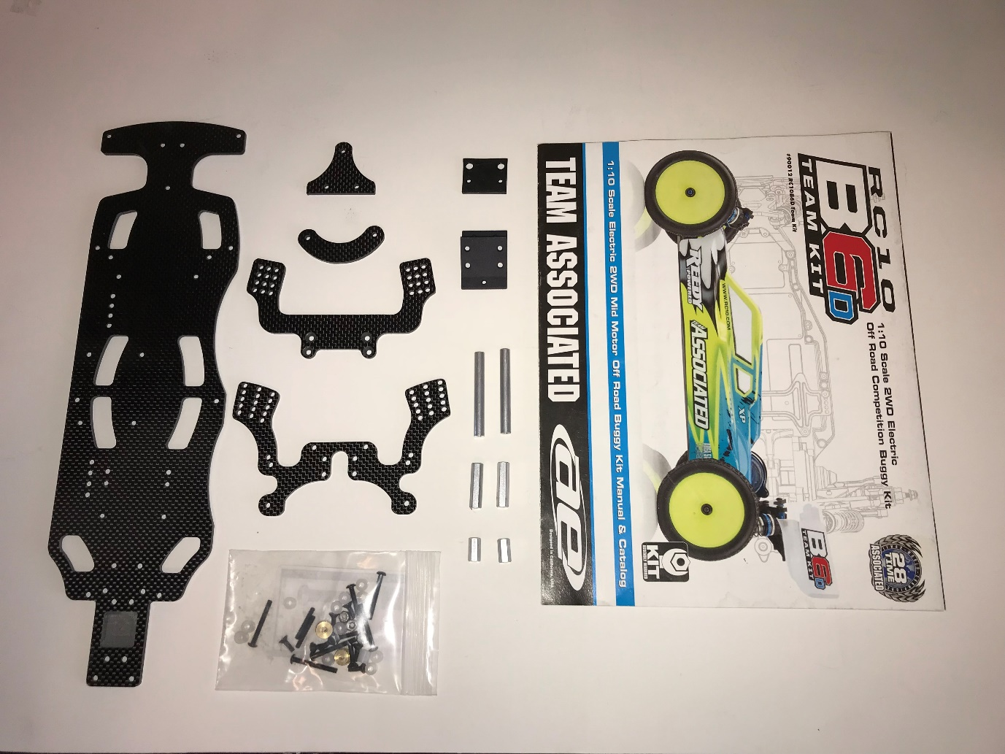
You will also need a set of Plan B adjustable rear arms, Custom Works sprint car cage and body painted or wrapped with your favorite colors and numbers.
https://www.pbr-rc.com/product-page/b5m-b6-adjustable-arms
http://www.customworksrc.com/cgi-bin/commerce.cgi?preadd=action&key=3430
http://www.customworksrc.com/cgi-bin/commerce.cgi?preadd=action&key=9110
http://www.customworksrc.com/cgi-bin/commerce.cgi?preadd=action&key=9050
http://www.customworksrc.com/cgi-bin/commerce.cgi?preadd=action&key=9055
Disclaimer: The standard setup notes listed below are suggestions only and of these build instructions can be modified to meet your racing style.

Step One

First assemble all of the standoffs onto the chassis. Standoffs shown in the pictures are standard setup positioning, but can be adjusted to your liking by using the extra battery positioning holes already cut for you. Standoffs in the pictures below are set for a battery position that will allow for a 40 to 60 percent front to rear weight distribution using a shorty battery pack.

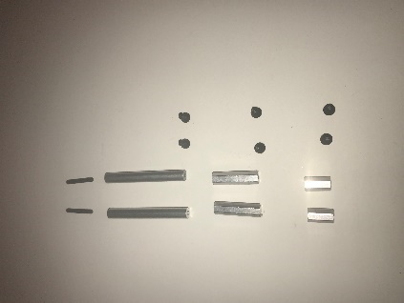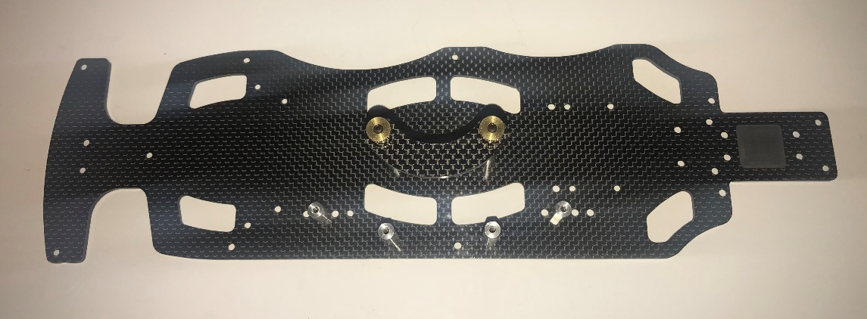
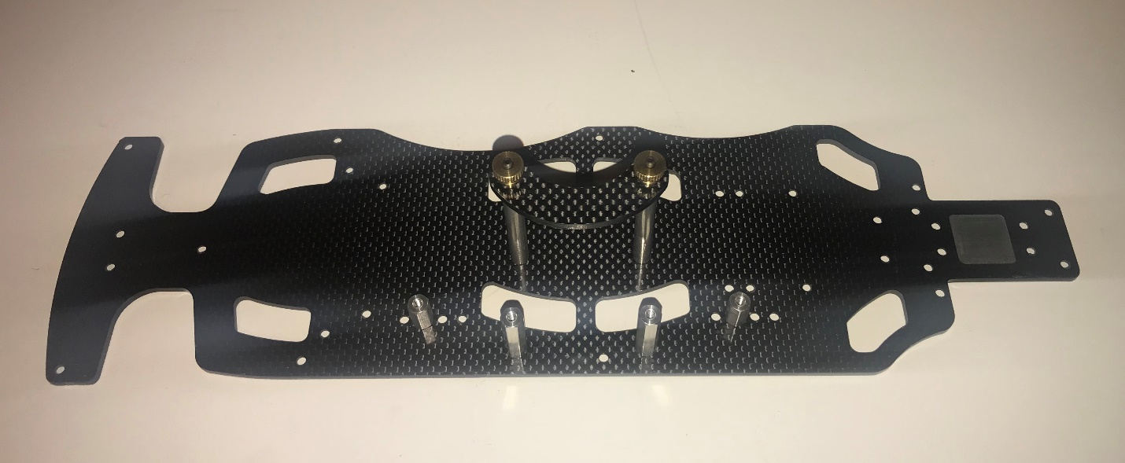

Step Two

Now follow your Team Associated instruction manual on building your front steering rack and front ball stud mount according to the book.
Next you will need the following ERC parts along with the newly built AE steering rack.
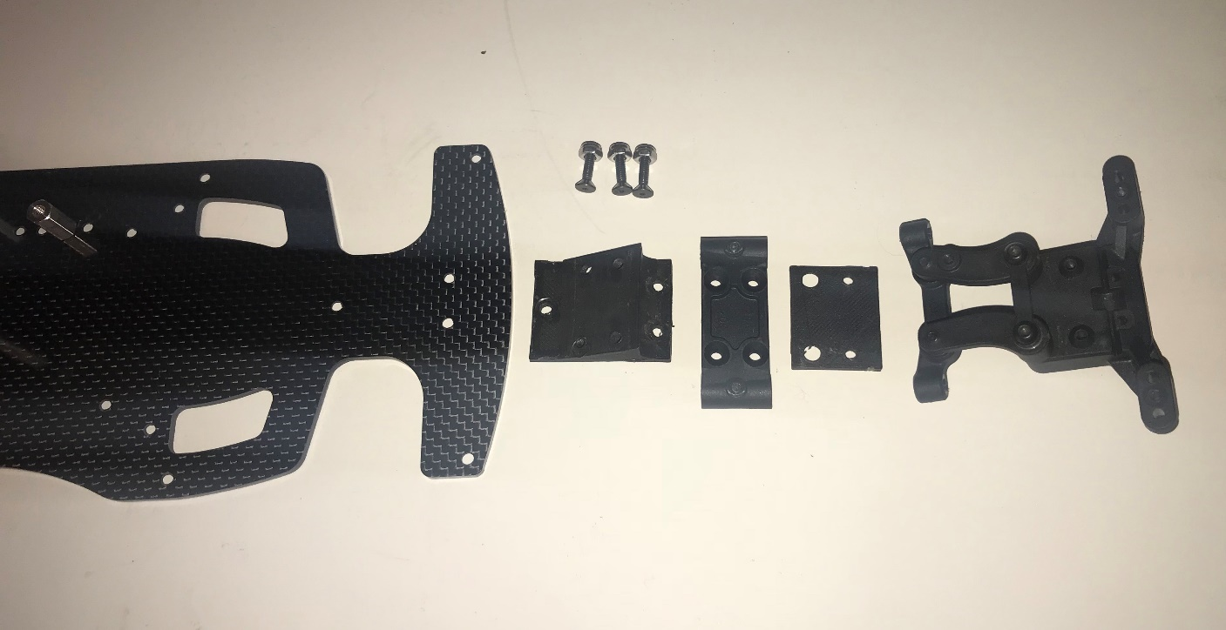

Using 2 – 3x18mm and 2 – 3x16mm flat head screws (not pictured above) attach the ERC Bulkhead and plate to the AE bulkhead and ball stud mount making sure the 30-degree bulkhead option is chosen for the standard setup. Make sure you get these tight without stripping. Then attach front gull wing arms, hinge pins and hinge pin brace before attaching to ERC CF Chassis.
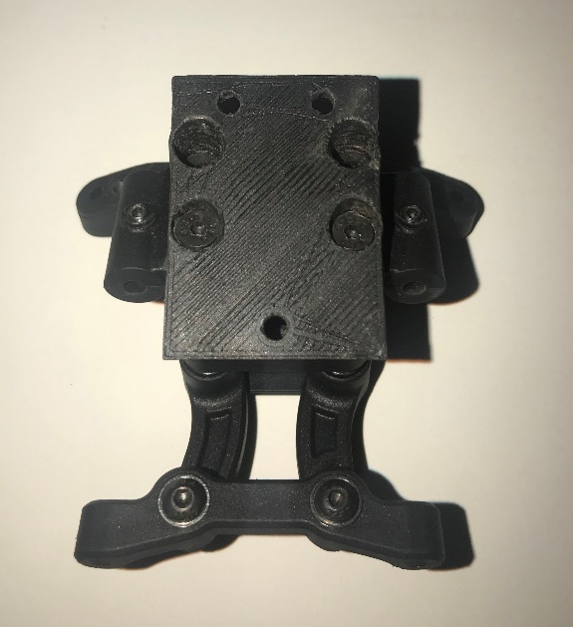
Next attach the bulkhead to the new carbon fiber chassis with the three screws and nuts provided by ERC.

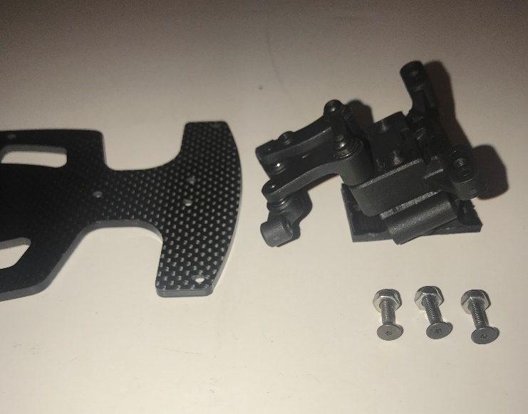 | 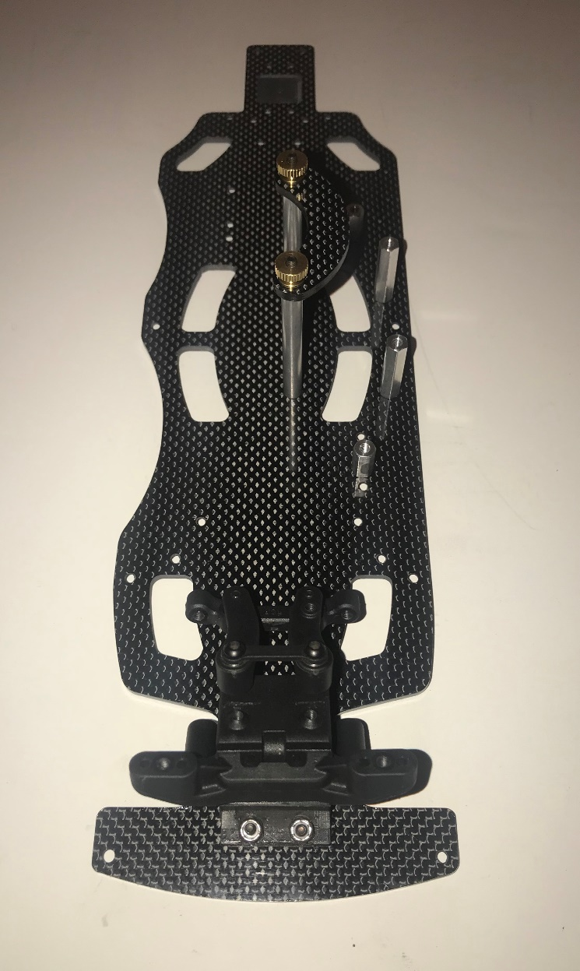
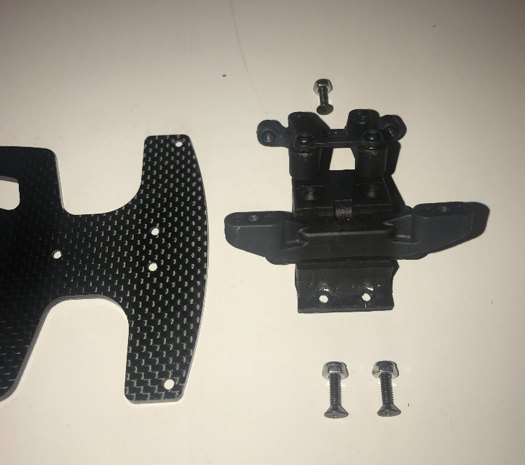

NOTE: Picture does not show arms attached but before you attach bulkhead assembly to chassis you may need to grind off some of the underneath side of the ball stud mount to make the arms move freely and install the arms before attaching to chassis.

Step Three

Follow your Team Associated instruction manual on installing your servo and side rails with the following modifications.
Cut side rails down using a Dremel and cutting wheel on the silver lines as shown. Right side rail shown in picture below only. Three cuts per side.
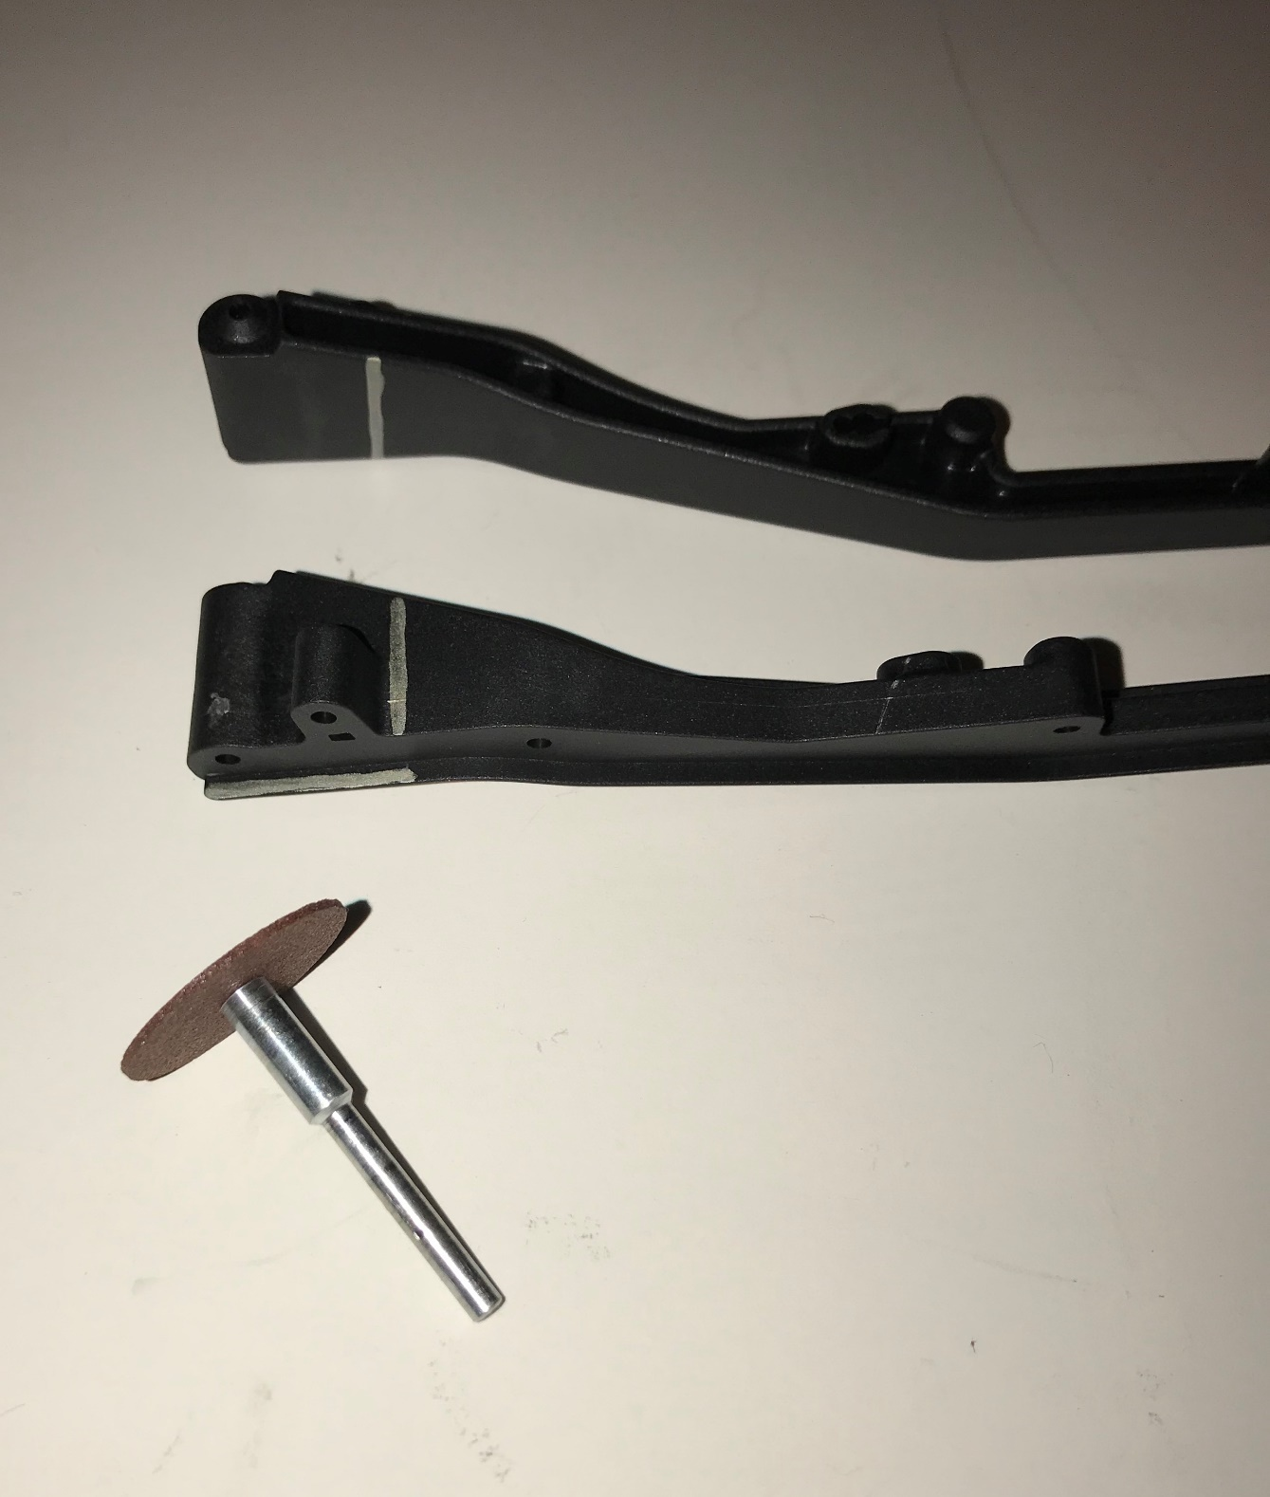
When done modifying the side rails, pictured below is what should be left. Dispose of the remaining side rails. They will not be needed.

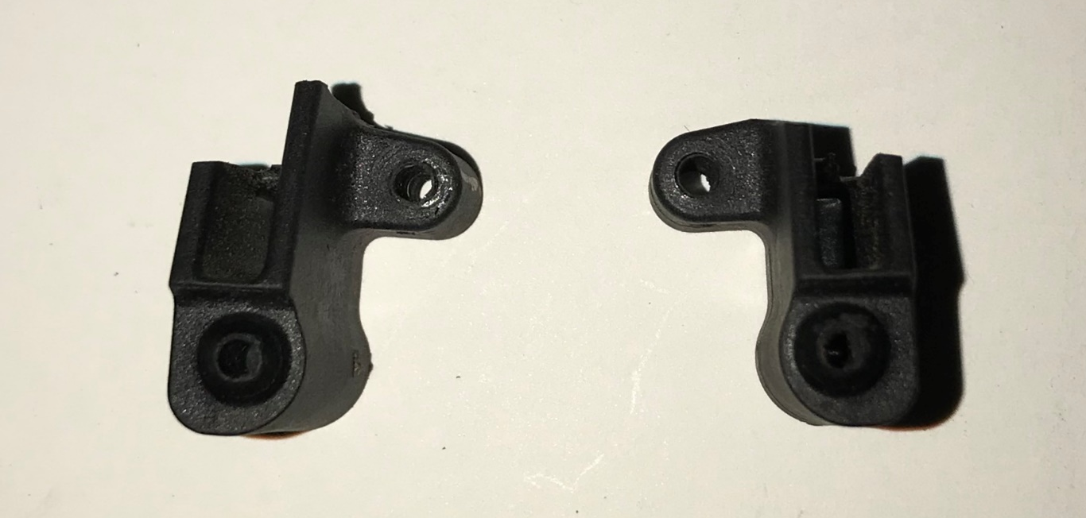

Now assemble servo and side rail parts to the ERC chassis as shown in the AE instruction manual.

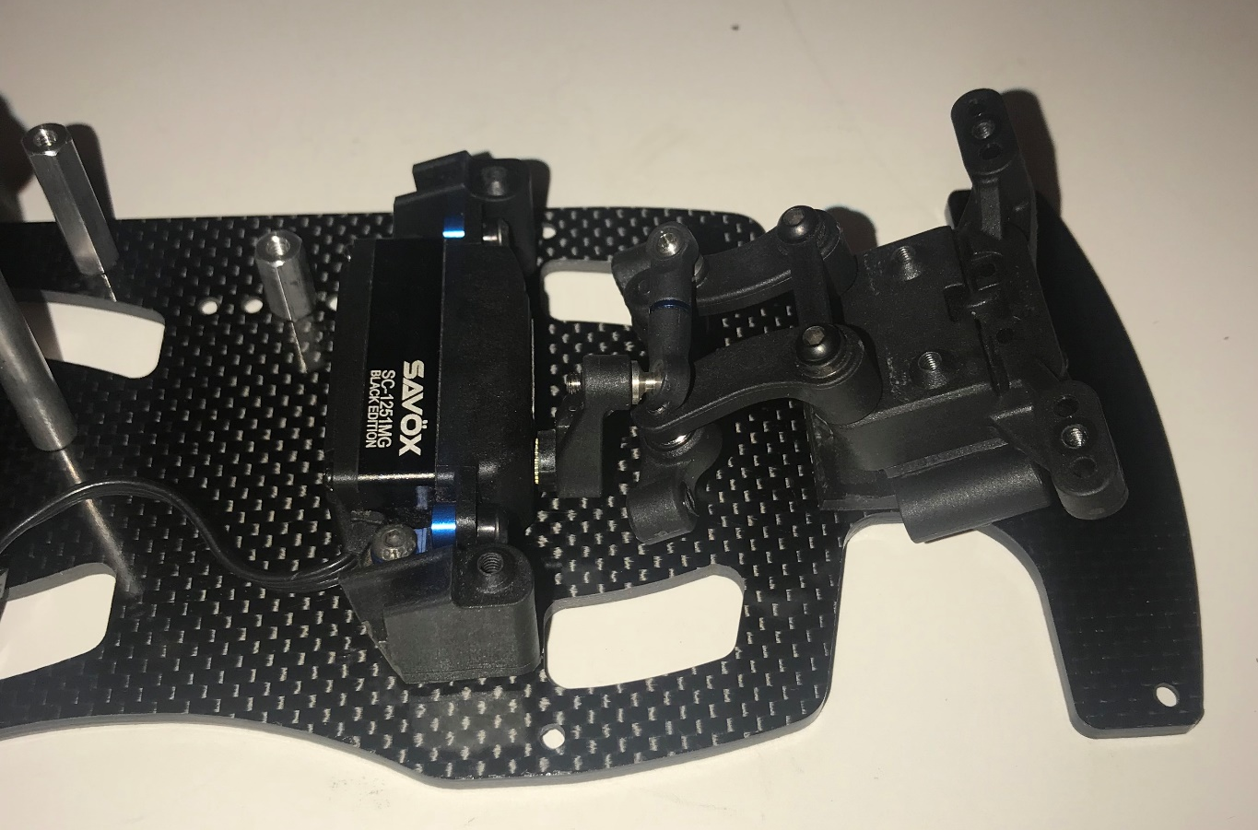

Step Four

Follow your Team Associated instruction manual on installing front top plate, front hubs, and camber links. Then attach the ERC carbon fiber front shock tower to ball stud mount.
Standard setup note: Use middle hole on ball stud mount and 1 mm spacer under ball stud. Also, on the front hub assembly, install 1 mm caster hat bushing on top and 2 mm bushing on bottom.
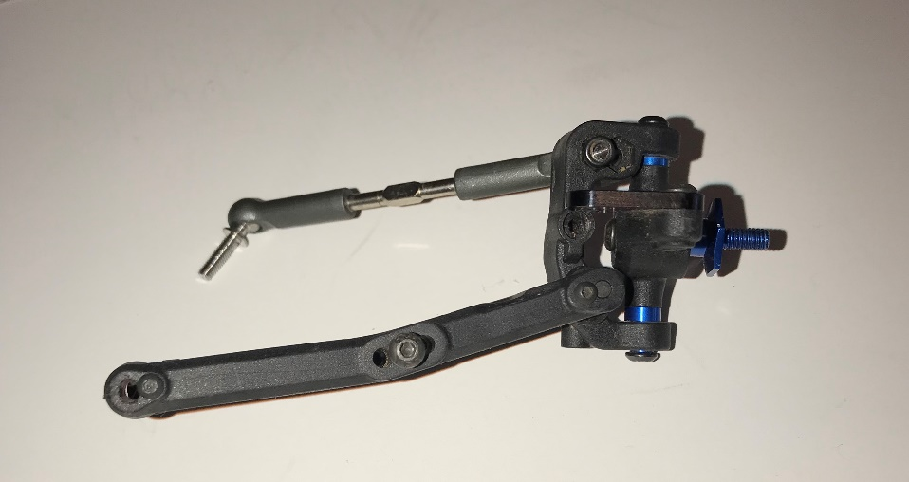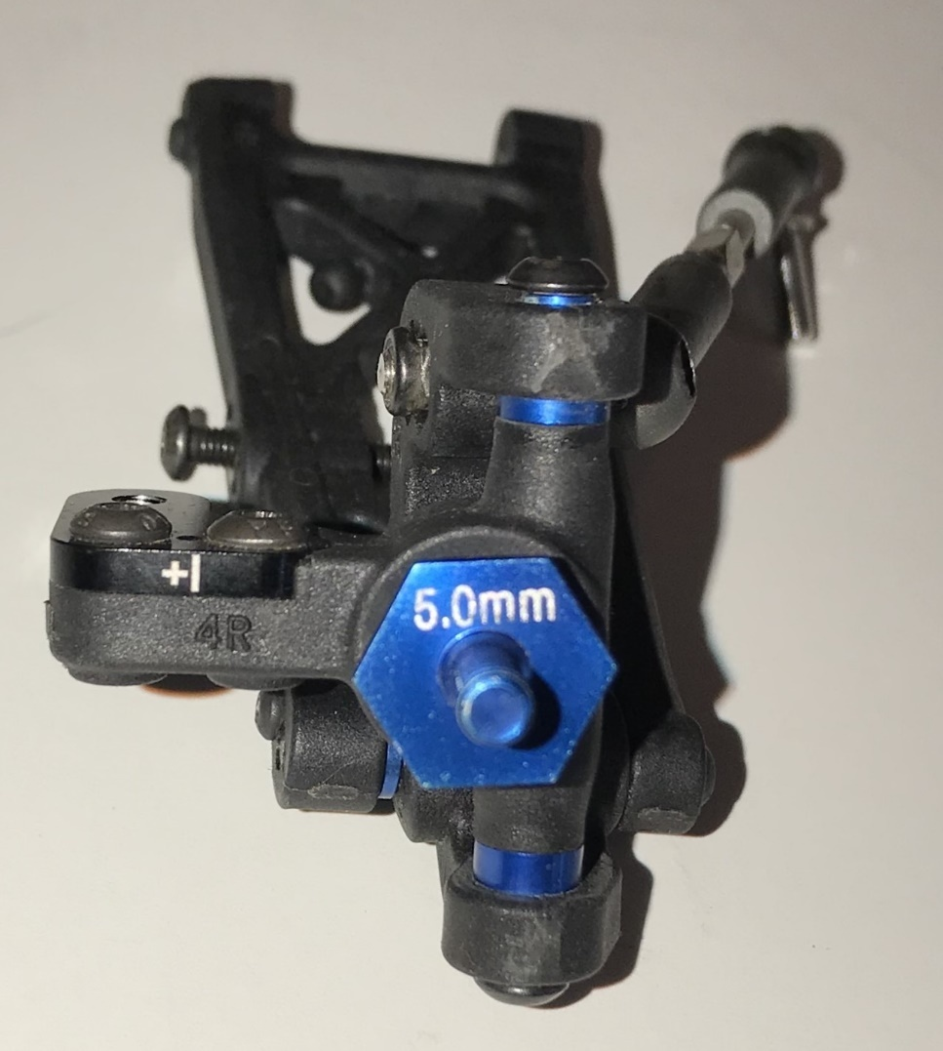
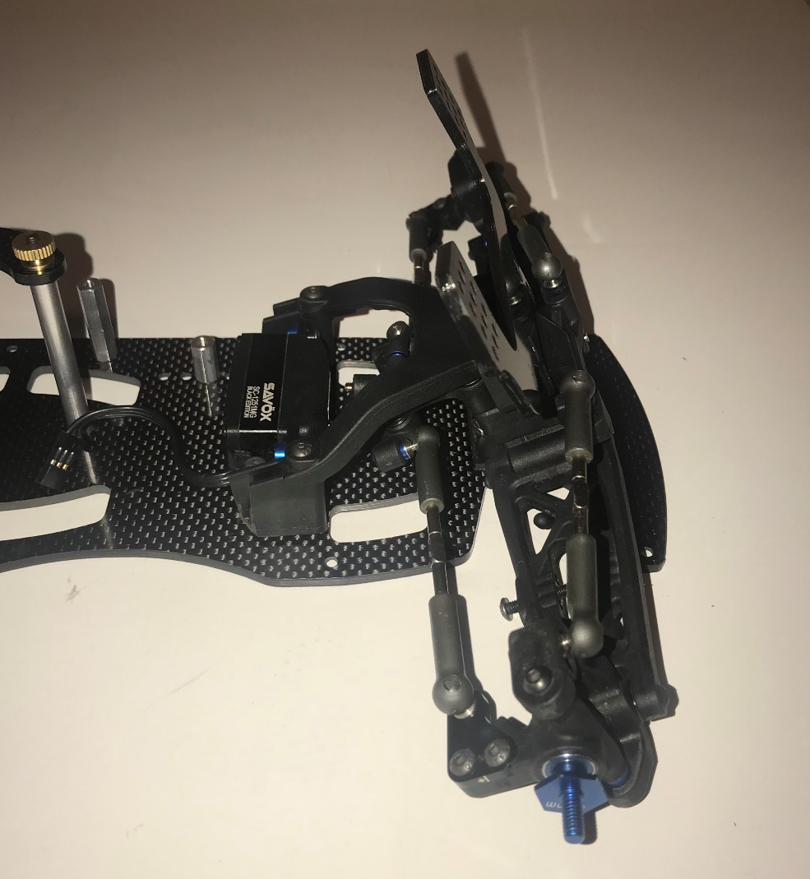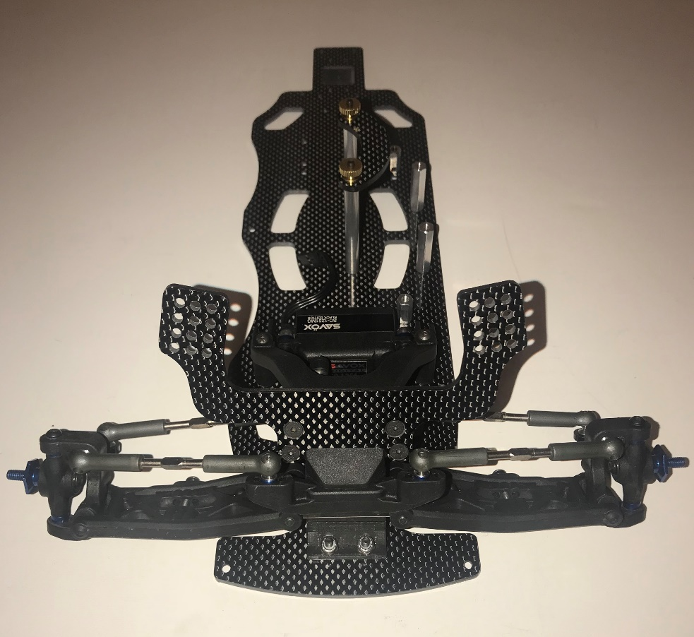

Step Five

Follow your Team Associated instruction manual to assemble your transmission, CVAs, rear hubs, and castor links. Use the Plan B adjustable rear arms and ERC provided spacers to build rear suspension.
Standard setup note: While building your transmission use the diff height insert in the #3 position and in the hub use the 0/3 tab down insert. Also build your rear hubs using rear hub link insert in the up position and attaching your camber link to the A position. When installing CVAs use 3 - 10x15mm axle shims on inside of hub to prevent axles from popping out of diff cups when racing or you can use the 65mm hole in CVA axle.
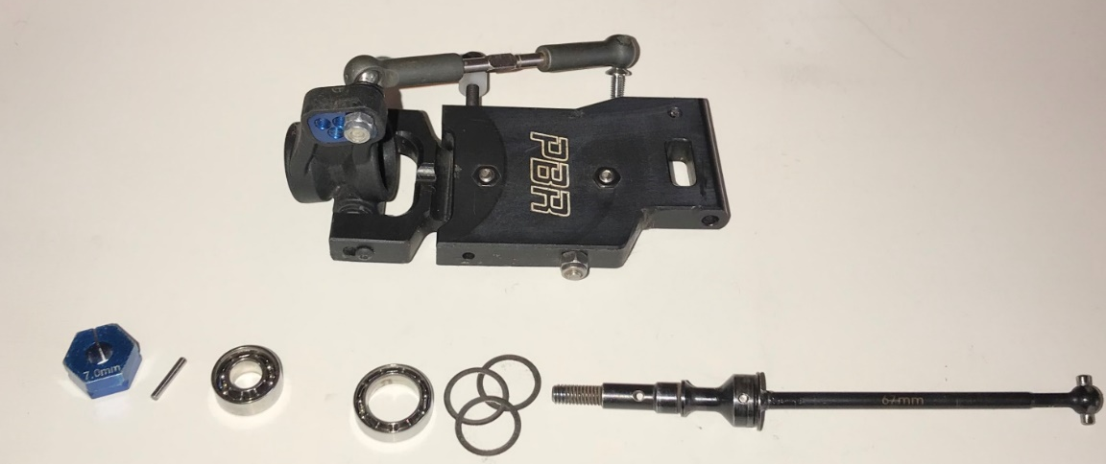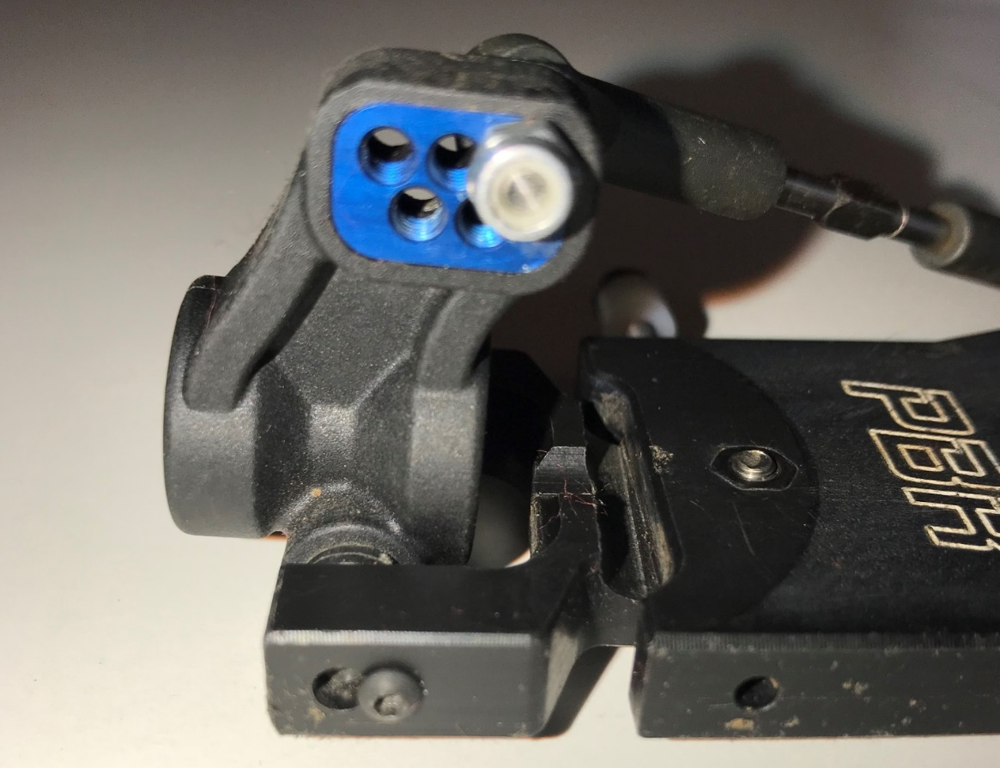
Use the zero arm mount inserts in both the C and D plates. Use 2 ERC provided spacers in front of the Plan B arms on the rear hinge pins to assemble the rear arms. Modify the rear bumper by cutting at the bend and use as a spacer.
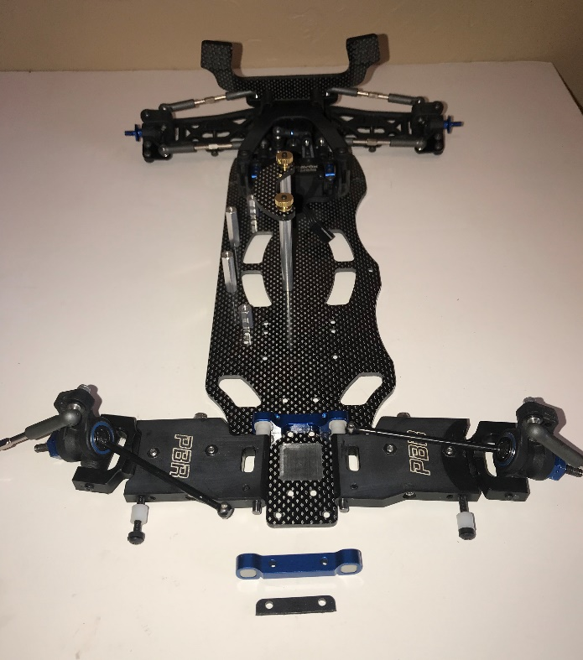
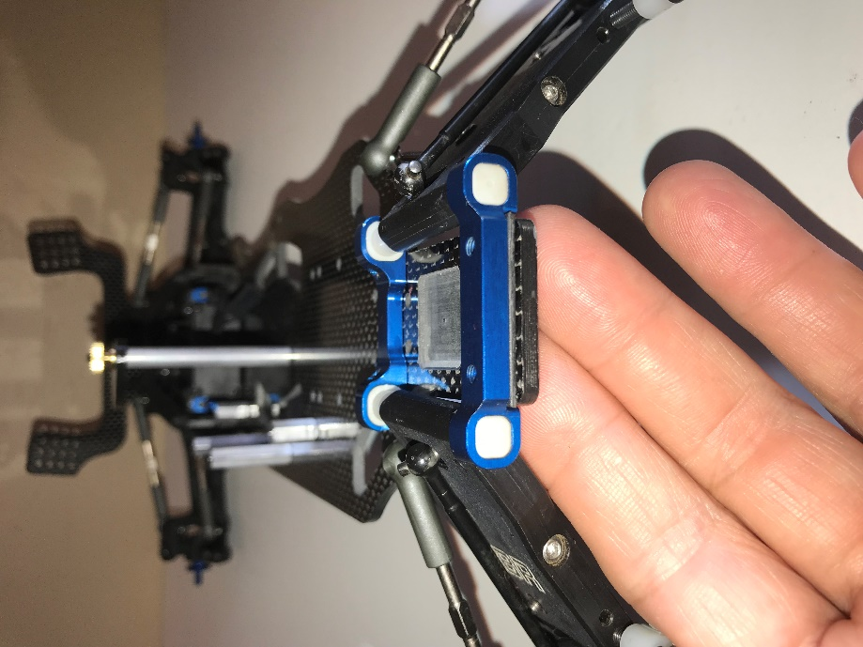

Install transmission with waterfall.
Standard setup note: Use inner most ball stud mounting position with NO spacers.
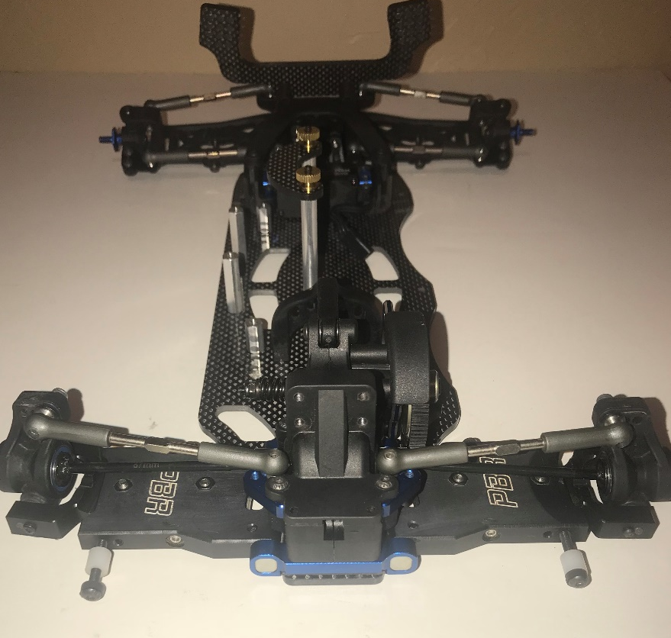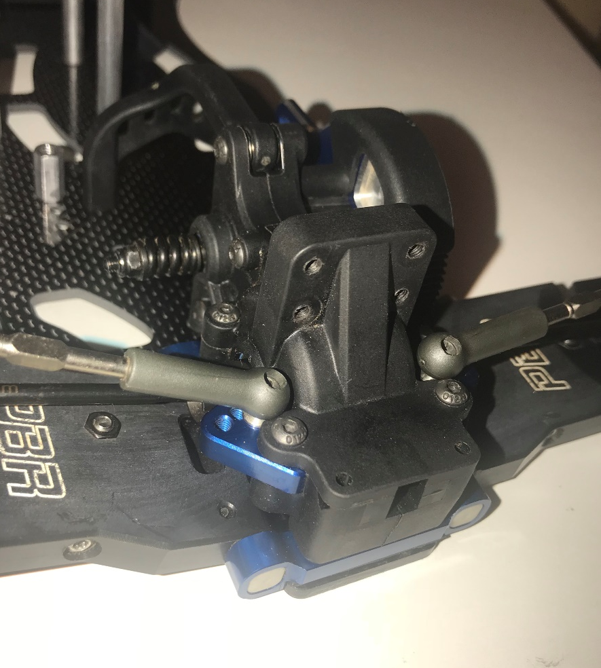

Step Six

Install ERC rear carbon fiber shock tower using spacers and provided screws. Install rear tail tank mount on shock tower.
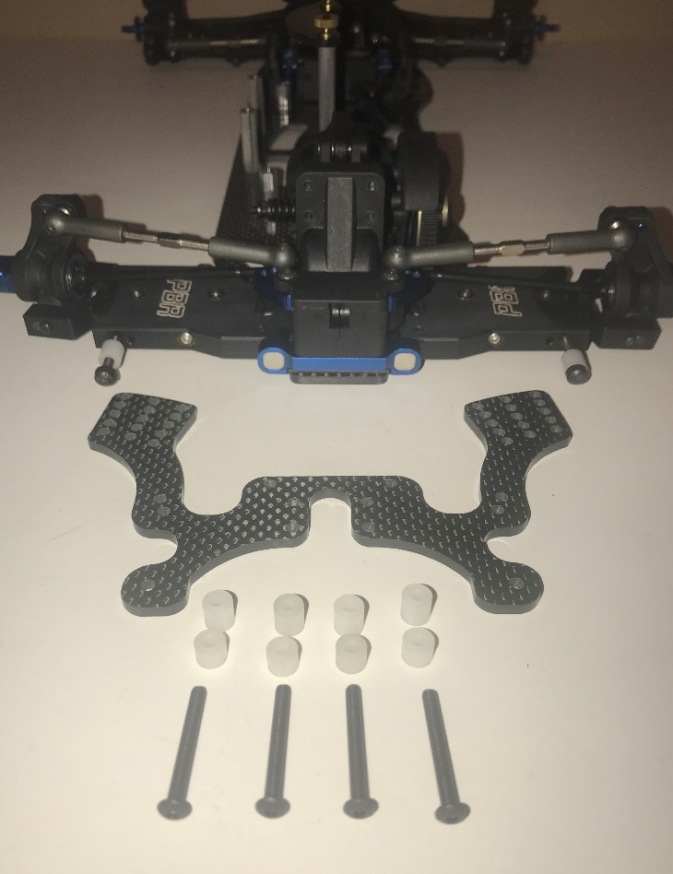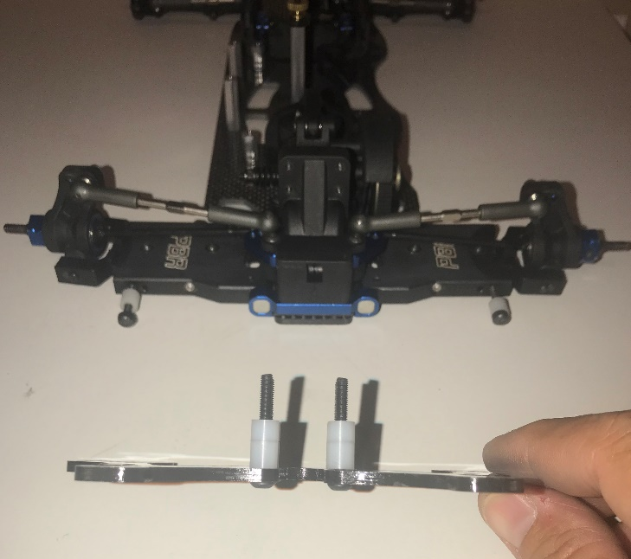
NOTE: Use one large and one small spacer on each of the four screws for proper spacing.

Step Six.1

Build AE shocks according to instruction manual and install. Install electronics and tires of your choice and install the Custom Works cage and body to complete installation.
Standard setup note: Build front shocks with 35wt Associated shock oil and 1.6 pistons with Custom Works Big Bore Yellow 5lb springs. Mount them in the second from bottom row on the inter most hole on the tower and on the arm the middle of the three mounting holes. Build the rear shocks with 35wt Associated shock oil and 1.8 pistons and 7.5 mm limiters inside the shocks. Use 6 mm shock spring spacers on the outside with a Custom Works Big Bore Red 6lb spring on the left side and a Custom Works Big Bore Green 7lb spring on the right side. Mount the shock on the second to the top row and outer most hole on shock tower and the outer most hole on the adjustable Plan B rear arm.
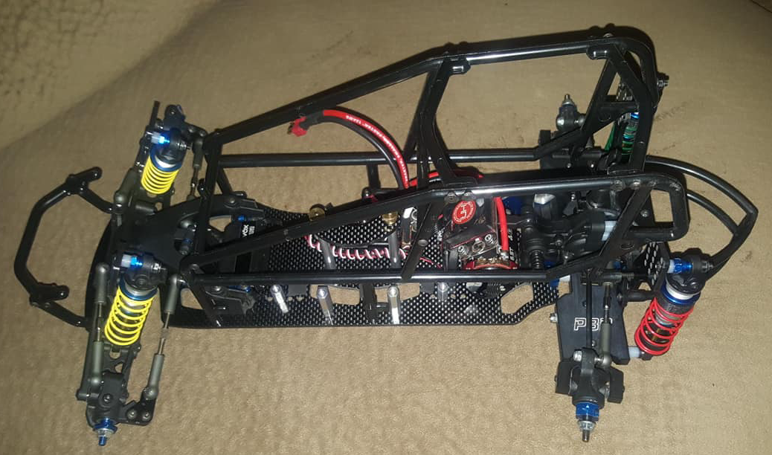

Enjoy your New B-SikOne Sprint Car

Website: https://evolutionracingconcepts.com/

Copyright © Evolution Racing Concepts – All Rights Reserved.

