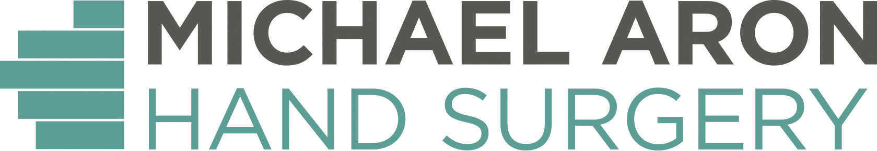

ROTATOR CUFF REPAIR PROTOCOL MEDIUM (2-5 cm)

REHAB PROGRESSION SUMMARY
0-6 weeks:Sling/immobilization. 0-6 weeks: Passive gentle ROM (Phase I). 4-8 weeks: Active-assisted ROM (Phase II). 6-12 weeks: Active ROM (Phase III). 12+ weeks: Strengthening (Phase IV)

• Sling/abd. pillow is worn for 4 weeks during the day and night • Remove sling for light activity and home exercise program as indicated by therapist

1st post-op visit PHASE I - PROM 0-6 weeks

Goals for treatment: • Decrease pain and swelling • Increase nutrition and healing response

PROM: • Begin passive ROM exercises in clinic • Pendulum exercise without weight • PROM above abd. pillow: ER, IR, flexion, extension, abduction • Table slides • Therapist: grade I, II joint mobilizations • Scapular retractions • Wrist/elbow exercises; grip exercises

Patient education: • Begin active assisted ROM at 4 weeks • No active motion for 6 weeks, all planes • No weights/PRE for 12 weeks • No active external rotation for 4 weeks • Limit external rotation to neutral for 4 weeks• Sling use as indicated by repair • Icing 3x/day for 20 minutes

4 weeks post-op PHASE II - ASSISTED-AROM

AROM: • Pendulum exercises with light weight • AAROM with cane & pullies, to patient tolerance (flexion, abduction - ER to neutral) • Body Blade - opposite hand, straight plane • Shoulder shrugs - light weight/high reps

Progress with: • Wall climbing/finger ladder • Scar mobility • Joint mobilizations - grade I/II • Quadruped rhythmic stabilization • Body Blade - opposite hand diagonals with trunk rotation • Biceps curls • Shoulder extension with Theraband • Shoulder shrugs • UBE - active assist only. AAROM(flexion to 145 and ER/IR)

6 weeks post-op PHASE III - AROM

AROM: • Continue with Phase II A-AROM • AAROM exercises with cane • AROM - all planes, no resistance • UBE - forward/reverse • Scapular retraction • Prone extension • Supine “holds” at 90° flexion; progress to small circles • Side-lying “holds” at 90° abduction; progress to small circles • Isometrics <50% effort, no pain (flexion, extension, abduction, ER) • Biceps curls/triceps extensions with light resistances, elbow at side

PHASE III - AROM 8 weeks post-op
Goal: Should have full PROM; with gentle passive stretching

AROM: • Continue with Phase III exercises, adding weight/resistance as indicated by therapist • Low-weight exercise (begin at 90° and increase to full ROM): flexion/extension, abduction, rows, scaption • Wall push-ups, wall push-ups plus • Shoulder IR/ER with low resistance • Scapular protraction ( “serratus punch”) • Prone fly

12 weeks post-op PHASE IV - STRENGTH

Goal: Should have full AROM; if not, begin aggressive stretching to achieve full ROM

Strength: • Body Blade, involved extremity: one-handed grip, abduction to 90°; two-handed grip, flexion to 90° • Kneeling push-ups, kneeling push-ups plus • Step-ups in kneeling push-up position • UBE with increased resistance • StairMaster in quadruped at level 12-15 • Treadmill in quadruped at 1.0 mph • Plyoball: circles, CW & CCW, 1 minute each direction; squares, CW & CCW, 1 minute each direction

