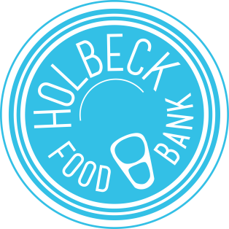

HOLBECK FOOD BANK
REFERRAL FORM

Holbeck Food Bank provides emergency food parcels for people in crisis who live in Holbeck and Beeston Hill. Each food parcel contains enough food for 3-5 days and contains non-perishable, nutritionally balanced food items. We take referrals for individuals, couples and families and deliver food parcels direct to people’s homes. Referrals received Monday to Friday before 1pm may be delivered on the same day if volunteers are available. Referrals received outside these hours will be processed as soon as possible but we cannot guarantee same-day delivery. Clients will be contacted before delivery. At present we only take referrals by email. Please send all emails to:

holbeckfoodbank@gmail.com

Unfortunately we are only able to serve the Leeds 11 area. To find out about food banks that serve other areas in Leeds, please try The Trussel Trust or Leeds Food Aid Network.

To make a referral to the Holbeck Food Bank we require the following information:

Your full name:
Organisation/ Agency:
Organisation contact number:
DETAILS OF INDIVIDUAL/FAMILY NEEDING FOOD
Full names of adults in household:
No. of children in household (plus ages)
Address:
Flat/House number:
Street:
Postcode:
Contact number:
Any dietary requirements:
Delivery time | Delivery will be between 10am and 3pm when volunteers are available. Only two attempts will be made.
Please also provide us with a brief summary of the crisis situation and why an emergency food parcel is needed:

Please note that as we are an emergency service we have a general limit of 3 parcels every 6 months. This policy is to help us reach those most in need until other support can be found and established. However, in exceptional circumstances this limit can be reviewed.

Please also be aware that while we will endeavour to have stock at all times there may be weeks were we are unable to provide emergency food parcels.

Holbeck Food Bank is run by Holbeck Christian Fellowship.

