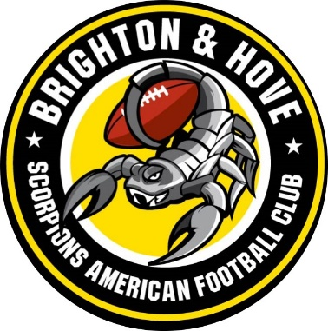

Brighton and Hove Scorpions American Football Club Anti-Bullying Policy

- Introduction.

The Brighton and Hove Scorpions American Football Club recognises its duty of care and responsibility to safeguard all participants from harm, promote and implement this anti-bullying policy in addition to our safeguarding and welfare policy and inclusion policy. These procedures seek to ensure that bullying behaviour is not accepted or condoned and require all members of The Brighton and Hove Scorpions American Football Club to be given information about, sign up to this policy, take action to investigate and respond to any alleged incidents of bullying, encourage and facilitate children and young people to play an active part in developing and adopting a code of conduct to address bullying and ensure that coaches are given access to information, guidance and/or training on bullying.

- All Brighton and Hove Scorpions American Football Club Members of Staff will:

Respect every child’s need for, and rights to a safe, secure and enjoyable environment, provide praise, recognition and opportunity for taking responsibility when and where available

Respect the feelings and views of others

Recognise that everyone is important and that our differences make each of us individual and should be valued

Show appreciation of others by acknowledging their qualities, contributions and progress

Be committed to the early identification of bullying, and prompt and collective action to deal with it

Ensure safety by having rules and practices carefully explained and displayed for all to see taking into account any additional learning, mental or physical abilities

Report incidents of bullying they see immediately to the Safeguarding and Welfare officer or their deputy

- Bullying

All forms of bullying will be addressed

Everybody in the club/organisation has a responsibility to work together to stop bullying

Bullying can include online as well as offline behaviour

Bullying can include:

- physical pushing
- kicking
- hitting
- pinching
- name calling
- sarcasm
- spreading rumours
- persistent teasing and emotional torment through ridicule
- humiliation or the continual ignoring of individuals
            - posting of derogatory or abusive comments
            - videos or images on social network sites racial taunts
            - graffiti
            - gestures
            - sectarianism
            - sexual comments/suggestions/behaviour
            - unwanted physical contact

(children with a disability, from ethnic minorities, young people who are gay or lesbian, or those with learning difficulties are more vulnerable to this form of abuse and are more likely to be targeted.)

- Support to the child

They should know who will listen to and support them (clubs safeguarding and welfare officer and any member of the coaching staff)

Systems should be established to open the door to children wishing to talk about bullying or any other issue that affects in line with the clubs safeguarding and welfare policy

Potential barriers to talking (including those associated with a child’s disability or impairment) need to be identified and addressed at the outset to enable children to approach adults for help

Children should have access to Helpline numbers Children NSPCC Helpline 0808 800 5000 ChildLine 0800 500 / www.childline.org.uk

Anyone who reports an incident of bullying will be listened to carefully and be supported

Any reported incident of bullying will be investigated objectively and will involve listening carefully to all those involved

Children being bullied will be supported and assistance given to uphold their right to play and live in a safe environment which allows their healthy development

Those who bully will be supported and encouraged to stop bullying

Sanctions for those bullying others that involves long periods of isolation, or which diminish and make individuals look or feel foolish in front of others, will be avoided.

- Support to the parents/guardians

Parents/Carers should be advised of The Brighton and Hove Scorpions American Football Club anti bullying policy and practice.

Any incident of bullying will be discussed with the child’s parent(s)/carer(s)

Parents will be consulted on action to be taken (for both victim and bully) and agreements made as to what action should be taken

Information and advice on coping with bullying will be made available

Support should be offered to the parent(s)/carer(s) including information on other agencies or support lines per appendix 2 of the safeguarding and welfare policy

Declaration
On behalf of Brighton and Hove Scorpions American Football Club we, the undersigned, will oversee the implementation of the Anti-Bullying Policy and take all necessary steps to ensure it is adhered to.

Chairman: Date:

Lead Safeguarding & Welfare Officer: Date:

