Conservation Corner

Conservation Corner is a weekly article produced by the Forest County

Land &Water Conservation Department. For more information contact Steve Kircher, County Conservationist-Land Information/GIS Director at 715-478-1387 or by e-mail at [lcc@co.forest.wi.us](mailto:lcc@co.forest.wi.us).

Next week, January 24 – 28 is Wisconsin Salt Awareness Week. Wisconsin Salt Wise is a coalition of organizations from across Wisconsin that work together to reduce salt pollution in our lakes, streams and drinking water. Their primary goal is to: educate residents, leaders and winter maintenance professionals on salt pollution and come up with solutions. They also focus on training and promote best practices to reduce salt pollution. Additionally, they will often recognize contractors that are committed to using the right amount of salt for conditions.

Here in Northern Wisconsin, we rely on salt to keep our roads safe in the winter and to soften water in our homes year-round but using more salt than is needed comes with a heavy price. In Wisconsin and much of the United States, chloride from salt is infiltrating into our lakes, streams and groundwater.

**It only takes 1 teaspoon of salt to pollute 5 gallons of water to a level that is toxic for freshwater ecosystems. We can all work together to use the right amount of salt!**

A 12-ounce coffee mug full of salt is enough to treat a 20-foot driveway or 10 sidewalk

squares. If scattered correctly, the pattern should look like the "correct" image below.

**Correct amount of salt: Incorrect Salt Application:**

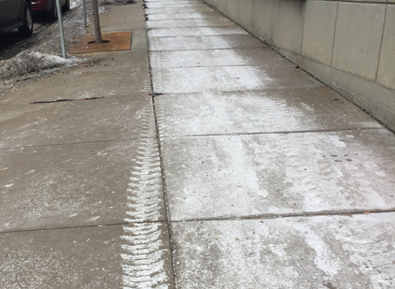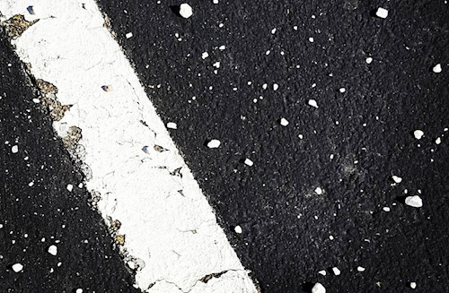

Once salt is in the environment it doesn’t go away. It ends up in our lakes, rivers, streams

and wetlands. Chloride from salt degrades freshwater ecosystems. As I stated befored, it only takes 1 teaspoon of salt to pollute 5 gallons of water to a level that is toxic to native aquatic

organisms (395 mg/L). Naturally occurring concentrations of chloride are >1 mg/L

throughout most of Wisconsin, but our surface water, groundwater and soil have been

absorbing virtually all of the salt spread in the state for more than six decades. The widespread use of salt has led to the steady salinization of surface water and groundwater, threatening freshwater resources and our drinking water.

Removing salt from water is cost-prohibitive. Once salt gets into water it is very difficult to remove. Treatment, like reverse osmosis or ion exchange, is costly to install and even more expensive to operate. It could cost millions or even billions of dollars, so preventing salt from entering our drinking water resources in the first place is the most cost-effective solution.

Salt weakens the concrete, brick and stone that make up our homes, garages, bridges, and roads. One ton of rock salt causes between $800 and $3,300 of damage to buildings, bridges and other infrastructure (source). Nationwide, we spend over $5 billion annually to repair salt damage to roads and bridges and we're not keeping up (source). Road and sidewalk salt can irritate your pets' toes, feet, and skin. Problems can also arise if a dog eats salt or licks their paws after a walk. Excess salt can cause toxicity concerns, throw off their electrolyte balance, or cause hypertension, cardiac arrhythmias, vomiting, increased urination, increased thirst, muscle tremors, or seizures. Keep your pets healthy by shoveling first, and applying only the right amount of salt to keep sidewalks safe.

Salt can stress plants and animals that have adapted to freshwater environments. Before reaching lethal levels, chloride (the negative ion in sodium chloride - NaCl), has a variety of direct and indirect impacts on the health of organisms in aquatic ecosystems.