Conservation Corner

*Conservation Corner is a weekly article produced by the Forest County Land &Water Conservation Department. For more information contact Steve Kircher, County Conservationist-Land Information/GIS Director at 715-478-1387 or by e-mail at* [*lcc@co.forest.wi.us*](mailto:lcc@co.forest.wi.us)*.*

Lake Property Ownwers, have you noticed erosion along your shoreline? This is a challenge that many shoreland property owners face, we would like to share some tips on how to keep your shoreland property in place!

The best way to identify and assess erosion problems is to check your shoreline regularly and monitor changing conditions. Warning signs of accelerated erosion problems include:

A large area of bare soil along the shore (especially on a steep/high shoreline bank).

 Nearshore gullies caused by overland runoff from rooftops, driveways, and access roads.

 A noticeable recession of the shoreline over time.

 Large patches of unusually cloudy (turbid) water near a lakeshore, or unusually high stream

turbidity (especially during periods of high water).

Choosing the best fit for your shoreland property depends on the quantity and speed of runoff from hard surfaces toward the water’s edge, and the amount of energy along the shore. Shoreline erosion on low energy sites can frequently be addressed by limiting the amount of foot traffic to, and along, the water’s edge. For example, you can create a purposeful path that meanders to the lake. You can also restore (or leave) native plants along the shore to create a no-mow zone. Further, you can allow aquatic plants to re-establish in the nearshore area.

**Best Practices for a Healthy Lake**

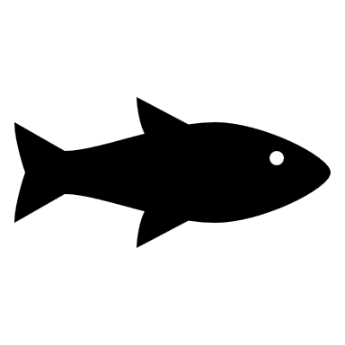Fish sticks are strategically placed groups of whole, dead trees that are partially or fully submerged

and anchored to the shore to create fish and wildlife habitat. These large woody structures also help

prevent bank erosion by reducing the energy to your shoreline.

*350 ft2* native plantings stabilize banks with trees, shrubs, grasses, and wildflowers that improve

wildlife habitat, slow runoff, and promote natural beauty.

Diversion practices prevent runoff from getting into your lake or stream by redirecting water to

areas (like a rain garden or rock infiltration pit) where it can soak into the ground instead.

Rain gardens create wildlife habitat and natural beauty while capturing and cleaning runoff.

**Get Started**

Before starting your erosion control project, consult with your county conservation and zoning department for local shoreland rules. It is also important to connect with the WDNR Water Management Specialist in your area.