Battlefield Tazewell: Clinch 7  
LAW ENFORCEMENT and NATIONAL GUARD

**TIME LINE**

|  |  |  |
| --- | --- | --- |
| Friday, Sept 10, 2021  3:00 PM  (At CarLot)  Baby St, Tazewell, VA 24651  5:00 PM - 9:00 PM  Check Opens Early Safety Briefs (by North40) Chrono  Friday Game Brief at Fairground 9pm (If you get Briefed good to Go for Saturday) | Saturday, Sept 11, 2021  8:00 AM - 9:00 AM  Saturday Check-in Chrono  (at CarLot)  9:00 AM - 10:00 AM  Saturday Game Briefs for those that didn’t Friday (At CarLot)  10:00 AM – 6 PM  Saturday Main Conflict (All AOs)  6:00 PM - 8:00 PM  Saturday Cool Down Soft Break in Main Conflict  8:00 PM - 11:00 AM  Saturday Night DAM missions (Carlot and Fairgrounds)  (Possible – Lake Special Missions) No Pyro at Night except Smoke | Sunday, Sept 12, 2021  9:00 AM - 1:00 PM  Sunday Final Conflict (Locations TBD based on conflict)  1:30 PM  Raffle |

**Story:**

For several years Southwest Virginia and Southern West Virginia has had massive hardships thanks to government. When the Government shut down all fossil fuel power plants one winter without warning 1000s went without power, 100s died, and no one seemed to care. Those that remained did spoke up, but that voice fell on deaf ears. Then when democracy failed, and the cities started having issue then came help … but not for Appalachia not for those that had the most hardship.

The people fought back raiding supplies and cities with the help of SF. The Government had enough and has sent in the National Guard to help Law Enforcement to calm and protect the people but not all the people want to be calmed ….

The Stage is set for a small town in Virginia with a river that runs thru it….

Battlefield Tazewell: Battle of the Clinch 7

**UNIFORMS**

Make sure to be in correct Uniforms in your Top, Bottoms, and Head Gear (hat, helmet)  
  
National Guard is All green Based Camos   
-Woodland, OD, Ranger Green, AOR2, Marpat, Multicam TROPIC etc  
DO NOT Wear normal Multicam  
Try to have Dark Gear if possible, recommend but not required

Law Enforcement is Full Black and Full Grey  
- Solid Black, Black Night camo, MC Black,   
Wolf Grey, Stone Grey, Grey.   
Try not to Mix and Match and have top and bottoms Black/Black and Grey/Grey to avoid Confusion with Civis  
Try to have Dark Gear if possible, recommend but not required   
If players do not Match LE and NG Color codes they are your Enemy.  
**Tans, MC, and mixmatches are not your Friends**

**Radios For LE/NG**  
Do not be on Other Public Channels – Private is ok

|  |  |  |  |  |  |  |  |
| --- | --- | --- | --- | --- | --- | --- | --- |
| **462.58750** |  | M |  | FRS 02 | Channel 2 | FMN | Other |
| **462.61250** |  | M |  | FRS 03 | Channel 3 | FMN | Other |
| **462.63750** |  | M |  | FRS 04 | Channel 4 | FMN | Other |
| **462.66250** |  | M |  | FRS 05 | Channel 5 | FMN | Other |
| **462.68750** |  | M |  | FRS 06 | Channel 6 | FMN | Other |
| **462.71250** |  | M |  | FRS 07 | Channel 7 | FMN | Other |
| **467.56250** |  | M |  | FRS 08 | Channel 8 | FMN | Other |
| **467.58750** |  | M |  | FRS 09 | Channel 9 | FMN | Other |
| **467.61250** |  | M |  | FRS 10 | Channel 10 |  |  |

**Areas of Operations (Friendly)**

**Tazewell County Fair Grounds**515 Fairground Rd, Tazewell, VA 24651 **National Guard’s Forward Operations Center.**   
 Key Notes (Rules of Engagement)

Barn and Stables – First Line of Defense against Enemy Raids  
(Rules of Engagement)  
 - High Fire Hazard – Please do not use Pyro INSIDE of Barn and Stables

Knuckles Hall – Storage and Assembly Area for NG  
 (Rules of Engagement)  
 - Leave Doors Open  
 - No Smoke in Building  
 - Any Loot or Bingos bring back here for Storage

Arena and Shelter – Last Line of Defense of Medical (Respawn)  
- Comms Tower in Play (Key Location for Comms and Intel)  
- Players can Camp in Arena for in danger respawn and resupply if Arena not under Attack

Peery Building  
(Out of Play -could change)  
Restrooms Emergency Cool Down area

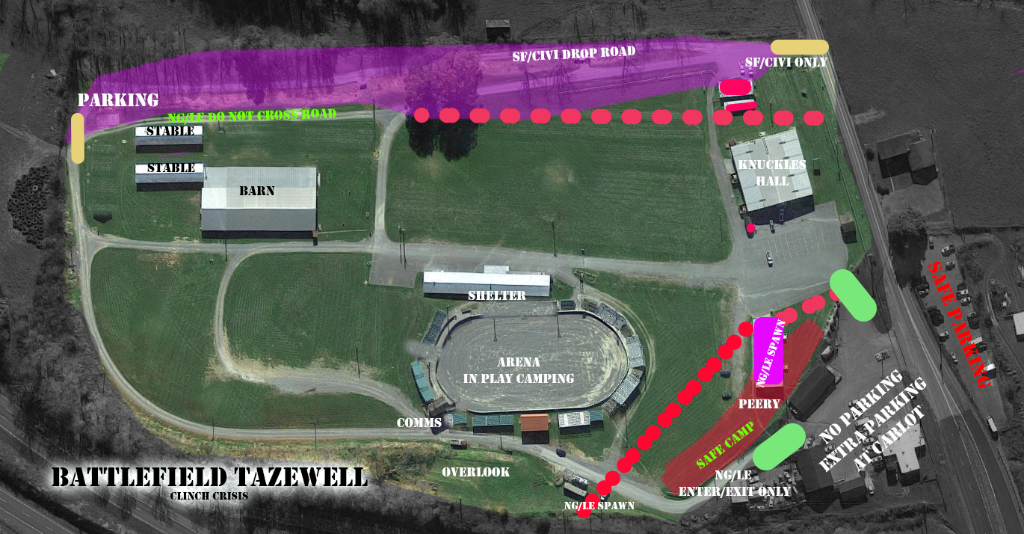

* Do not Cross Road past Barns  
  Caution Tape – don’t Shoot into or Cross  
  Do not shoot at Glass or lights   
  Do not move anything  
  Do not Lock or unlock Doors

CIVI/SF may only enter the AO from there Drop Road (Marked Tan)  
NG/LE may inter in the 2 Roads near Campsite and Main Road (this is hot way in Marked Green)

**Car Lot   
Baby St, Tazewell, VA 24651  
Law Enforcement’s Station  
Lockup and Vehicle Workshop**

Key Notes (Rules of Engagement)

Lockup Building – The Old Police Station and Holding Station  
 Please Shoot at Player Once they are in Building  
 Don’t Shoot in from Outside Doorways unless have no other choice

Station was hit by Bomb no Power but Police are using this to hide and store High Value Items or possibly HVTs

Workshop – Motorcade Repair and Storage Area

Please Shoot at Player Once they are in Building  
 Don’t Shoot in from Outside Doorways unless have no other choice  
 Has limited Lights that can be turned on and off by both Sides

Vehicle Repair Parts for Attack and Transport Vehicles (in play does not affect between AO vehicles)

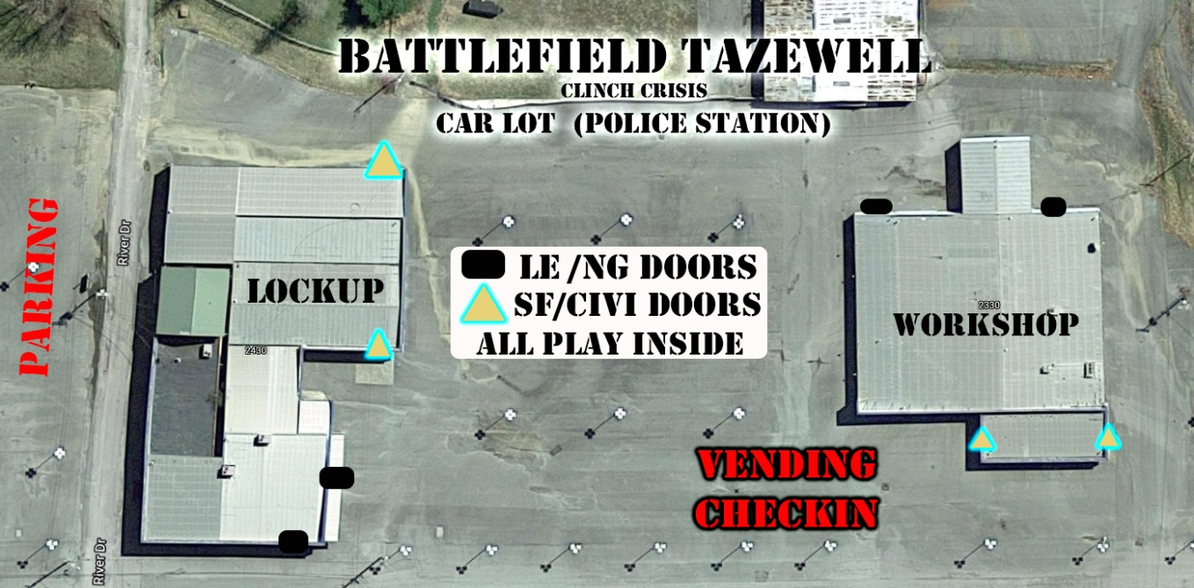

* Please Shoot at Player Once they are in Building  
  Don’t Shoot in from Outside Doorways unless have no other choice   
  Do not shoot at Glass or lights   
  Do not move anything  
  Do not Lock or unlock Doors  
  Semi only unless you are SMG (remember MED that’s 20 to a door and you must go through the door before you can shoot another 20 on full auto)  
  **No Medics at This AO, limited number of players in at a time**   
  **12 each side for each Building. Once one person comes off the next waiting may enter**

**Areas of Operations (OPFOR)**

## Bluestone 81°22'37., 37°12'26 US-2, Newport, WA 99156 37.207439, -81.376969 Water Reservoir and unfinished Business Park Rogue Special Forces teams have Dropped outside of Tazewell

Key Notes (Rules of Engagement)  
Once Vehicles and Troops clear the entrance and Spawn Areas, they are in Max Danger.   
We have Safe Road into our Staging/Spawn  
If any Vehicle of LE/NG passes Safe zone its considered Hostile to OPFOR

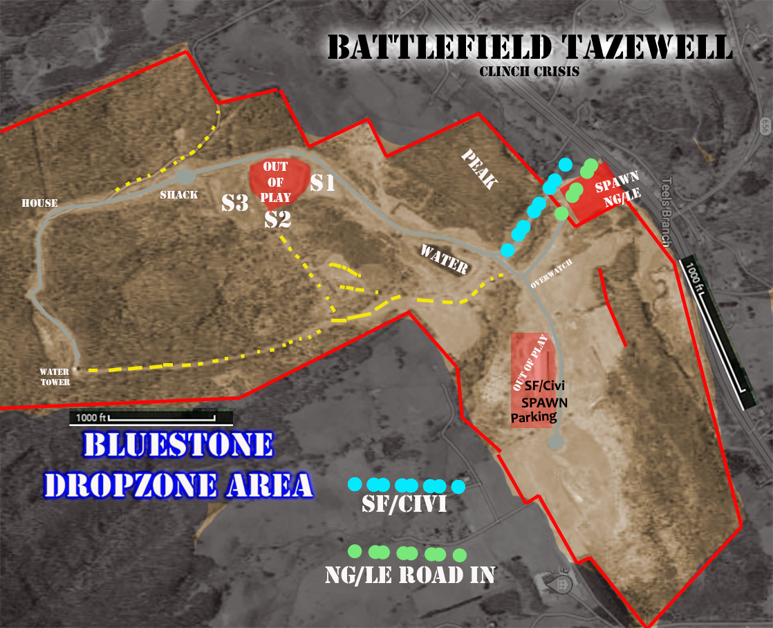

Do not Cross Fences at the Borders or Main Road  
There is an Old Fence near Overlook its ok to cross it.  
There is a Shell building the SF is using for Parking and Spawn don’t shoot near it   
There is construction on S2 don’t go on S2 shelf

We believe the Shack, House, and Water Tower are very important. Keep that in MindAssume the Paved Roads will have Civilians drivers check your targets for non-combative vehicles (they should go straight to Spawn Parking for SF/Civi)

ROE does not allow us to stop or shoot Traffic unless you know 100%, they are dangerous (Look for Dead Rags or Blinkers)  
SF is believed to have made hidden camp sites they have supplies at. We need to find these sites and know how much a Danger they are.

Cutting off supplies and keeping SF worried about Bluestone will ensure we have easier time at other AOs

**Lincolnshire Park and Lake  
Lincolnshire Park, Tazewell, VA 24651  
Park and Lake Access to major Roads, Supplies, Personal**

Key Notes (Rules of Engagement)  
 Do not Cross any Fences those are the out of Bounds.   
 Do not damage or Move objects.   
 Don’t damage the Playground

No not shoot out of play Area (Parking Lots at entrance and in town)

SF and Civis Might have a Hot Drop Zone near the Pool we need to watch for that so we don’t get hit from 2 sides

We also know they will/can Drop Players off along the creek road across at the end of the Baseball fields

ON one side of the Lake are the Docks we might have to drop off and Protech items, while also taking items of the Civis

The Outlook is a Key Terrain known to be a trouble spot.   
  
There isn’t Much need to go past the Docks or Outlook

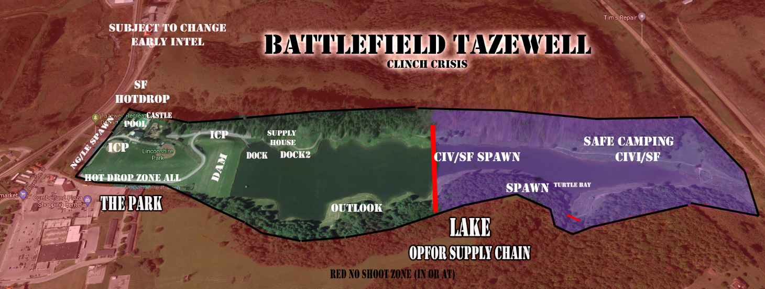

**Missions (Missions and Fragos are Organic)  
Commanders and Players need to give updates to Staff and Admins for what you’re doing to Shape the game**

Phase 1 – Foothold  
Making sure you have a good plan and strong defense  
Send out Recon Teams to Bluestone  
Capture the Playground at Park and Hold it

Phase 2 – Dig in or Strike Back  
Ensure Comms Tower and supplies are safe  
Move on to Lake and try to control all of Park and Docks  
Map Bluestone Key areas and Troops  
  
Car Lot FRAGO (As needed)  
If Vehicles are taken out go and retrieve or request Repair Parts  
Protect any HVT, Intel, Key Items, and Repair Kits

8pm Phase 3 – Night Ops (Car Lot and Fairground)  
Defend what you have until Opfor leaves  
Possible Lake FRAGO   
  
Sunday Phase 4 - Classified  
Operation Home Run (Park)   
or   
Operation Water from Stone (Bluestone)

Important

With Covid to keep a safe environment we will ask you to try to stay out of large groups except those you game with.

We will be limited the number of people on the Transports and ask all to respect Mask and non- mask wearers. If you want to be within 6 feet of each other, please think about having a mask inside. No mask is required outside during play. But please try to keep distance and long-term hanging out to those you didn’t come with down.

We have lots of land to play with and being on county and town land we must try to follow the health department Rules.