Battlefield Tazewell: Clinch 7  
**Civilian Militia** and Rogue Special Forces

**TIME LINE**

|  |  |  |
| --- | --- | --- |
| Friday, Sept 10, 2021  3:00 PM  (At CarLot)  Baby St, Tazewell, VA 24651  5:00 PM - 9:00 PM  Check Opens Early Safety Briefs (by North40) Chrono  Friday Game Brief at Lincolnshire Park 8pm (If you get Briefed good to Go for Saturday) | Saturday, Sept 11, 2021  8:00 AM - 9:00 AM  Saturday Check-in Chrono  (at CarLot)  **9:00 AM - 10:00 AM**  Saturday Game Briefs for those that didn’t Friday (At CarLot)  10:00 AM – 6 PM  Saturday Main Conflict (All AOs)  6:00 PM - 8:00 PM  Saturday Cool Down Soft Break in Main Conflict  8:00 PM - 11:00 AM  Saturday Night DAM missions (Carlot and Fairgrounds)  (Possible – Lake Special Missions) No Pyro at Night except Smoke | Sunday, Sept 12, 2021  9:00 AM - 1:00 PM  Sunday Final Conflict (Locations TBD based on conflict)  1:30 PM  Raffle |

**Story:**

For several years Southwest Virginia and Southern West Virginia has had massive hardships thanks to government. When the Government shut down all fossil fuel power plants one winter without warning 1000s went without power, 100s died, and no one seemed to care. Those that remained did spoke up, but that voice fell on deaf ears. Then when democracy failed, and the cities started having issue then came help … but not for Appalachia not for those that had the most hardship.

The people fought back raiding supplies and cities with the help of SF. The Government had enough and has sent in the National Guard to help Law Enforcement to calm and protect the people but not all the people want to be calmed ….

The Stage is set for a small town in Virginia with a river that runs thru it….

Battlefield Tazewell: Battle of the Clinch 7

**UNIFORMS**

Make sure to be in correct Uniforms in your Top, Bottoms, and Head Gear (hat, helmet)  
  
Special Forces is Standard Multicam   
DO NOT WEAR Multicam TROPIC  
Try to have MC Gear or Tan if possible, recommend but not required

Civilian is Tans, Khakis, Jeans, Multicolored  
- NO Solid Black, Green camo   
Try to Mix and Match and have top and bottoms   
Gear Doesn’t Matter  
Your Only Friend is those in Standard Multicam

**Radios For LE/NG**  
Do not be on Other Public Channels – Private is ok

|  |  |  |  |  |  |  |  |
| --- | --- | --- | --- | --- | --- | --- | --- |
| **467.63750** |  | M |  | FRS 11 | Channel 11 | FMN | Other |
| **467.66250** |  | M |  | FRS 12 | Channel 12 | FMN | Other |
| **467.68750** |  | M |  | FRS 13 | Channel 13 | FMN | Other |
| **467.71250** |  | M |  | FRS 14 | Channel 14 | FMN | Other |
| **462.55000** |  | M |  | FRS 15 | Channel 15 | FMN | Other |
| **462.57500** |  | M |  | FRS 16 | Channel 16 | FMN | Other |
| **462.60000** |  | M |  | FRS 17 | Channel 17 | FMN | Other |
| **462.62500** |  | M |  | FRS 18 | Channel 18 | FMN | Other |
| **462.65000** |  | M |  | FRS 19 | Channel 19 | FMN | Other |
| **462.67500** |  | M |  | FRS 20 | Channel 20 | FMN | Other |
| **462.70000** |  | M |  | FRS 21 | Channel 21 | FMN | Other |

**Areas of Operations (OPFOR)**

**Tazewell County Fair Grounds**515 Fairground Rd, Tazewell, VA 24651 **National Guard’s Forward Operations Center.**   
 Key Notes (Rules of Engagement)

Enter the Drop Road. Keep Cars parked at entrance or on Road   
If Drive onto AO you Vehicle is Live  
Try not to Fire unless you Cross out of Safe Zone

Barn and Stables – Gateway into Fairgrounds  
(Rules of Engagement)  
 - High Fire Hazard – Please do not use Pyro INSIDE of Barn and Stables

Knuckles Hall – Storage and Assembly Area for NG  
 (Rules of Engagement)  
 - Leave Doors Open  
 - No Smoke in Building  
 - Any Loot or Bingos bring back Docks for Storage

Arena and Shelter – NG StrongHold  
- Comms Tower in Play (Key Location for Comms and Intel Raid get what you need and get out)  
  
Peery Building  
(Out of Play -could change)

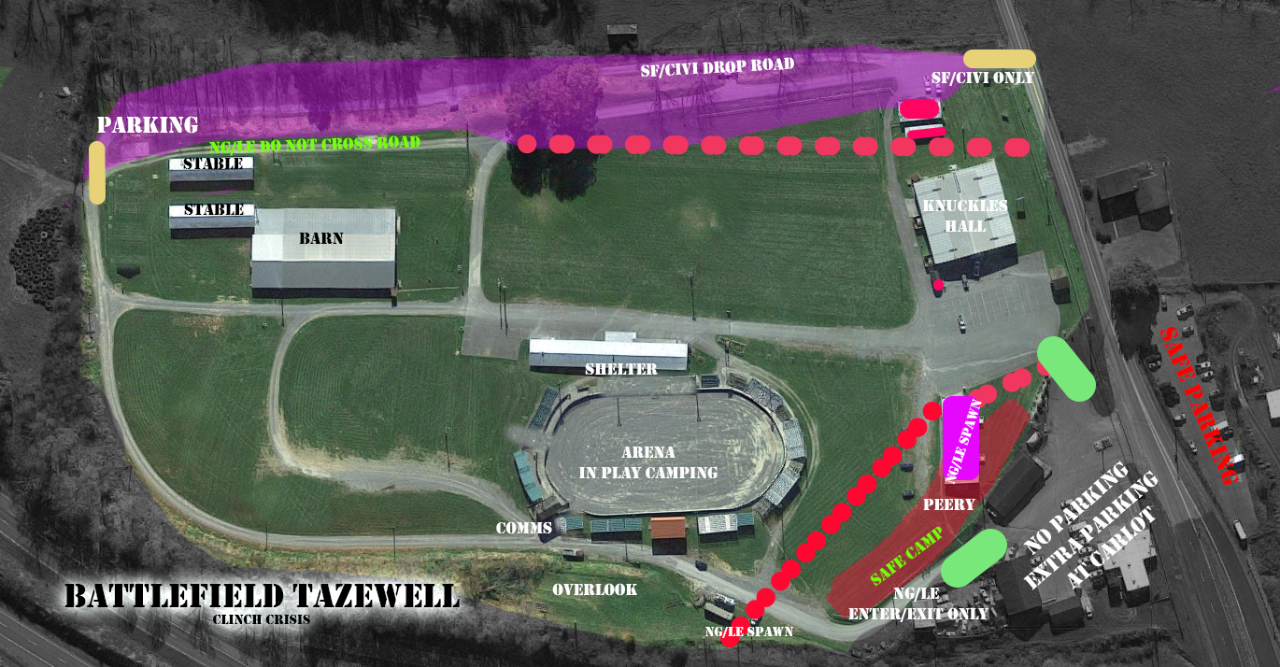

* Do not Cross Road Caution Tape past Arena near Camp and Park Area  
  Caution Tape – don’t Shoot into or Cross  
  Do not shoot at Glass or lights   
  Do not move anything  
  Do not Lock or unlock Doors

CIVI/SF may only enter the AO from there Drop Road (Marked Tan)  
NG/LE may inter in the 2 Roads near Campsite and Main Road (this is hot way in Marked Green)

**Car Lot   
Baby St, Tazewell, VA 24651  
Law Enforcement’s Station  
Lockup and Vehicle Workshop**

Key Notes (Rules of Engagement)

Lockup Building – The Old Police Station and Holding Station  
 Please Shoot at Player Once they are in Building  
 Don’t Shoot in from Outside Doorways unless have no other choice

We hit the Station with a Bomb on Friday, no Power but Police are using this to hide and store High Value Items or possibly HVTs

Workshop – Motorcade Repair and Storage Area

Please Shoot at Player Once they are in Building  
 Don’t Shoot in from Outside Doorways unless have no other choice  
 Has limited Lights that can be turned on and off by both Sides

Vehicle Repair Parts for Attack and Transport Vehicles (in play does not affect between AO vehicles)

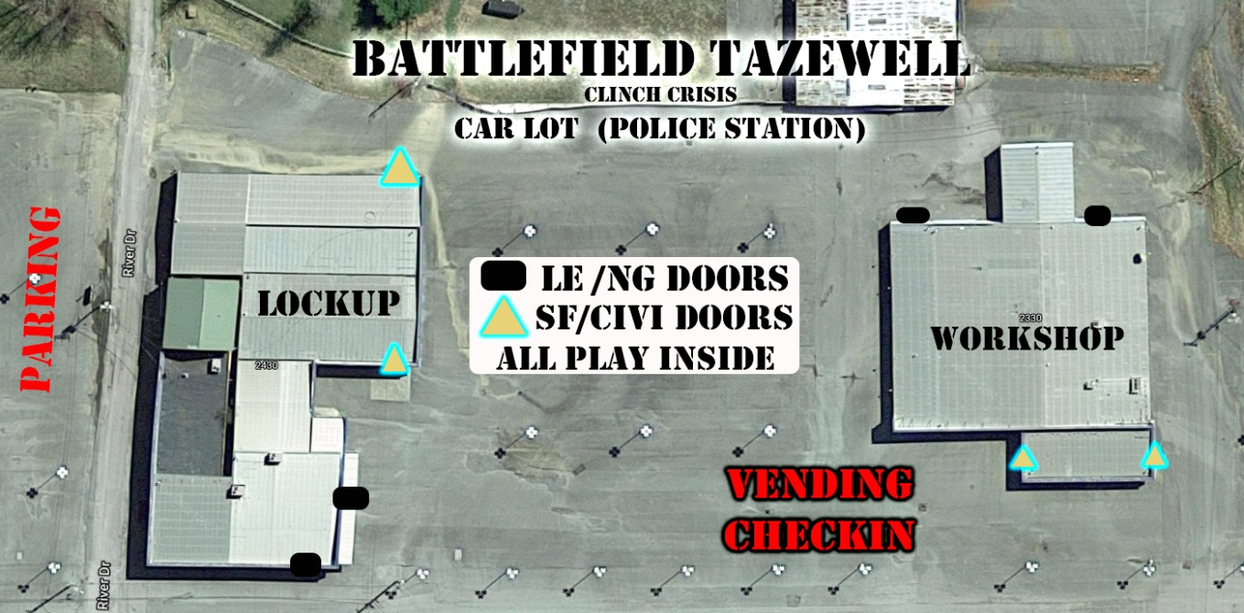

* Please Shoot at Player Once they are in Building  
  Don’t Shoot in from Outside Doorways unless have no other choice   
  Do not shoot at Glass or lights   
  Do not move anything  
  Do not Lock or unlock Doors  
  Semi only unless you are SMG (remember MED that’s 20 to a door and you must go through the door before you can shoot another 20 on full auto)  
  **No Medics at This AO, limited number of players in at a time**   
  **12 each side for each Building. Once one person comes off the next waiting may enter**

**Areas of Operations (CIVI/SF)**

## Bluestone 81°22'37., 37°12'26 US-2, Newport, WA 99156 37.207439, -81.376969 Water Reservoir and unfinished Business Park Rogue Special Forces teams have Dropped outside of Tazewell

Key Notes (Rules of Engagement)  
Let Vehicles and Troops Clear the Safe Zone.   
Use and Protect the Blue Road in and Out for Civis and SF troops.   
If any Vehicle of LE/NG passes Safe zone its considered Hostile.  
Use Dead Lights or Emergency Blinkers to enter AO, Must Report to Main Spawn/Parking before Active on AO

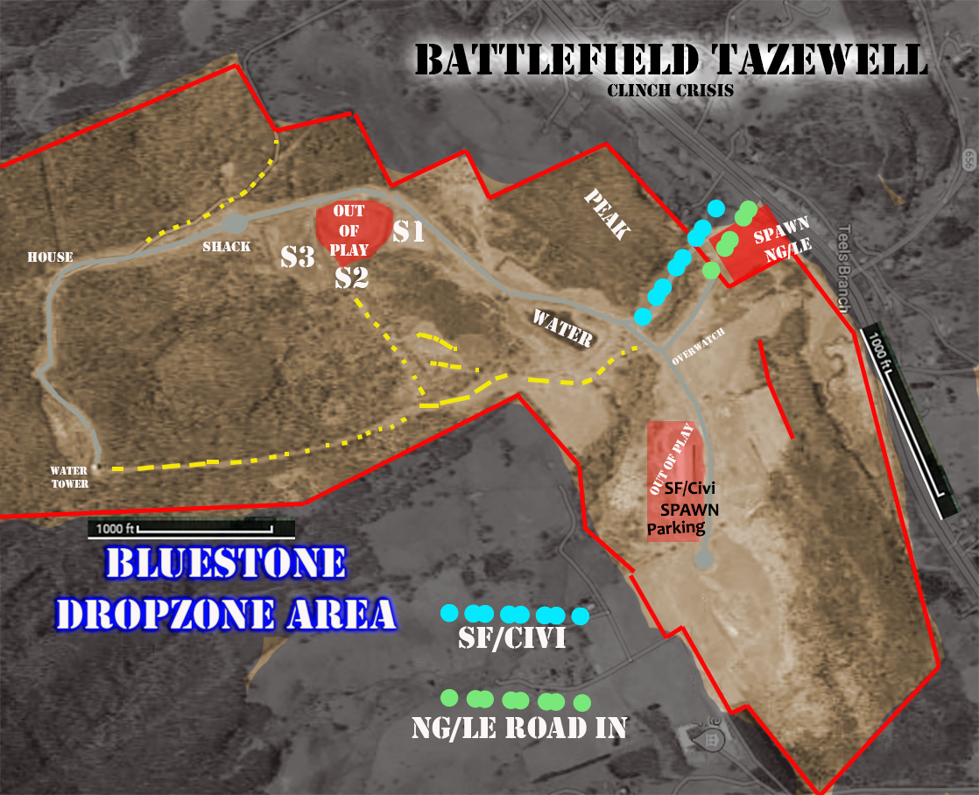

Do not Cross Fences at the Borders or Main Road  
There is an Old Fence near Overlook its ok to cross it.  
There is a Shell building we are using for Parking and Spawn, Clear it before engaging.   
There is construction on S2 don’t go on S2 shelf

The Shack, House, and Water Tower are very important for us. The Water is low for everyone if we lose water, it game over.

No Vehicles are allowed in the AO unless Staff or Civi/SF coming to Spawn. If an Enemy Vehicle comes in its Hostile  
Our hidden camp sites are Key to keep us from having to Medic at Spawn they can have supplies at them. We need to keep these sites hidden and in Play. If any Enemy gets near them they shut down as a spawn and supply **(YOU CANT MOVE THEM TILL YOU ARE ALIVE)**

This is our First line in and last line out of Tazewell County.

**Lincolnshire Park and Lake  
Lincolnshire Park, Tazewell, VA 24651  
Park and Lake Access to major Roads, Supplies, Personal**

Key Notes (Rules of Engagement)  
 Do not Cross any Fences those are the out of Bounds.   
 Do not damage or Move objects.   
 Don’t damage the Playground

No not shoot out of play Area (Parking Lots at entrance and in town)

There is a second entrance into the Park near the Pool. You can Park and Drop off hot or Possibly Drive in the trail into the AO. If you are Killed this is not a Spawn. The only Spawns are back at the Lake. Either you push in or go back to the Front and Drive or walk back to Spawn.

The Main Road in you can also Drop in IF you Vehicle is Live.

Docks at the Lake are very important. Any important Items we need to keep there and Safe. Also don’t Shoot up the building there too bad.

The Outlook is a Key Terrain Set up and command center there. If the Outlook and Docs are Both Taken no one can Leave the Lake.   
  
Spawn is far, remember that. Play Smart but NG and LE Spawn is far to once they get to Lake.

There could possibly be a Attack Boat coming. It has same Rules as other Vehicles. One Gunner but as of now Who ever controls the Docks get it. So Lose the Docks… The Boat will dump you and control comes over to NG/LE or its Shut down till you get the Docks back  
  
Do not shoot Past the Pool into the Parking Lot. Let Players clear the Fences and Tape… but if they shoot early …shoot back  
  
There are windows at this AO do not shoot them out or at Lights

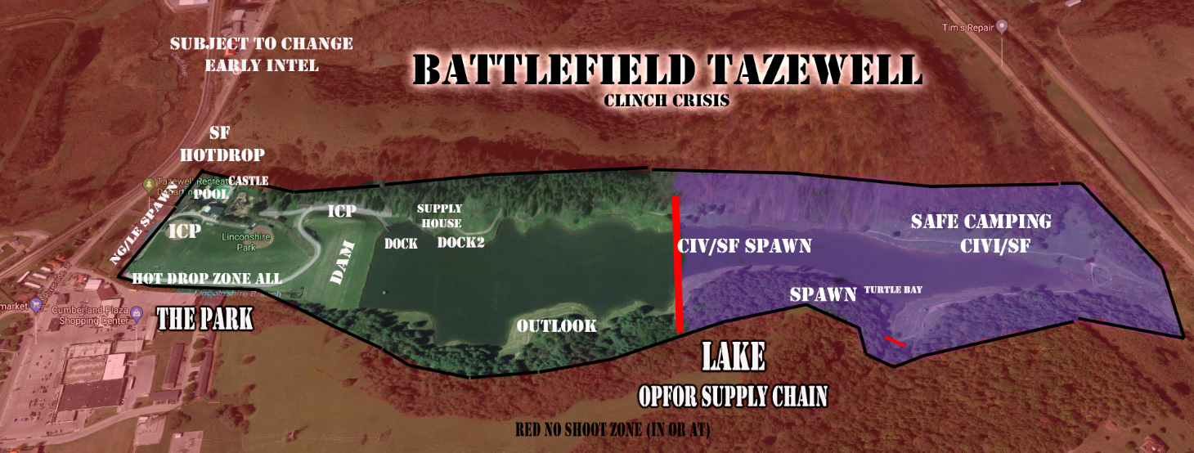

**Missions (Missions and Fragos are Organic)  
Commanders and Players need to give updates to Staff and Admins for what you’re doing to Shape the game**

Phase 1 – Saying Hello  
Making sure you have a good defensive plan for Park and Bluestone   
Try to keep Camp Sites Hidden  
No Enemy should set foot near Lake or inside of Bluestone  
Send out Recon and Assault Teams to Fairgrounds  
Defend the Playground at Park slow advance if possible

Phase 2 – Blood in the Water  
Look for Enemy Command and important Players. Try to keep them out of play at Spawn.   
Hunt for Key Items at Fairgrounds and Carlot  
Protect Key Items at Bluestone at House and Water Tower  
  
Car Lot FRAGO (As needed)  
If Vehicles are taken out go and retrieve Repair Parts  
Take any HVT, Intel, Key Items, and Repair Kits

8pm Phase 3 – Night Ops (Car Lot and Fairground)  
Defend what you have until Opfor leaves  
Possible Lake FRAGO   
  
Sunday Phase 4 - Classified  
Operation Home Run (Park)   
or   
Operation Water from Stone (Bluestone)

More Missions will be based on what players and leadership decide is important to the Success of the Overall Mission.  
  
Over all Mission - Drive NG/LE into submission and have the Resources to be survive the winter in Southwest Virginia.

Important

With Covid to keep a safe environment we will ask you to try to stay out of large groups except those you game with.

We will be limited the number of people on the Transports and ask all to respect Mask and non- mask wearers. If you want to be within 6 feet of each other, please think about having a mask inside. No mask is required outside during play. But please try to keep distance and long-term hanging out to those you didn’t come with down.

We have lots of land to play with and being on county and town land we must try to follow the health department Rules.