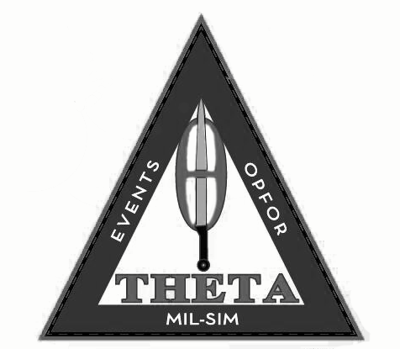

GENERAL RULES
https://thetaevents.com/rules
Full rules on Theta Events FB page note and on website
BIO BBs only at Events
Safety  Do not Move anything unless told to move it  Do not Break anything unless told can  If not sure ask before doing.  Always use Full Seal Rated eye pro. No one wants to stop playing because someone is hurt, NO MESH  If Injury happens, call Real World. Only that area is injury is stopped not the whole game. But the Frago mission becomes getting Staff and Medical there as fast as possible.  Never lay hands on anyone.  Do not Bind players. - if you want to cuff have them hold the cuffs  Required to have Light (normal and red), dead rag, and water on you during game. Lights will be going on and off.  Lasers are not to be pointed into faces.  If under 16 Face protection required. | Staff  Most Games have 3 sets of Staff  Admins -  Theta Events has final say so in all matters, we will try to deal with any issues in an adult matter. Tell us your side and we will get the other side. Most of the time it’s just a miss understanding or players are tired.  Safety Refs  These people are here to get you in contact with Admins. They most of the time are in a set area for a play to come to them and they will get a hold of Admin. The first concern is safety and reporting to Admins with they see in the games and how players are acting.  In game Refs.  Players are always embedded into all units that report to Admins the coming and goings of the day. Some of these refs never say a word to players unless it’s a safety issue. Others will be more direct and give warning. They police their own side more than another team.  In Most Games the CO of your side is also a Full ref reporting directly to Admins | Other  No Yelling Call your Hits or Cussing other players. This will get you a walk back to Spawn  Hardpoint Spawns (HQs)  We have Spawns that are Safe the enemy can't go in, Mags out and eye Pro can come off  Soft Spawns (FOBs)  These are Spawns that can be turned off by events in the game or if they are under attack. Do not Take your Eye Pro off here  If there is a prop or something of interested do not move it, report it. Only get credit for items or missions that are ACTIVE.  Special Game Smoke  We could use EG65 CMs to sim a reactor Blowing if a reactor blows this gas will let off and that area could be deadly to anyone outside in that smoke  Radioactive Items.  Can use special items for Radioactive Areas  NO RUNNING INSIDE
Ammo  Mags and Ammo Do not exceed these for these type weapons  600 rounds for Rifleman Class  1000 rounds for SMG Class  150 rounds for Snipers Class  100 rounds for Heavy Sniper Class  300 rounds for DMR Class  2500 Rounds for LMG Class  1500 rounds for Heavy MG Class  350 rounds for Shotguns  3000 rounds for Vehicle Gunner  100 in Pistols (does not count against other ammo caps)  no more than 2 grenades  no more than 2 smoke  No Speed loaders or BB Bags in the Field on player  Can reload anytime back at Base/FOB in games  Grenades must be Pull or Blank fire Type BB or Explode  Getting hit with BB,  Being Trapped in Room with 15 feet  15 Kill zone outside without Cover  Thunder B/V Flash Bangs or Distraction Types are just that not kill must Explode | Chrono  Riflemen (semi)  1.55 Joules with .32s  No MED  DMR (semi)  1.99 joules and under with .32 50 foot MED (has to have 18+ inch barrel)  Sniper (bolt)  2.5 joules with .32  100 foot MED  Heavy Sniper (.338-50 Cal)  (Bolt or trigger delay semi)  2.99 joules shooting .40 or higher 150 foot MED  (If use 6mm or 6.44mm BB must Chrono with Your own BBs for Joules for this class)  LMG (Fullauto)  1.55 joules with .32  50 foot MED for Fullauto  Full auto Outside only  Must be 50 foot from Door or Window to shoot in  Must have Barrel sticking out door or window to shot out  HMG (Fullauto)  1.99 joules with .32 100 foot MED (Large Cal)  Full auto Outside only  Must be 50 foot from Door or Window to shoot in  Must have Barrel sticking out door or window to shot out  SMG (Fullauto)  1.00 joules with .32 (has to be SMG round) 20 foot MED on Full, no MED on Semi, must be pistol Cal type do not use over .32s | Vehicles  MAX Speed 5-10mph  50-100 foot MEDs.  No one within 10 feet of vehicle unless deployed from it.  Needs Dead Rags to show it's out.  Types of Vehicles  Troop Transports  Can NOT be Shot with BBs.  Can Be taken out with Rockets over 30 feet away, Satchels, or landmines. Will not have gunners  Troops can dismount and load with a 10 foot buffer before getting hit or killed for safety of the Vehicle and players  Attack (Technical or Armor)  Allowed to have One Full Auto Gunner  Gunner has to be exposed and can be Shot with BBs. If gunner is killed must follow Wounded Rules but the Vehicle isn't taken out.  Rest of crew are allowed to dismount and protect Vehicle or Stop and switch Gunner to Gun position. No just shooting out of windows.  Vehicle Takeout  Can be taken out by Driving over Landmine with tire, Rocket Strike (30 foot med on strike), 203 rocket strike, or hit with Satchel (must be at least 10 feet away) (under hand throw)  BBs do not Kill Vehicles only Gunners if they have them  Each Vehicle is recommend but not required to have spotter looking for hits and players if possible  Satchels and Rockets MUST Hit Vehicle, NO splash damage.

