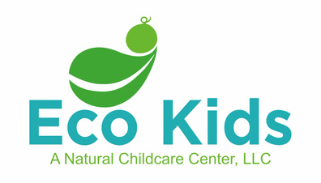
ALLERGY AND ANAPHYLAXIS POLICY

Anaphylaxis Prevention
- Upon enrollment and whenever there are changes, parents/guardians will be required to provide Eco Kids with up-to-date information regarding their child’s medical conditions, including any allergies the child may have and any emergency medications prescribed for potential anaphylaxis. The parents/guardians will work in conjunction with Eco Kids and the child’s physician to complete the documents required for any allergy that the child may have. These documents will guide all staff in the necessary actions to take during an allergic or anaphylactic reaction. Eco Kids will keep these documents and any emergency medications in a designated area known to all the staff members as outlined in Eco Kids’ healthcare plan and will ask for updated paperwork when necessary.
Documents
- Any child with a known allergy will have the following documents on file when applicable:
- NYS OCFS form 7006 – Individual Health Care Plan for a Child with Special Healthcare Needs or approved equivalent
- NYS OCFS form 6029 – Individual Allergy and Anaphylaxis Emergency Plan or approved equivalent
- NYS OCFS for 7002 – Medication Consent Form or approved equivalent

These forms will be completed by the child’s parents in conjunction with Eco Kids and the child’s physician. In the event of anaphylactic reaction, staff will call 911 and follow the instructions outlined in these documents.
Staff Training
- All staff members will be trained in the prevention, recognition and response to food and other allergic reactions and anaphylaxis upon hire and annually thereafter. In addition, at least one staff member will complete the required NYS training on allergies and anaphylaxis. Several staff members will also maintain certifications in CPR & First Aid and medication administration. If a child with an allergy requires the administration of Epinephrine or other emergency medications, the parents will be required to train any staff member caring for that child on the administration of the prescribed medication.

Strategies to Reduce the Risk of Exposure to Allergic Triggers
- Each classroom will have a posting with a list of individual children’s allergies that is visible to all staff and volunteers caring for the child. All staff will take steps to prevent exposure to a child’s known allergy, including but not limited to reading food labels. Handwashing, cleaning and all other regulations related to allergies and anaphylaxis as outlined in the OCFS Childcare Regulations will be followed by all staff and volunteers.
Communication
- Upon enrollment of a child with a known allergy, all staff and volunteers will be made aware of the child’s allergy and associated medication needs, as well as ways to reduce the risk to exposure to said allergen. In addition, all parents and children will be made aware of any allergies in the classroom, as well as actions being taken to reduce exposure. Confidentiality will be maintained when discussing any child’s allergy with parents and other children.
Annual Notification to Families
- Families will be given a copy of the Eco Kids’ Allergy and Anaphylaxis Policy upon enrollment. This policy will be reviewed and updated annually. Families will receive an updated copy of this policy annually and whenever changes are made.

