Longcroft Allotment Association
Newsletter: Winter 2020
www.longcroftallotmentassociation.org.uk
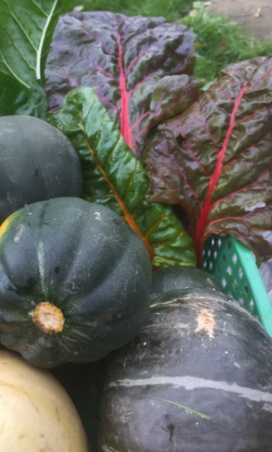  It's that time of Year  December and January are quiet months on the plot – the perfect time for getting organised: planning, and housekeeping.  It’s a good time to sort through any leftover seeds and decide which ones to keep and which to throw out – seeds typically have a life of around two years and results deteriorate over time. You may also wish to discard any seeds that you didn’t enjoy growing (or eating!). And, while you’re at it, think about what to plant and where in the year ahead. A good crop rotation plan will help to limit pests and diseases.  Also those cold/rainy days when there’s little incentive to visit the plot are an opportunity to ensure your garden tools are clean, sharp or otherwise in good condition.  Check the condition of any crops that are in storage – fruit, potatoes, onions and squashes are the main candidates.  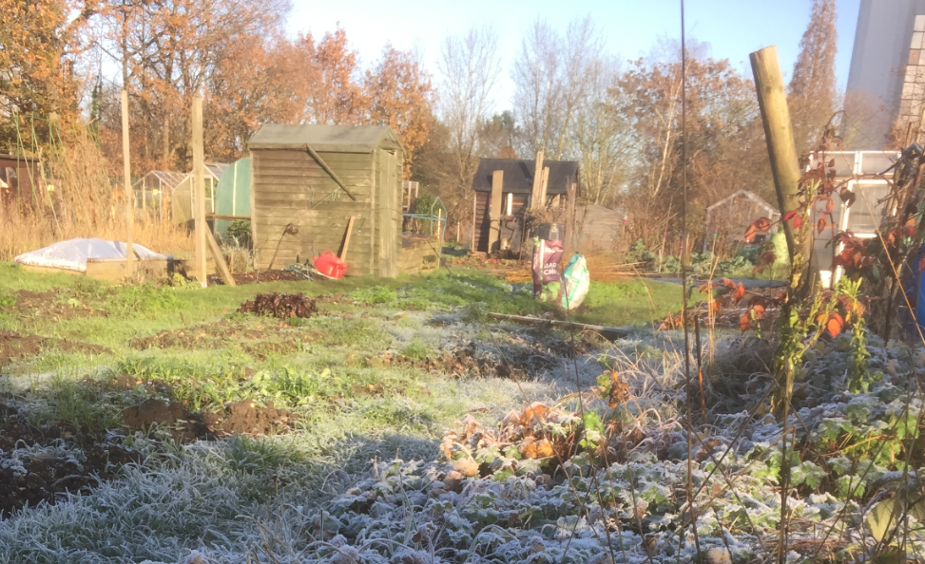 | Jobs  November: Order seeds for the coming year. Prepare you plot by winter digging. Considering covering empty ground for winter.  December: Prune hard fruit trees (apples, pears) and currants, gooseberries and autumn raspberries. Remove faded leaves from winter brassicas. Cover beds.  January: Spread manure over empty beds. Clean pots, store produce, and plan for the year ahead. Start to chit potatoes.  Plant  November/December/ January: Fruit trees, fruit bushes and rhubarb. Garlic sets, shallots, hardy peas and broad beans (Aquadulce varieties), winter salad leaves.  Harvest  November/December: Leeks, root vegetables, brassicas (cabbage, kale, Brussels sprouts), late salad crops.  January: Parsnips, swedes, hardy winter brassicas: cabbages, kale, Brussels sprouts.
Coronavirus Update
We continue to be affected by Coronavirus and recommend that members work their allotments during the lockdown, either alone or with members of their families/household. The Government have now removed the limit on exercise time, but we all need to observe good standards of hygiene and maintain social distancing.
Other Updates
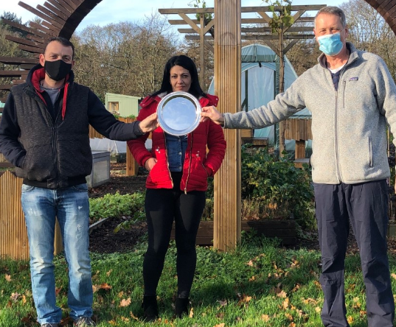
2020 Pumpkin Competition: Thomas Markatopoulos has repeated his success of last year and grown the Association's largest pumpkin of 2020. The photograph shows Andrew Hepher, LAA Chair, presenting the 2020 Giant Pumpkin trophy to Thomas and Alexandra Papageorgio.
The seeds for the pumpkin, and all others used in this year's competition, were saved from the previous winning pumpkin. The variety is Atlantic Giant which can produce specimens of more than 1,000kg!
Water Supplies: These have been turned off at both sites to reduce the risk of frost damage over winter. The water supplies will be restored in the spring, ahead of the next growing season.
Shop at Digswell: Next year we plan to open the shop once in March, twice in April and then once monthly until October, with dates announced and a rota in place from the beginning of the season.
Broadwater: The Council has funded the repair to the walls and the addition of a new roof to the communal shed. Work started on Monday, 26th October and was completed by the following week.
Digswell: Site/plot inspections have been completed.
New Members: Since the last newsletter was sent out we have had no new members.
Waiting List: This currently stands at twenty two for Digswell and twenty three for Broadwater.
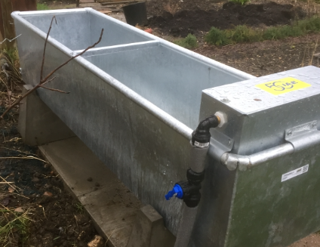
Polite Reminder – Use of Water Tanks/Troughs
With the current coronavirus outbreak it is especially important to observe good hygiene practices.
Please remember that water tanks are only to be used for drawing water, using watering cans or other containers. They should not be used for washing hands, tools or vegetables.

Crop Planner

Apples
There are only two or three types of apple depending on how they are classified as: eating/dessert or cooking; or early, mid-season or late; dwarf, semi-dwarf or standard. Apples cross-pollinate so trees need to grow close to other apple trees of a similar group.
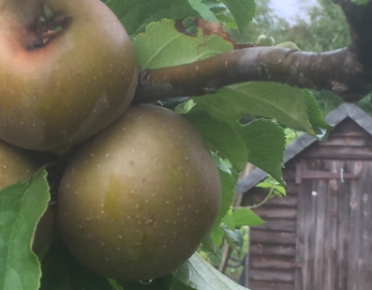
Trees should be planted (and subsequently hard pruned) between November and February in well-drained, fertile soil at a location with full sun. They will need summer pruning (to maintain shape and remove unwanted spurs) between July and August, and harvested from late August through autumn. Apples are ripe when they come away from the branch easily.
Apples can be stored in a cool, dark place over winter by wrapping them in paper to prevent any disease spreading. Eating apples are eaten raw (and are good when added to some savoury dishes, such as potato salad), while cooking apples can be used in baked desserts and cakes, or to thicken and flavour savoury dishes, chutneys and sauces.
Autumn/Winter Recipe
Spiced Red Cabbage with Apple
A simple sweet/ savoury accompaniment to hot or cold roast meats.
One medium red cabbage, 450-600 g (1 – 1½lbs)  4-5 star anise  ½ teaspoon ground cinnamon  200ml (½ pint) water or stock | 50g (2oz) brown sugar  100ml (¼ pint) cider or wine vinegar  2-3 cooking apples  Salt and pepper to taste
Finely shred the cabbage and simmer with all the ingredients other than the apples in a saucepan for approximately 30 minutes.
Peel and core the apple and chop into slices. Add to the pan and simmer for a further 15 minutes until the mixture is thick.
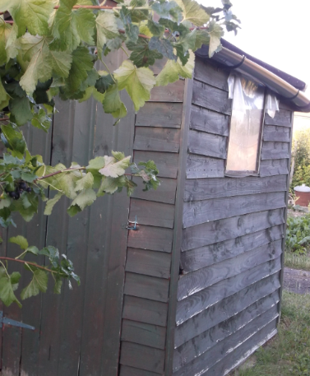
Down at the Shed
The Shop at Digswell is now closed for the winter.
Next year we plan to open the shop once in March, twice in April and then once monthly until October, with dates announced and a rota in place from the beginning of the season.
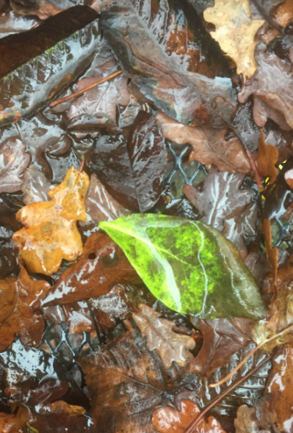
Greener Fingers – Leaf Mould
Autumn is the perfect time to gather the ingredients for leaf mould.
Being virtually all carbon, leaf mould does not have high levels of plant nutrients: nitrogen, potassium and phosphorus, but does contain some trace elements. Leaf mould can be dug into the soil to improve structure and retain water. Its water retention also means it can also be applied as a mulch r used to supplement soil in containers. It helps to form ecosystems within your soil and is, for example, attractive to worms.
To make leaf mould, simply gather autumn leaves and allow them to rot for at least two years. Oak, hornbeam and beech leaves rot quickly and produce the quickest results. Freshly fallen leaves are slightly acidic they become neutral as they decompose.
The leaves can be rotted in bin bags (with some holes to allow the decaying leaves to ‘breathe’) or in a large open container enclosed by pallets or chicken wire. Keep the leaves moist to aid decomposition and you can speed the process up by: adding a few layers of soil and/or manure; shredding the leaves before storing them; and regular turning to aerate the mixture.
The leaf mould is ready to use when it looks like dark soil.
Loss/Preservation of Nutrients in Pickles and Chutneys
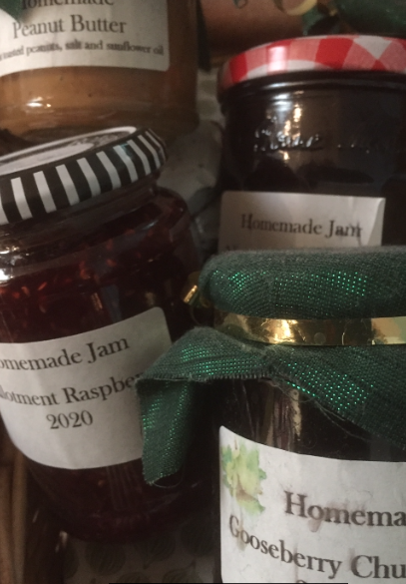
Pickles and chutneys are long established methods for preserving excess produce, but how much of the nutritional benefit of our fresh produce is lost in their preservation?
Cooking fruit and vegetables, followed by immersion in a combination of vinegar and sugar kills bacteria, fungi and yeasts to assist their preservation. However, there are nutrient losses at various stages in the process of preparing vegetables/fruit during pickling or preparing chutney. Vitamins, minerals and other nutrients are lost soon after picking, when produce is washed, and when vegetables are chopped and this process is accelerated when they are cooked – particular at the high temperatures required to make chutney. If they are exposed to the light during storage there is further loss of vitamins A and C.
The degradation is greater for more finely chopped ingredients, and storage in oil tends to result in greater retention of nutrients (but is generally less suited to the UK palate).
Pickled vegetables retain at least some of the nutritional value of their fresh ingredients and the use of sauerkraut, for example, has helped to eliminate scurvy on historic long sea journeys and polar explorations.
The main benefits of chutneys and pickles is to prolong the life of their contents – something which they achieve admirably whilst offering delicious supplements to meals and snacks.
Comments and feedback
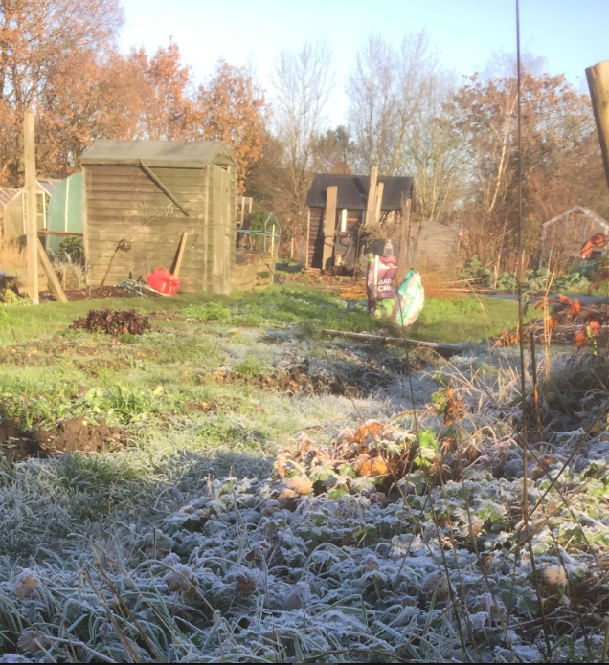
If you have any news, tips, features, recipes or photographs that you would like to submit for future issues of the Newsletter please send them to :Newsletter Editor: email@longcroftallotmentassociation.org.uk
Visit the Longcroft Allotment Association website: www.longcroftallotmentassociation.org.uk

