PICCOLO PRE ORDERS
NAME | STARTER | MAIN | SIDES | NOTES

Name of booking:
Date / Time of booking:
Phone Number:

NAME | STARTER | MAIN | NOTES
Kay | Gamberoni | Branzino Mare
Andy | Costine | Ribeye Steak | Medium Rare
Karina | Chicken Liver Pate | Angello Italiano

Name of booking: Kay Carpenter
Time of booking: 9:00pm
Phone Number: 07709 430773

NAME | STARTER | MAIN | NOTES
Janet Clouston | Arancine Vegetable  (Rice Balls) | Angello Italiano  (Lamb Shank)
Paul Clouston | Arancine Vegetable  (Rice Balls) | 12oz Ribeye Steak | Cooked Medium

Name of booking: Janet Clouston
Time of booking: 9pm
Phone Number: 07772466321

NAME | STARTER | MAIN | NOTES
Joan | King prawns | Rib eye steak
Geoff | Chicken pate | Rib eye steak
Pauline | Baby back ribs | Lamb shank
Judi | Chicken pate | Rib eye steak | Medium rare
David | King prawns | Rib eye steak | Medium rare
Martin | King prawns | Rib eye steak
Pam | King prawns | Rib eye steak

Name of booking: Pauline Dabbs
Time of booking: 21.00
Phone Number: 01614289212
Request is it possible to have table on ground floor due to mobility issues

JAMES HINE 5 PEOPLE 9PM
Starters

2 x arancine
2 x gamboroni
1 x chicken liver pate

Mains

2 x Branzino
1x Pollo Cacio
1 x Angello Italiano
1 x Ribeye Steak

MAGDALENA KEPA
31.12.23
9:30pm
07805412477

Starters:
Chicken liver pate
Costine

Mains:
Angello Italiano
Pollo Cacio e Pepe

9:30PM
CHERYL
STARTERS – PATE / RIBS
MAINS – LAMB X 2

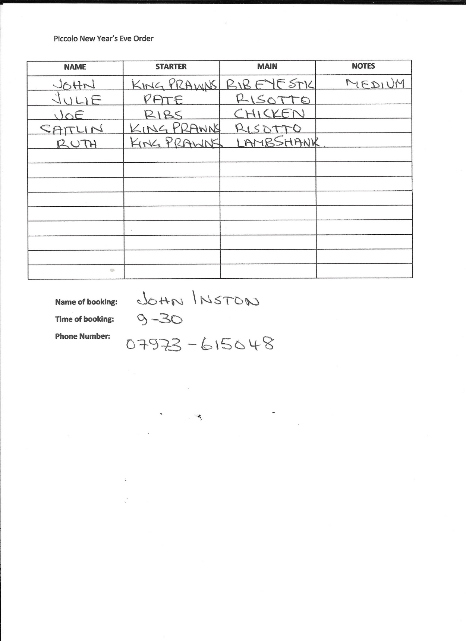
9:45PM LUKE RUSSELL
Starters:
Pate
Prawns

Main:
Lamb
Ribeye (medium rare)

