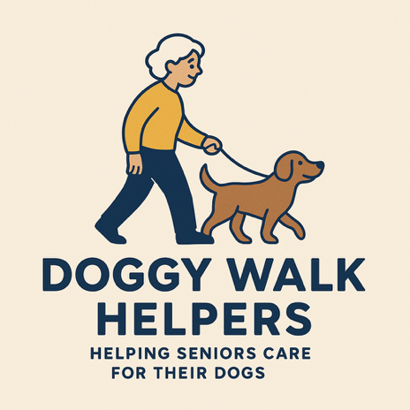

General Information Form
Your Name
Address
Postcode
Email Address
Phone:Home
Mobile
Work

Security Information
Gate Codes/Alarm Instructions

Your Dog's Details
Name
Age
Gender (M/F)
Breed
Colou
rIs Your Dog Microchipped? (Y/N)
Is Your Dog Insured? (Y/N)
How Long Have You Owned Your Dog?Please briefly describe your dog's history (e.g. if adopted)
Date Of Last Immunisation
Neutered?
Yes
No
No but will be by
Un-Neutered Bitch?
Date of Last Season

Up To Date With Shots?
Yes
No
No but will be by?
Date of Last Kennel Cough vaccination (Bordetella)?
Allergies:
Please list any pre-existing or current health conditionsPlease list any medication your dog is currently taking and instructionsPlease indicate if your dog has any sensitive areas on his/her bodyPlease describe any restrictions on your dog’s activity (e.g. due to physical limitations such as hip dysplasia)Is your dog allowed treats while under the care of Doggy Walk Helpers?

Social Skills
Please give a brief description of any formal obedience training your dog has received- How does your dog react to other people and dogs when on walks?

Behaviour
Please describe general behaviour and energy levels (both inside and when out)

Please provide details if your dog is anxious around, or frightened by, any of the following:
NoisesActionsObjectsBreeds or Types of DogTypes of People
Where does your dog sit when travelling in the Car? Front? Back? Boot?
Does your Dog ever get car sick?
Does your dog have specific command to "go to the bathroom"?
Does your dog behave differently on and off lead?
Does your dog play off lead with other dogs?
Does your dog live with children?
How does your dog behave around new children?
How does your dog behave around livestock?
Has your dog ever jumped on someone (if so, please describe the circumstances)?
Has your dog growled or snarled at someone (if so, please describe the circumstances)?
Has your dog ever bitten someone (if so, please describe the circumstances)?
Has your dog ever bitten another dog, other than play-biting (if so, please describe the circumstances)?
Does your dog allow you to take things out of his/her mouth?
What type of dogs does your dog prefer to socialise with (e.g., small, females, playful, calm, etc.)?

Will Chase:
Doesn’t Chase
Cats
Deer
Livestock
Small Animals
Off Lead with Owner:
Yes - Always
Usually
Occasionally
Never
Recall:
Very Good
Average
Poor
Notes:
Type of Lead
:Standard
Extendable
Type of Restraint:
Full check
Half Check
Standard Collar
Gentle Leader
Halter
Harness
Muzzle
Other

Routine
Please describe pick up and return routine. Please give any other information that you think would be useful to enable us to give your dog the best possible care while under the care of Doggy Walk Helpers:

