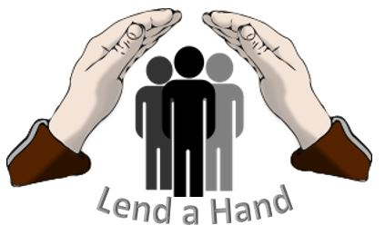

Dear Community Member, Business Owner or Manager,

On Saturday, May 30, 2020, the 9th Annual Lend A Hand Charity Event will be held at the Lower Dauphin Kreiser-Hallman Field in Hummelstown, PA. Since its inception, over $130,000 has been raised. 100% of the proceeds have been donated to individuals or families that have experienced a life changing event resulting from illness, accident, or natural disaster.

This year’s all-day event will feature four different field hockey tournaments to include middle school teams, high school teams, youth teams and adult teams. Plus, softball and baseball activities have been added to our event. We anticipate several hundred athletes, family members, friends, and community supporters to be part of this special day.

Our online auction with items donated by individuals or businesses will go live on May 1 and will be updated as new donations are received. On the day of the event, we offer our very popular bags of donated raffle items from businesses, colleges, and community members. You can help with our event by offering an item or service to be auctioned or raffled off. Event sponsorships are also available as outlined in the attached donation/sponsorship form.

The Lend A Hand event was founded and organized by Linda Kreiser, Head Coach of the Lower Dauphin Field Hockey Program for the last 43 years. Coach Kreiser is a nationally known and recognized field hockey coach who has impacted the lives of thousands of young athletes over the years. The Lend A Hand event is a program supported by the Lower Dauphin Falcon Foundation, a non-profit 501(C)(3) organization, tax identification number 20-8500809.

Thank you for considering contributing to our charity event. Attached is the form to be completed if you would like to donate an item or be an event sponsor. We will begin promoting your contribution as soon as we have the form returned so your generosity can be recognized as a contributor to our event. One of our committee volunteers will follow up with you, or you can call 717-576-7432 to have the form picked up, or you can email it to info@lend-a-hand.net. Your actual donated item does not need to be received until May 15, 2020.

Sincerely,
.
Linda Kreiser
Founder / Executive Director – Lend a Hand Charity Event
Head Coach - Lower Dauphin Field Hockey Program

DONATION / SPONSORSHIP FORM

Information Needed

Business Name:_______________________________________________
Business Address:_____________________________________________
Contact Person:_______________________________________________
Phone:______________________________________________________
Donation Item: _______________________________________________
Sponsorship Level (see below):__________________________________
Preferred Pick Up Date: ________________________________________
*Note: If a product (stick, clothing, picture, vacation house, etc) is being donated, a picture will be needed to post on the LAH auction site.
____ Check here if you would like a tax-deductible receipt for your donation.
Event Sponsorship opportunities will be recognized in many ways leading up to the Event as well as on May 30, 2020.

Platinum Sponsors contributing >$1,000
Receive Donor Preference on recognition plus all options available
Gold Sponsors contributing $1,000
Mentioned on -
Web Site
Flyers and Printed Communication
Event Shirts
Social Media Communication
Day of Event PA Announcements
Day of Event Signs
Silver Sponsors contributing $500
Mentioned on -
Web Site
Flyers and Printed Communication
Social Media Communication
Day of Event Signs
Bronze Sponsors contributing $250
Mentioned on -
Web Site
Day of Event Signs
Friends Sponsors contributing $50
Mentioned on -
Day of Event Signs

