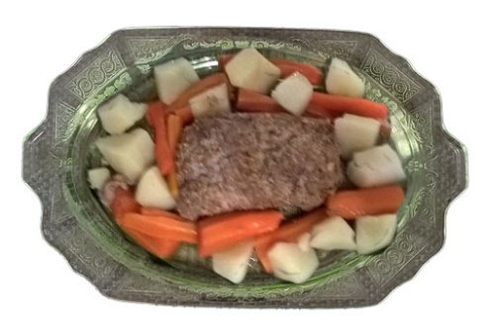

Meatloaf Potatoes and Carrots

2 pounds hamburg

1 package meatloaf seasoning mix

2 eggs… Italian Seasoning bread crumbs

Ketchup…diced onion…

Potatoes and carrots

Mix hamburg…seasoning mix… eggs…

Sprinkle with Italian Seasoning bread crumbs

Add some ketchup and onion over top…

Mix again and form loaf…

Place in oven roaster and add diced potatoes and carrots… add water to cover potatoes and carrots…. This makes a nice broth…

Bake @ 350 for 1 ½ - 2 hours