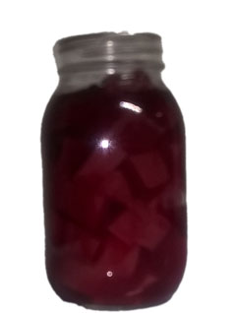2

cups sugar

2 cups water

2 cups apple cider vinegar

1 teaspoon cloves

1 teaspoon allspice

1 tablespoon cinnamon

DO NOT PRESSURE CAN

Wash beets several times to get dirt off… cut most of the tops off but not completely so that moisture stays in the beets.

Place in a pot of boiling water… bring to boil and cook until tender. (usually 1 – 1 ½ hour)

Put all other ingredients into a pot and cook until sugar is dissolved and blended

Place beets into cold water… take skins off…. (they will come off very easily) cut into small pieces…

Place into jar and pour warm other ingredients over them

Process in boiling water bath for 15 minutes