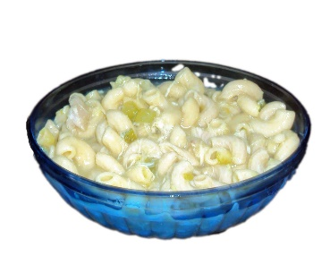

Chicken and Chicken Broth

(Best if chicken cooked in pressure cooker)

1 cup celery

1 -2 tablespoons chicken soup starter

(for extra seasoning)

Ditalini Pasta ( or any 16 oz pasta ) amount can vary depending on how much you are making

Cook chicken in pressure cooker for 30 minutes on high… Let chicken cool a little then de-bone and cut into bite size pieces and add to chicken broth… cut celery into bite size pieces and add to chicken broth… bring to boil… add pasta to broth and cook for an additional 30 -35 minutes