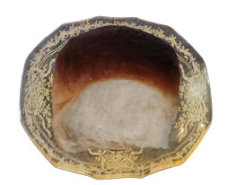

Dinner Rolls

Start by using frozen bread dough loafs… or rolls… after thawing…

If using bread dough loafs divide into 7 balls… if using dinner rolls knead

2 rolls together to make larger dinner rolls…

Knead until smooth and elastic…

Place into a greased baking pan…

Poke tops with fork to put air holes in dough…

Place in a warm area free from drafts until at least doubled in size….

Bake @ 350 for 25 – 30 minutes