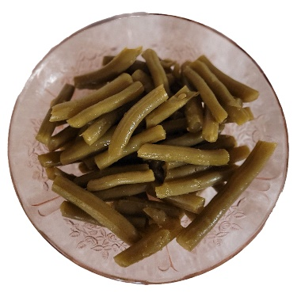

Fried Green Beans

1 can green beans…either home canned…fresh… or store bought…

Small amount of oil…

Diced onion… (optional)

Put some olive oil into skillet…

Drain green beans and add to skillet…

Add sone diced onion (optional)

Cook on medium for 15-20 minutes