## On Point Dog Trainings - Business Card (Front)

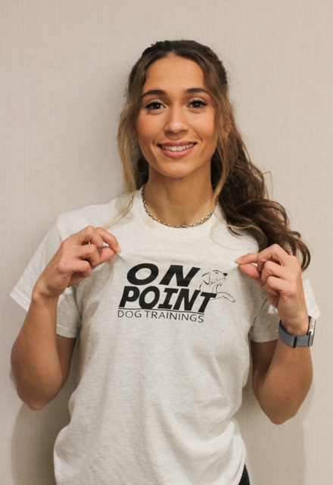

Maria Licavoli  
Certified Dog Trainer  
📞 (314) 201-2742  
✉️ Maria@onpointdogtrainings.com  
🌐 OnPointDogTrainings.com

## On Point Dog Trainings - Business Card (Back)

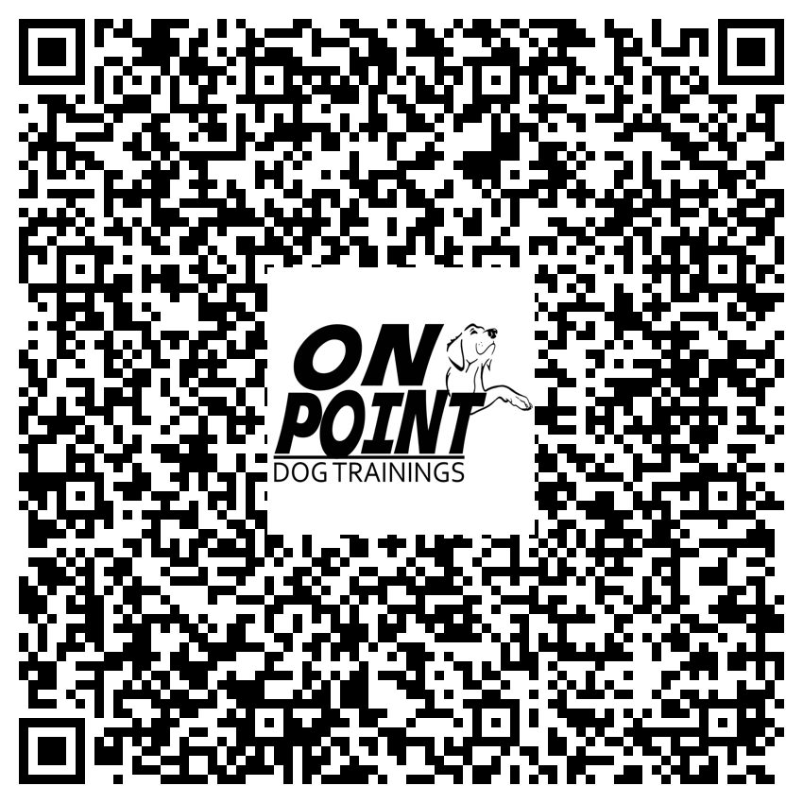

**Training • Dog Sitting • Dog Watching**Scan QR code to visit website, call, or email directly.