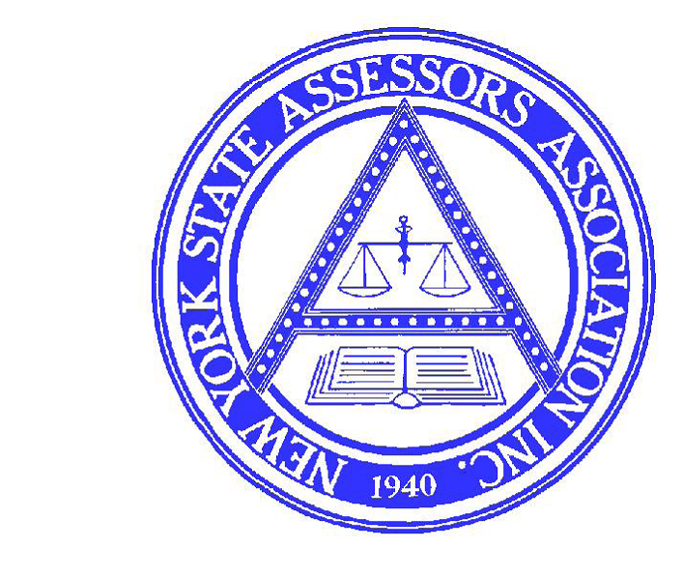
Date Rec’d:

Initials:
IAO ETHICS COMPLAINT FORM

COMPLAINANT NAME_______________________________________________________________________

ADDRESS__________________________________________________________________________________

TELEPHONE________________________________________________________________________________

E-MAIL____________________________________________________________________________________

LOCATION (VILLAGE, TOWN, CITY OR COUNTY OF COMPLAINT) _____________________________________

NATURE OF COMPLAINT
- AS PER ARTICLE 13, SECTION 1 (9) (A) OF THE NYSAA CONSTITUTION AND BYLAWS, COMPLAINTS MUST BE FILED WITHIN 1 YEAR OF THE DATE OF THE ALLEGED VIOLATION.
- IN VIOLATION OF SECTION(S) AND PARAGRAPH (S) OF THE NYSAA CONSTITUTION AND BYLAWS-ARTICLE XIII-CODE OF ETHICS AND STANDARDS OF PRACTICE (PROVIDE SPECIFIC CITATIONS).
- PLEASE ATTACH ANY PERTINENT DOCUMENTATION.
- USE ADDITIONAL SHEETS IF NECESSARY.
- PLEASE NOTE THAT COMPLAINTS WILL BE RETURNED FOR SPECIFIC INFORMATION UNLESS PROVIDED WITH INITIAL COMPLAINT.

__________________________________________________________________________________________

__________________________________________________________________________________________

__________________________________________________________________________________________

__________________________________________________________________________________________

__________________________________________________________________________________________

__________________________________________________________________________________________

__________________________________________________________________________________________

SIGNATURE_____________________________________________ DATE: _____________________________

MAIL TO: NEW YORK STATE ASSESSORS ASSOCIATION, C/O CHAIR-ETHICS COMMITTEE, 116 SALINA ST., SUITE 8, LIVERPOOL, NY 13088

